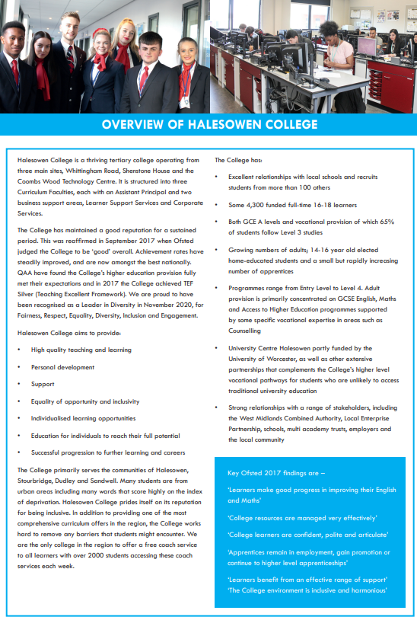



**QP057**

**Job Description for Sous Chef**

|  |  |
| --- | --- |
| **Line Manager:** | Restaurant Manager |
| **Contacts:** | College Staff, Students, Suppliers, Contractors, General Public, College Stakeholders, Government Agencies |
| **Job Purpose:** | Employed by Halesowen College subsidiary company Halesowen College Enterprises Limited you will assist the Restaurant Manager and Production Chef, in ensuring we offer a quality service in Bistro at B63. Responsible for working alongside the Production Chef to operate the Production Kitchen for services offered to internal and external customers, and train and supervise student’s in the Production Kitchen. You will support the Restaurant Manager and Production Chef to write and cost menus. To oversee and ensure completion of all kitchen related health and safety policies and documentation, alongside the Production Chef. |
| **Hours:** | 40 hours per week based on full time, but fractional posts available, can be daytime, evening or weekend so must be flexible. Occasional extra hours and weekend work may be required, for which time off in lieu is given. Staff are expected to support College events outside of core business hours. |
| **Salary:** | £10.05 per hour (pending a pay review) |
| **Annual Leave:** | The leave year runs from 1 August to 31 July  20 days and 8 bank holidays (5 days annual leave must be used for College Closure Days) |
| **Pension:** | NEST pension scheme |
| **Staff Benefits:** | <https://jobs.halesowen.ac.uk/index.cfm?action=content&content=1> |

***Duties and Responsibilities:***

1. To assist the Restaurant Manager and Production Chef including:

(b) Costing and writing menus for Bistro at B63.

(c) Assisting in the co-ordination of health and safety policies and documentation relating to the kitchen and restaurant.

2. To oversee and ensure completion of kitchen related health and safety policies and documentation, such as safe systems of work, COSHH, food hygiene regulations, allergen awareness regulations and records, environmental health records.

3. To develop and produce a high-quality standard of food to cater for both internal and external customers.

4. To be cost efficient with the creation and development of menus, ensuring minimal wastage.

5. To cater for and assist with College functions when required.

6. To supervise students within the production kitchen.

7. To thoroughly clean down the production kitchen after each use to maintain high levels of cleanliness.

8. To undertake any other duties which may from time to time be required, and which are commensurate with the post holder’s skills and experience.

**Under DBS legislation and guidelines this is a regulated activity.**

Any other duties, which may from time to time, be required and which are commensurate with the skills experience and grade of the post holder.

**Data Protection**

You are required to meet the specifications of the College’s Data Protection Policy as part of your conditions of employment. This will include information relating to past and prospective employees and students, suppliers and customers.

**Harassment and Discrimination**

You have a duty not to discriminate against or harass colleagues, contractors, students, parents, guardians or potential students or other College visitors, by reason of their age, sex, sexual orientation, gender re-assignment, marriage and civil partnership, pregnancy or maternity, race, disability or religion and belief.

**Safeguarding and Staff Code of Conduct**

You have a duty to abide by the Staff Code of Conduct and Safeguarding Policy.

**Health and Safety**

The College and its employees have legal obligations in respect of the health, safety and welfare of persons at work and the protection of others against risks to health and safety in connection with their activities. Specific health and safety responsibilities are detailed in the College Health and Safety Policy.

Other information for job holders/applicants:

**Disclosure and Barring Service Check**

This post, due to its nature, duties and responsibilities, will be subject to a check by the DBS. The level of check which will apply shall be an “Enhanced” level check.  Information about this disclosure can be found at [www.gov.uk](http://www.gov.uk).

To prevent abuse and implement good practice Halesowen College ensures that recruitment practices are robust and rigorous and that all staff employed have up to date and acceptable references, a full and complete employment history, an Enhanced DBS check and a check of the DBS barred lists.

**Safeguarding**   
Halesowen College is committed to safeguarding and promoting the welfare of young people and vulnerable adults and expects all staff and volunteers to share this commitment.  
Successful applicants will be subject to an enhanced Disclosure and Barring check.

**Equality and Diversity**

Halesowen College is proud of its work in embedding equality and diversity principles in its activities and welcomes applications from all suitably qualified people, irrespective of age, sex, gender reassignment, marital or civil partnership status, disability, race, ethnic or national origin, religion or beliefs, sexual orientation, unrelated criminal convictions or family responsibilities.

We welcome all sections of the community and value the contributions to the achievement of the College’s mission that are made by members of the College from a wide range of backgrounds and experiences. All staff must demonstrate an awareness of equality and diversity principles, as set out in College policies that includes **F**airness, **R**espect, **E**quality, **D**iversity, **I**nclusion and **E**ngagement. It is expected that all members of staff on appointment are committed to and include these principles in their work.

More information on our Equality and Diversity policy can be found at <https://www.halesowen.ac.uk/about/equality-diversity/>

**Childcare Facilities**

There is a day Nursery on the Whittingham Road campus for babies from 12 weeks and children aged 2 to 5 years. It is open 8.00 am to 5.30 pm Monday to Thursday and 8.30 am to 5.00 pm Friday. Further details are available from the Nursery staff on 0121 602 7677.

It is registered at present for 29 children in the early year’s age range. The baby room caters for 9 babies.

**Information Technology**

The College has approximately 2,600 computers across its sites including PCs, laptops, netbooks and Macs running a range of industry standard software. Equipment is available for long and short term loans, and guest access to our wireless network is provided for personal devices. We also run a PC booking system to ensure you can get access to a computer when you need it. A wide range of classroom technologies are in place such as the Moodle Virtual Learning Environment, cameras, voting devices and interactive whiteboards/data projectors.

All staff and students are given a personal computer account with access to email and storage which is available on and off site.

**Smoking**

Halesowen College is a designated smoke-free environment within the perimeter of all College property by order of the College Governors. This rule applies equally to staff and students, and to all categories of visitor. Acceptance of this rule is a condition of employment for staff, and a condition of being a student for students.

**Campus**

The College has three sites, Whittingham Road, Shenstone House and Coombs Wood. Staff can be asked to be based at and/or work across all campuses.

**Note: This job description is current at the time of issue. It should be recognised that, in keeping with organisational changes and developments, it may be necessary to review the duties listed from time to time and change them to meet organisational objectives.**

