Job Description

Job Title | Digital Trainer – Apprenticeships
Department | Business Skills Solutions
Reports To | Apprenticeship Manager
Grade
Location | Solar House -Stratford (Travel to other campuses will be required)

Job D
Our Vision
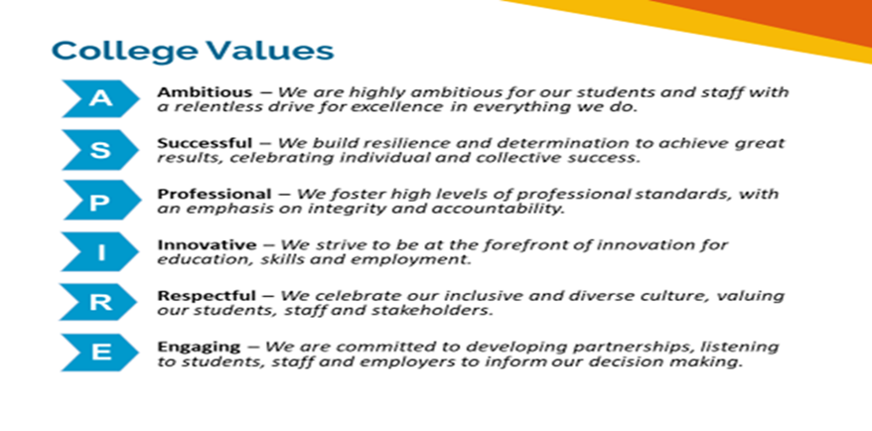 Equality of Opportunity

The college has a strong commitment to working towards the implementation of equality of opportunity in both service delivery and employment. The College's mission and strategic objectives directly support this aim. All employees are required to actively support the development, dissemination and implementation of this aim and related policies and programmes.

Safeguarding of Children and Vulnerable Adults

The College is committed to safeguarding and promotes the welfare of all learners and expects its staff to share this commitment. In addition they will also state that the College is committed to safeguarding and promotes the welfare of all learners and expects its staff to share this commitment. All posts in the College are subject to an Enhanced DBS check and barred person’s list check.

Job Description
Job Purpose

The Digital Trainer - Apprenticeships will contribute to the intellectual life of the Institute of Technology through making a range of contributions to student education and experience through curriculum development and the delivery of teaching. The Trainer will deliver high quality teaching including making improvements in key aspects of teaching, learning and assessment and contribute to the administration of key academic and college activities including employer engagement.
Managing a caseload of apprentices on one or more Digital apprenticeship standards, including (but not exclusive to) Information communications technician, Network engineer, DevOps engineer, Cyber Security Technician or Data Analyst at level 3 and above, the Trainer will be responsible for ensuring all knowledge, skills and behaviours are achieved in a timely manner and apprentices are well prepared for their End Point Assessment.

Key Duties and Responsibilities

General
- Implement and adhere to College policies, mission, values and strategic objectives
- Take responsibility for own professional development ensuring full compliance of all internal and external training requirements
- Ensure the safeguarding of students and British Values, Citizenship and Environmental Sustainability & Development is understood and embedded within the role.
- Understand and comply with Safeguarding legislation, ensuring that this commitment is demonstrated in all aspects of the role as appropriate
- Further promote, develop and embed equality of opportunity, prevent discrimination and maximise the diversity of both staff and students.
- Ensure the Health and Safety policy and procedures are followed at all times and that good practice is embedded throughout all aspects of the role. Ensuring the required risk assessments and training is up to date.
- Participate in the college’s staff learning and development and annual appraisal requirements
- Contribute to the effective management of the college via meetings
- Collaborate with other areas of the College as required to ensure effective delivery of cross -College programmes and partners.
- Work with other support services to meet the needs of the college on specific projects/tasks outside of your main area of work.
- Ensure all data is handled in line with the General Data Protection Regulations.
- Undertake such duties and hours of work that may be required of you commensurate with your grade, this may be at college locations or sites where the college provides a service.
- Support College initiatives and aspirations to achieve Net Zero carbon.

Teaching, Learning and Assessment

- Organise, design and deliver teaching and assessment as required by the college. This will include delivering lectures, classes and seminars in core and specialist subjects with due regard to best practice and the overall teaching strategy in the specialist area.
- To design and assess across a variety of digital apprenticeship standards and apply practices that provide scope for outstanding levels of stretch, ensuring all students are significantly challenged to achieve their full potential, and acquire knowledge, skills and understanding that are most highly valued by employers.
- Apply specialist and up-to-date subject specialism knowledge to embedding employability into the curriculum and course unit structure.
- Actively contribute to curriculum development and the review of courses in accordance with the teaching and learning strategy of the college and to meet awarding body /End Point Assessment Organisation (EPAO) standards.
- Make innovations in teaching and learning through the development of teaching materials, forms of pedagogy, or appropriate teaching collaborations online and in person.
- To contribute effectively to teamwork in course delivery across programmes as necessary, including group tutorials including referring to specialist services as appropriate, and proactively identifying engagement issues to support learner retention, achievement and progression.
- Actively contribute to curriculum development and the review of courses in accordance with the teaching and learning strategy and associated quality assurance frameworks.
- To plan and deliver in line with sector-recognised standards and recent industry innovation and practices.
- To work within the course team and managers to review the course and participate in the College quality assurance cycle and to complete course reviews and action plans and attend academic boards as needed.
- Actively contribute to curriculum development and the review of courses in accordance with the strategy of the Institute of Technology.
Duties specific to the role
- Ensure regular internal quality assurance checks on the work submitted by apprentices throughout their programme.
- Ensure full compliance with college’s e-portfolio system to deliver training and record learner progress including off-the-job training tracking.
- Work with the business development team and Apprenticeship Manager to ensure delivery models are understood and when new apprenticeship starts can be onboarded.
- Complete inductions with apprentices and their line managers ensuring they are fully aware of their commitment to the programme and understand all aspects of the delivery.
- Ensure full compliance with IfATE, DAS, Ofsted and ESFA regulations and maintain rigorous and robust quality assurance processes.
- Manage the end point assessment organisation (EPAO) relationships, ensuring EPAO requirements are adhered to.
- Work with the Institute of Technology Director Designate and Apprenticeship Manager to build a new curriculum portfolio in line with the project plan and employer expectations.
- Work to promote and continuously enhance the reputation of the college both internally and externally.
- Maintain regular contact with employers to ensure effective communication, establish strong relationships whilst maintaining an efficient delivery programme(s).
- Ensure all apprentices are spending 20% of their working week undertaking off-the -job training.
- Ensure delivery plans are produced that are adapted for individual apprentices, according to prior learning and previous experience.
- Ensure progress are taking place with the employer, apprentice and the college a minimum of every 6-8 weeks.
- Promote progression opportunities to apprentices, so they are clear of potential destinations on completion of their programme.
- Co-ordinate and participate in events, both during and outside of normal working hours (including evenings and weekends) and promotional activities as required.

Additional requirements prior to appointment

- individuals are asked to complete a medical questionnaire in order that the College’s Medical Health Contractor can ascertain their medical fitness for the post.

This job description and person specification is current at the date of issue. Changing organisational needs may require the job description to change, within reason, after prior consultation with the post holder.

Person Specification

Qualifications
Essential
- To be qualified to at least Level 6 in the relevant subject area specialism
- To hold a full teaching qualification for FE such as a PGCE or a Higher Education teaching accreditation at Associate Fellow or Fellow level, or in the process of obtaining accreditation
- Minimum of level 2 qualification in English and Maths
Desirable
- Recognised Health and Safety qualifications
- Relevant teaching qualification
- Assessor and verifier qualification
- Knowledge of other technical skills listed below is an advantage.

  - Information systems
  - Network security
  - Linux
  - Cryptography
  - Python™
  - Vulnerability assessment
  - UNIX
  - Information assurance
  - Penetration testing
  - Intrusion detection
  - Certified Information Systems Security Professional (CISSP)™
  - Certified Information Systems Auditor (CISA)™
  - Certified Information Security Manager (CISM)™
  - CompTIA Security+™
  - CEH/CHFI
  - Web systems and technologies
  - LPT

Training to develop or increase your digital knowledge will be available throughout your employment.

Experience:
- Experience in teaching at a rage of levels in large or small group settings with the demonstrable ability to deliver teaching from Level 3 to Level 6
- Experience of apprenticeship standards and the latest Institute for Apprenticeships & Technical Education (IfATE) requirements.
- Relevant and recent industry experience
- Successful experience of designing and delivering learning in relevant teaching/vocational areas across levels
- Engagement in academic and peer research & collaboration in the specialist field
- Experience of managing apprenticeship provision ensuring EPAO requirements.
- Experience of robust tracking and monitoring for all apprenticeship activity
- Experience of managing own workload, diary management and working independently to tight schedules
- Working with, understanding and motivating learners on programme

Knowledge and Skills:
- The ability to deliver excellence in teaching, learning and assessment
- Ability to relate to and motivate apprentices from a variety of backgrounds and ages, and to employ effective and engaging teaching and learning strategies
- Business driven approach to work in line with the college values and ethics.
- Excellent communication skills, both verbal and written and ability to convey and explain concepts in straightforward language
- Excellent organisational and administrative skills
- Accurate record-keeping, tracking and monitoring across a wide-ranging portfolio of apprenticeship standards, maintaining adherence to deadlines
- Good presentation and interpersonal skills
- Ability to establish productive and supportive working relationships with apprentices, employers and colleagues
- Proficient IT Skills across a range of software packages
- Commitment to and enthusiasm for delivering an excellent service
- Great team working skills
- Effective time management and able to work to challenging deadlines
- Demonstrable knowledge of incorporating Equality and Diversity alongside employability skills within the curriculum.
- Understanding of Child and Vulnerable Adult protection (Safeguarding Agenda) and the willingness to increase knowledge.
- An understanding of health and safety requirements of a working environment.

Review Details
Job Title | Apprenticeship Trainer – Digital
Date Created | April 2022
Date Issued to Employee by Line Manager
Version | 1

