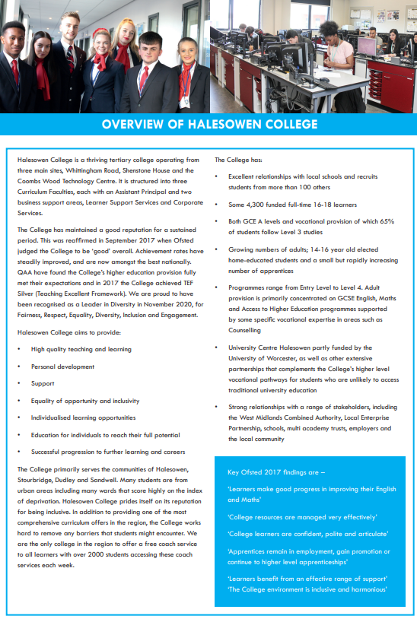
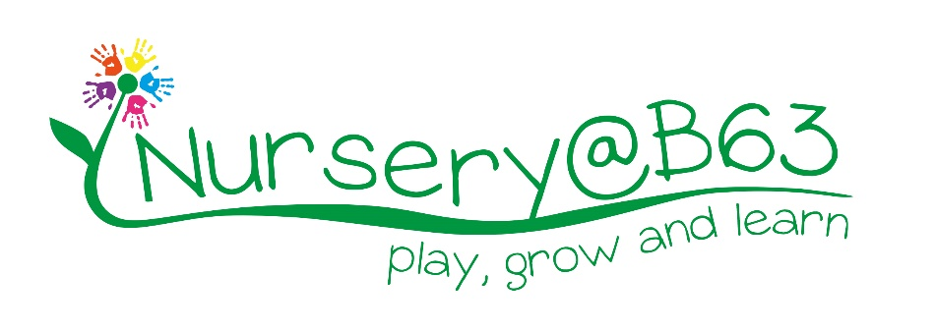

Job Description - Nursery Senior Practitioner – Third in Charge

Responsible to: | Nursery Manager
Contacts: | Nursery children, College staff, Students, Parents, Guardians, General Public, College Stakeholders.
Job Purpose: | - To be a role model to the staff team. Be able to showcase high quality practice with regards to individual and group work with children, dealing with staff and parent issues as they arise.  - To provide high quality care and early years learning experiences for all children who attend the Nursery.  - To provide leadership and management to other nursery staff, ensuring that the nursery operates at optimum level. To act as a role model, promoting professionalism and best practice at all times.  - To take responsibility alongside the Nursery Management Team for the safety, security and well-being of all children, staff and visitors at all times.  - To support the Nursery Manager/ Deputy to ensure that safeguarding procedures are followed in line with Local Authority and Halesowen College Enterprise procedures.  - To ensure compliance with all nursery policies and procedure and government legislations – Ofsted
Hours: | 40 hours per week. 40 Hours per week to be worked on a rotating shift basis.  Occasional extra hours and weekend work may be required, for which time off in lieu is given. Staff are expected to support College events outside of core business hours, such as open events.
Salary: | £20.283.70 per annum
Annual Leave: | The leave year runs from 1 August to 31 July  Existing holiday entitlement will be honoured.
Pension: | NEST or SMART Pension Scheme

Main duties and responsibilities:
Management
- As a senior nursery practitioner, you will be a delegated key holder, responsible for supporting the Manager/ Deputy in opening and locking up the building, and ensuring the safety and wellbeing of children whilst responsible for your shift.
- To cover shifts and act as the responsible person in the absence of the Manager and Deputy. A requirement of this post is the ability to ‘act up’ or deputise where needed.
- To provide feedback and support to the manager on all aspects of the day to day operation of the nursery.
- To assist in the training and development of staff to ensure the highest level of childcare practise. To support staff by completing peer reviews and providing relevant feedback.
- Perform specific routine management administration duties, where required.
- To support Nursery Occupancy levels by leading ‘show arounds’ and dealing with Nursery enquiries.
- Provide support to families and staff upon enrolment, assisting with registration and settling in visits.
- Ensure all information is securely monitored in accordance with GDPR legislation.
- Ensure high quality records are kept.
Childcare and Education
- To manage an allocated room, leading the team and acting as key worker for a group of children – observing, recording and assessing their progress and development.
- To maintain high quality parent partnerships.
- To work as oversee and supervise the daily running of the whole setting, ensuring that best practice is being applied by all staff.
- To develop high quality interactions with children, to build on and extend their thinking and learning.
- To plan, prepare and deliver a wide range of play experiences that promote children’s physical, intellectual and emotional development.
- Lead the Room’s planning appropriately for children using the Early Years Foundation Stage (EYFS) curriculum for guidance.
- To help children acquire self-help skills including washing hands, feeding, dressing, toileting and personal hygiene.
- To support each child in developing self-esteem, confidence and feeling of competence as well as providing a sense of belonging through a wide range of methods.
- To maintain an up to date knowledge of current issues, legislations and practise through attending regular training workshops that promote personal and professional development.
- To work collaboratively with fellow colleagues to create a positive, proactive and effective Nursery team.
Health and Safety
- To be fully aware of, and implement health and safety standards and ensure that these are met in accordance with the setting’s Policies and Procedures.
- To share in the responsibility for safeguarding and promoting the welfare of all children within the nursery.
- To report and record all accidents and incidents appropriately
- Ensuring the premises and the environment are safe, clean, tidy and well maintained
- Completion of daily risk assessments and appropriate action taken.
- Be fully aware of all emergency and security procedures e.g. fire precautions, security, dropping off and collection of children.
- To fully comply with and implement Covid-19 Health and Safety Procedures.
Communication
- To build and maintain excellent relationships with parents/carers by ensuring regular quality communication. To support the Team in uploading children’s information to Tapestry.
- To ensure that staff communication with children, parents and the staff team is polite and courteous at all times.
- To attend, participate and lead in staff meetings, parent and social events.
- Report all maintenance requirements to the manager to ensure their immediate attention.
- To work effectively with the staff team, senior management and other professionals to ensure the smooth running of the provision and a consistent professional work approach across the nursery staff.
- Be a key person carrying out all related responsibilities in building relationships with a small group of children and their families.
- Work with external agencies and support in implementing learning programmes as appropriate.

Parent Partnerships
- To liaise with parents and to encourage their involvement in all aspects of the nursery and their child’s care.
- To encourage positive relationships between staff and parents, ensuring that an effective exchange of information is present in daily interactions.
- To value parental contributions to the care of all children.
- To recognise the importance of the role parents play in early education and that their continued involvement is crucial to successful learning.
- To lead and actively support the settings parent group at fundraising and social events.
Equal Opportunities
- To ensure that practice fully embraces the nursery’s equality of opportunity policy at all times.
- To ensure that everyone is treated as individuals with respect and full consideration in line with the nursery’s equal opportunities policy.
- To assist in the provision of a high-quality environment that is inclusive to all and meets the needs of individual children from differing cultures, religious backgrounds and their respective stages of development.
- To ensure that the nursery setting reflects the identity of the local community and the children/families attending the nursery.
General Tasks
- To respect confidentiality within the setting at all times
- To carry out any other relevant additional duties as required
- Ensure that staff are effectively deployed throughout the nursery
- Daily health and safety checks
- Ensure food hygiene standards are being maintained
- Ensure security of the children and premises are upheld
Relevant Experiences:
Essential
- Minimum two years of similar nursery experience.
- Excellent Early Years Practice.
- Ability to develop good working relationships with parents and other service providers (multi-agency approach)
- Providing superb care and education to children from a wide range of backgrounds, including those with special educational needs.
- The ability to effectively motivate, lead and manage a small team.
- Willingness to work towards a recognised Team Leader Qualification

Under DBS legislation and guidelines this is a regulated activity.

Any other duties, which may from time to time, be required and which are commensurate with the skills experience and grade of the post holder.
Disclosure and Barring Service Check
This post, due to its nature, duties and responsibilities, will be subject to a check by the DBS. The level of check which will apply shall be an “Enhanced” level check with both Children’s and Adult’s barred list information requested. Information about this disclosure can be found at www.gov.uk.

Applicants are requested to write a letter of application outlining experience, skills, and abilities in relation to the person specification.

Data Protection
You are required to meet the specifications of the College’s Data Protection Policy as part of your conditions of employment. This will include information relating to past and prospective employees and students, suppliers and customers.

Harassment and Discrimination
You have a duty not to discriminate against or harass colleagues, contractors, students, parents, guardians or potential students or other College visitors, by reason of their age, sex, sexual orientation, gender re-assignment, marriage and civil partnership, pregnancy or maternity, race, disability or religion and belief.

Safeguarding and Staff Code of Conduct
You have a duty to abide by the Staff Code of Conduct and Safeguarding Policy.

Health and Safety
The College and its employees have legal obligations in respect of the health, safety and welfare of persons at work and the protection of others against risks to health and safety in connection with their activities. Specific health and safety responsibilities are detailed in the College Health and Safety Policy.

Other information for job holders/applicants:

To prevent abuse and implement good practice Halesowen College ensures that recruitment practices are robust and rigorous and that all staff employed have up to date and acceptable references, a full and complete employment history, an Enhanced DBS check and a check of the DBS barred lists.

Safeguarding
Halesowen College is committed to safeguarding and promoting the welfare of young people and vulnerable adults and expects all staff and volunteers to share this commitment.
Successful applicants will be subject to an enhanced Disclosure and Barring check.

Equality and Diversity
Halesowen College is proud of its work in embedding equality and diversity principles in its activities and welcomes applications from all suitably qualified people, irrespective of age, sex, gender reassignment, marital or civil partnership status, disability, race, ethnic or national origin, religion or beliefs, sexual orientation, unrelated criminal convictions or family responsibilities.

We welcome all sections of the community and value the contributions to the achievement of the College’s mission that are made by members of the College from a wide range of backgrounds and experiences. All staff must demonstrate an awareness of equality and diversity principles, as set out in College policies that includes Fairness, Respect, Equality, Diversity, Inclusion and Engagement. It is expected that all members of staff on appointment are committed to and include these principles in their work.

More information on our Equality and Diversity policy can be found at https://www.halesowen.ac.uk/about/equality-diversity/

Childcare Facilities
There is a day Nursery on the Whittingham Road campus for babies from 12 weeks and children aged 2 to 5 years. It is open 8.00 am to 5.30 pm Monday to Thursday and 8.30 am to 5.00 pm Friday. Further details are available from the Nursery staff on 0121 602 7677.
It is registered at present for 29 children in the early year’s age range. The baby room caters for 9 babies.

Information Technology
The College has approximately 2,600 computers across its sites including PCs, laptops, netbooks and Macs running a range of industry standard software. Equipment is available for long and short term loans, and guest access to our wireless network is provided for personal devices. We also run a PC booking system to ensure you can get access to a computer when you need it. A wide range of classroom technologies are in place such as the Moodle Virtual Learning Environment, cameras, voting devices and interactive whiteboards/data projectors.

All staff and students are given a personal computer account with access to email and storage which is available on and off site.

Smoking
Halesowen College is a designated smoke-free environment within the perimeter of all College property by order of the College Governors. This rule applies equally to staff and students, and to all categories of visitor. Acceptance of this rule is a condition of employment for staff, and a condition of being a student for students.

Campus
The College has three sites, Whittingham Road, Shenstone House and Coombs Wood. Staff can be asked to be based at and/or work across all campuses.

Note: This job description is current at the time of issue. It should be recognised that, in keeping with organisational changes and developments, it may be necessary to review the duties listed from time to time and change them to meet organisational objectives.

