Job Description

Job Title | Uniform Public Services Lecturer
Directorate | Professional Service Industries
School | Creative Industries
Reports To | Head of School
Grade | Hourly paid
Contract | Full-time
Location | East Ham Campus
D
Our Vision
“To develop the skills, confidence, and qualifications for local people to lead rich lives and build great careers. “

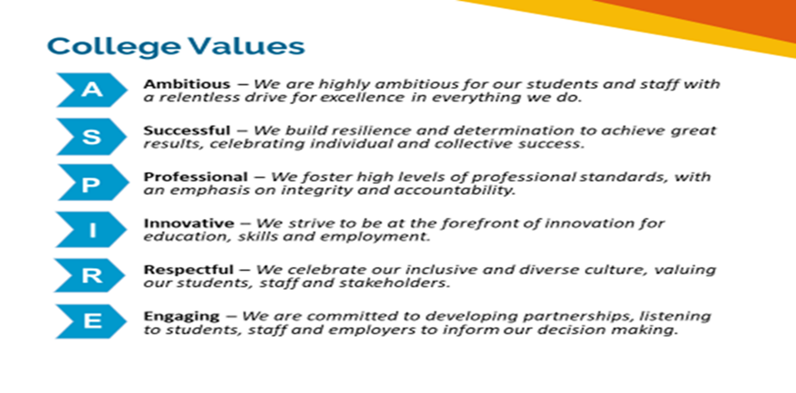
Safeguarding of Children and vulnerable adults
Newham College is committed to safeguarding and promoting the welfare of our learners and young people. We expect all staff to share this commitment. As this role involves regulated activity, the successful applicant will be required to undertake an enhanced DBS check and additional pre-employment checks.

Equality of Opportunity
The College has a strong commitment to working toward the implementation of equality of opportunity in both service delivery and employment. The College’s mission and strategic objectives directly support this aim. All employees are required to actively support the development, dissemination implementation of this aim and related policies and programmes.
We encourage and welcome applications from all individuals, regardless of age, disability, sex, sexual orientation, gender reassignment or identity, race, religion or belief and marriage and civil partnership.
Job Description
Job Purpose
The candidate appointed will join an innovated and dynamic team involved in the delivery through a range a of 16-18 full-time study programmes within the Directorate of Professional Service Industries. They will prepare and deliver teaching for a range of topics, provide advice and support students, acting as a Personal Tutor, conduct Internal Quality Assurance as well as related teacher administration duties.

Key Duties and Responsibilities

- Design, plan and implement effective and inclusive teaching and supporting learning activities.
- To provide high quality teaching, learning, assessment and internal moderation across a range of courses.
- Teach across a range of modules/units or within a subject area using appropriate teaching, learning support and assessment methods and technologies.
- Assess the work and progress of students and provide them with constructive feedback
- Contribute to the delivery, tracking and monitoring of key skill performance amongst cohorts of students in Public Services.
- Seek ways of improving performance by reflecting on teaching design and delivery and obtaining and analysing feedback.
- Contribute to outreach and/or widening participation activities within the school.
- Tutorship of students, giving appropriate support to enable students to achieve their academic, personal and vocational targets.
- Interviewing and giving guidance to potential students.
- Assisting students in their progression to either Higher Education or employment.
- Contribute to the development and continual improvement of courses, coordinating effectively with both staff and student.

Person Specification

Essential qualifications/training:
- A recognised teaching qualification e. PCET, PGCE or QCF Level 5 Diploma in Education
- Comprehensive understanding of the curriculum with subject specialism to at least Level 4
- Strong experience of delivering to 16+ age group with varied abilities in an educational setting
- Degree (or appropriate qualification) in relevant discipline in either Public Service, Sociology, Social Policy, Humanities and Law & Criminology
- GCSE or Level 2 in Maths and English

Desirable qualifications/training:
- Internal Verifier Qualification
- Current training and CPD taken in the past 2-years relevant to the role and vocational area

Experience:
- Experience of planning and delivering in line with Ofsted requirements to at least “good”
- Ability to plan learning in line with Ofsted requirements
- Experience in teaching/assessing courses at a range of levels and providing high quality feedback and assessment
- Excellent written and verbal communication skills
- Experience meeting targets, KPI’s or deadlines
- Familiar with safeguarding and relevant procedures
- Working parents, families and external partners

Knowledge and Skills:
- Able to motivate and inspire people to achieve
- Passionate about the learning and skills agenda
- Excellent communication and written skills
- Comprehensive IT skills and E-Learning
- Excellent communications skills with people at all levels
- A team player who is hardworking and capable of working on own initiative
- Must have good organisational and time management skills
- Commitment to the College aims and ethos
- Ability to work quickly and accurately under pressure
- Ability to prioritise work to deadlines
- Ability to work flexibly as a member of the team
- Accurate record keeping

Review Details
Job Title | Public Services Lecturer
Date Created | 22.5.24
Date Issued to Employee by Line Manager
Version

