Job summary – Tutorial Manager
Team: | Tutoring
Salary: | Starting salary £45,224.00 with progression up to £51,307.00 (Grade M1-M2, spinal points 32 to 38)
Job Summary:

Newham Sixth Form College (NewVIc) is London’s largest sixth form college. It is a vibrant centre for sixth form education with the great majority of students coming from our local schools in Newham.

NewVIc’s mission: Enhancing lives through excellent education and learning.

NewVIc’s vision: The first choice college for enhancing the lives of students in partnership with parents, employers and community.

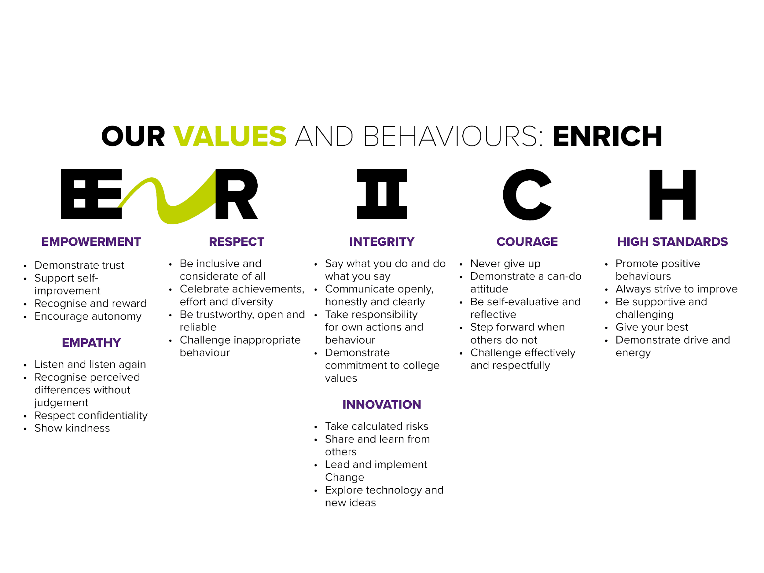

We are looking for an energetic and proactive Tutorial Manager who will make a real difference in our aspirational and ambitious college and improve the quality of the student experience.

NewVIc has around 2,800 full-time 16-19 year old students. We offer a broad and inclusive curriculum from entry level to level three. Most of our advanced level students progress to university and we have exceptionally high progression rates. Each student has a personal tutor, with whom they meet in group and 1-1 tutorials, whose focus is to support students in their personal development and help them to achieve their academic goals.

The post holder will be responsible for the tutorial curriculum across the college and lead and develop the work of our team of progress tutors. We are looking for someone who can further progress our work in areas covering all aspects of student pastoral support and safeguarding as well as drive up attendance and ensure consistency in our tutorial delivery.

Tutorial is part of our wide range of support services which seek to remove barriers to retention, attendance and achievement. The post holder would work closely with Heads of Curriculum to ensure high levels of student attendance in support of achieving outstanding student success.

The successful post holder will line-manage our Progress Tutor Team, and be a part of our College Management Team, working closely with both curriculum and support managers across the college. The post holder would also work with external networks and partners to ensure tutorial at NewVIc is at the forefront of current developments and exemplary practice.

Vacancy ID: | MP/02
Closing date: | 12 noon, 29 September 2021
Application form: | For further details, or for an application pack, please visit https://www.newvic.ac.uk/jobs or email jobs@newvic.ac.uk

Selection process:
Candidates are longlisted on the basis of their written application and the extent to which they meet the standard criteria. You are advised to ensure that you use your supporting statement to indicate the extent to which you meet each of the criteria in the person specification below.
The selection day usually starts with a briefing on the post and the college. You may also be asked to complete a short written activity, take part in an observed group activity and/or make a presentation to the panel.
Following these activities the selection panel decides which candidates to take through to interview, usually on the afternoon of the same day.

Job Description for Tutorial Manager

Reports to: | Assistant Principal – HR and Student Services
Main purpose | - To manage tutorial provision across the college, supporting tutors to remove barriers, and achieving team, cross-college and whole-college objectives  - To manage the tutorial curriculum and plan the programme across all levels and programmes  - To manage progression to university, apprenticeships and employment
Main activities | Tutoring  - Tutor for a number of groups as agreed with Assistant Principal Student Services  Tutorial Manager Duties  - Manage and co-ordinate the tutorial curriculum, devising differentiated tutorial programmes with high quality materials which cover all aspects of student pastoral support and safeguarding  - Manage and co-ordinate student progress reviews and target setting to maximise retention, achievement and progress  - Manage the progress tutor team  - Be responsible for quality assurance within tutorial and developing KPIs, including undertaking observations  - Identify the training needs of tutors, planning and delivering training, and inducting and mentoring new tutors  - Be responsible for the college’s attendance and punctuality monitoring, developing new initiatives and processes to drive up attendance  - Co-ordinate the disciplinary process and be responsible for implementation of the college’s disciplinary policy  - Manage and co-ordinate parental liaison college-wide, including communications, reporting, and parents’ events such as Parents’ evenings, Parent Council and Parent Forum  - Be responsible for the UCAS process  - Manage and co-ordinate autumn induction for new and returning students  - Contribute to our support for LGBT students and achieving our equality objectives for this area  - Liaise with other student services managers to ensure good communication across support services and a joined up approach  - Keep up to date with current tutorial developments, liaising with external partners and networks, and reporting back to senior managers  - Participate in CPD to develop skills and expertise  - Contribute to the work of the College Management Team

Person Specification – Tutorial Manager

You are advised to use your supporting statement to indicate the extent to which you meet each of these criteria

Method of Assessment key - A – application form, T – Task, I - interview
Education/Qualifications | Essential | Desirable | Method of assessment
- Degree | X |  | A
- A recognised teaching qualification | X |  | A
- A grade C or higher in English and maths GCSE (or equivalent) | X |  | A
Knowledge, Skills and Attributes
- Leadership, setting high standards and high expectations |  |  | A, I
- Proactive, energetic approach with a “can do” attitude | X |  | A,T,I
- Resilience and the ability to remain calm under pressure | X |  | A,T,I
- Understanding of the distinct nature of pastoral support and its impact | X |  | A,I
- Team worker, able to work collaboratively with others, with a consultative management style | X |  | A,I
- Strong communication skills including excellent written English | X |  | A,T,I
- Strong organisational skills and ability to meet deadlines | X |  | T,I
- Intelligent understanding of current developments affecting the post-16 curriculum with particular reference to safeguarding, Prevent and British values, and employability | X |  | A,T,I
- Knowledge of progression options including university and apprenticeships | X |  | A,T,I
- Ability to use IT to support delivery | X |  | A,T,I
Experience
- Record of outstanding practice as a tutor | X |  | A,T,I
- Successful experience of managing a team or function | X |  | A,T,I
- Successful experience of developing high quality tutorial materials | X |  | A,I
- Successful experience of implementing disciplinary processes | X |  | A,I
- Successful experience of the UCAS application process | X |  | A,I
- Successful experience of different levels and types of post 16 programmes of study |  | X | A,I
- Successful experience of mentoring or delivering training |  | X | A,I
- Successful experience of implementing use of cross-college IT systems and processes |  | X | A,I
Attitudes
- Commitment to NewVIc values | X |  | A,I
- Commitment to high quality post-16 education and training | X |  | A,I
- Commitment to equality and diversity | X |  | A,I

Useful websites:

NewVIc
www.newvic.ac.uk
The college’s own website.

Newham Council
www.newham.gov.uk
The website of Newham Council.

https://www.gov.uk/
The website for Government services and information

The 2018 Ofsted inspection report on NewVIc
www.newvic.ac.uk/statutory-information

Other Information

Health and Safety - all employees must comply with the requirements of the Health and Safety at Work Act 1974 and affiliated regulations. Employees are also required to comply with the college’s Health and Safety Policies and take reasonable care for the health and safety of themselves and of other persons who may be affected by their acts or omissions. Where the college has a statutory duty with regard to health and safety employees are required to co-operate with the college and its managers and officers so far as is necessary to enable the college to meet that duty. This includes using equipment and substances in accordance with training and instruction and the reporting of serious dangers to your own or others’ safety.

The College operates a smoke-free policy and the post-holder is prohibited from smoking in any of the College's buildings, enclosed spaces within the buildings, and College vehicles. Staff will not be released for a break that is specifically for smoking.

Equality – the postholder must be committed to the college’s Equality and Diversity Policy and advancing equality through our Equality Objectives.

Annual leave – the postholder will be entitled to 32 days annual leave per annum to be taken outside of term time, plus three compulsory closure days between 25 and 31 December.

Performance – the postholder will be required to participate in performance reviews and undertake a plan of training where necessary.

NewVIc supports the professional development of its staff. The strong team culture in the college provides a stimulating environment in which to develop your skills. Development needs are discussed during the appraisal process and there is a generous budget for staff development requests that support team and college objectives.

There is an induction programme for new staff.

Confirmation of appointment is subject to a satisfactory 10 month probation period.

The postholder will be required to adhere to College policies and procedures.

This post is eligible for membership of the Local Government Pension Scheme (LGPS).

In addition to the responsibilities listed above, all employees must be adaptable in their approach and undertake other duties that are commensurate with the postholder’s level, wherever they may be, to achieve the objectives of the College.

The postholder will be required to have a clearance from the Disclosure and Barring Services. Criminal convictions will only be taken into account when they are relevant to the post.

We are committed to safeguarding and promoting the welfare of children and young people. We expect all staff to share this commitment and participate in statutory training in safeguarding and Prevent.

