Job Description:

Job Title | Environmental Sustainability Manager
Department | Estates
Grade | Business Pay scale - P04 (spine 41 – 44)
Contract | Full-time, Permanent
Location | Newham College London – All Sites/Campuses

Our Vision & Values
“To develop the skills, confidence, and qualifications for local people to lead rich lives and build great careers. “

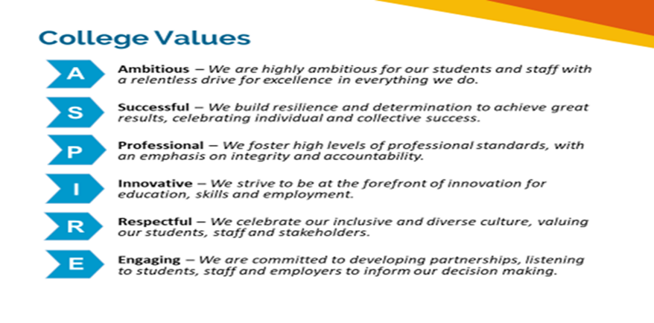

Equality of Opportunity
The college has a strong commitment to working towards the implementation of equality of opportunity in both service delivery and employment. The College's mission and strategic objectives directly support this aim. All employees are required to actively support the development, dissemination and implementation of this aim and related policies and programmes.

Safeguarding of Children and Vulnerable Adults
The College is committed to safeguarding and promotes the welfare of all learners and expects its staff to share this commitment. In addition, they will also state that the College is committed to safeguarding and promotes the welfare of all learners and expects its staff to share this commitment. All posts in the College are subject to an Enhanced DBS check and Barred List check.

Job Purpose

- Working with the Director of Estates & Capital Projects, lead on the implementation of the NCFE Green Strategy.
- Drive and embed environmental sustainability practices at NCFE resulting in a measurable reduction in the college’s environmental footprint.
- Advise, inform, prioritise and cost work on estate decarbonisation and lead its implementation with Director of Estates & Capital Projects.
- Act as a champion for environmental sustainability across NCFE.

Key duties and responsibilities of the post

DUTIES AND RESPONSIBILITIES:
- Implement Newham College’s Green Strategy in collaboration with the Director of Estates & Capital Pro and key support Directors, and the COO

- Provide environmental training to staff, with a particular focus on the college’s estates team and other key support teams in calculating the carbon footprint of their work and ways to reduce it.

- Track, measure and report on Newham College ’s carbon footprint, ensuring progress on this work is published annually in line with the Streamlined Energy and Carbon Reporting requirements.

- Report, prioritise, cost and plan actions for Newham College to take to make a measurable difference in its carbon footprint.

- Consulting with the college’s Sustainability Group, recommend a target for net zero carbon and devise a roadmap for the college to achieve it.

- Advise on and support the implementation of Newham College ’s estate decarbonisation projects, reporting to and securing approval from the college’s Green Investment Board.

- Implement agreed actions to achieve environmental sustainability targets, working closely with the Director of Estates & Capital Projects and other key colleagues.

- Devise tools and systems for monitoring progress towards agreed environmental sustainability goals, including cost savings achieved through the actions.

- Ensure compliance with environmental legislation and that Newham College’s environmental work builds on and reflects national and international best practice.

- Ensure a robust quality management system is implemented and maintained across the College.

- Assess, analyse and collate environmental performance data and report information to internal staff and regulatory bodies.

- Advise the college’s refurbishment and capital development projects to ensure that they follow environmental best practice.

- Act as a champion for environmental issues across Newham College, promoting and raising awareness at all levels of the college of the impact of emerging environmental issues and the difference Newham College can make.

- Work with the Executive Director of Marketing & Communications on developing and implementing Newham College’s engagement strategy on environmental sustainability.

- Understand and comply with Safeguarding legislation, ensuring that this commitment is demonstrated in all aspects of the role as appropriate

- Take responsibility for own professional development ensuring full compliance of all internal and external training requirements.
Person specification

The College is seeking to appoint highly skilled, dynamic, flexible, and committed people with the potential to help us realise our mission and strategic objectives. To help the appointing panel recruit the best possible candidate and be able to assess each candidate’s abilities and suitability for the role objectively, the skills, experience and qualifications required are set out in detail in the skills and Knowledge Specification below.

Except where explicitly stated otherwise, the following qualities are all deemed essential to the requirements of the post. The College will, therefore, be seeking evidence of these in the selection process, which will include the written application, an assessment centre, face-to-face interview(s) and the content of substantive references, to make an appointment.

Skills and Knowledge

- Excellent written and verbal communication skills; a thorough proof-reader
- Strong interpersonal skills and a demonstrable ability to build effective relationships both inside and outside the organisation
- An ability to work to meet objectives and deadlines; the ability to manage a diverse workload within tight deadlines; strong project management skills
- Numerate and confident in handling financial data and multi-year project budgets
- A good researcher, with excellent attention to detail
Technical skills:

- A proven track record in delivering measurable reductions in an organisation’s carbon footprint and achieving net zero carbon.
- Experience of developing environmental sustainability policies and action plans.
- Experience in working on environmental sustainability in the education or not-for-profit sector
- Experience of developing environmental reporting tools, with financial indicators.
Generic skills:
- Excellent written and verbal communication skills; a thorough proof-reader Strong interpersonal skills and a demonstrable ability to build effective relationships both inside and outside the organisation
- An ability to work to meet objectives and deadlines; the ability to manage a diverse workload within tight deadlines; strong project management skills
- Numerate and confident in handling financial data and multi-year project budgets
- A good researcher, with excellent attention to detail
- Knowledge of Microsoft packages

Experience:
- A proven track record in delivering measurable reductions in an organisation’s carbon footprint and achieving net zero carbon.
- Experience of developing environmental sustainability policies and action plans.
- Experience in working on environmental sustainability in the education or not-for-profit sector
- Experience of developing environmental reporting tools, with financial indicators.

Qualifications:

Essential:
- Educated to degree level or equivalent in a relevant subject e.g. environmental sciences

Desirable:

- Membership of the Institute of Environmental Management and Assessment (IEMA)

- Experience of the further education sector
- Evidence of continuous professional development in environmental sustainability
- Awareness and understanding of safeguarding and welfare of children.

