Job Description:

Job Title | Lecturer in Functional Skills Maths
Department | ESOL Department
Reports to | Head of School
Grade | Unqualified Lecturer Band 1 (Spine 1 – 2) and Qualified Lecturer Band 2 (Spine 3 -10)
Contract | Full-time, Permanent
Location | East Ham Campus

Our Vision & Values

“To develop the skills, confidence and qualifications for local people to lead rich lives and build great careers. “

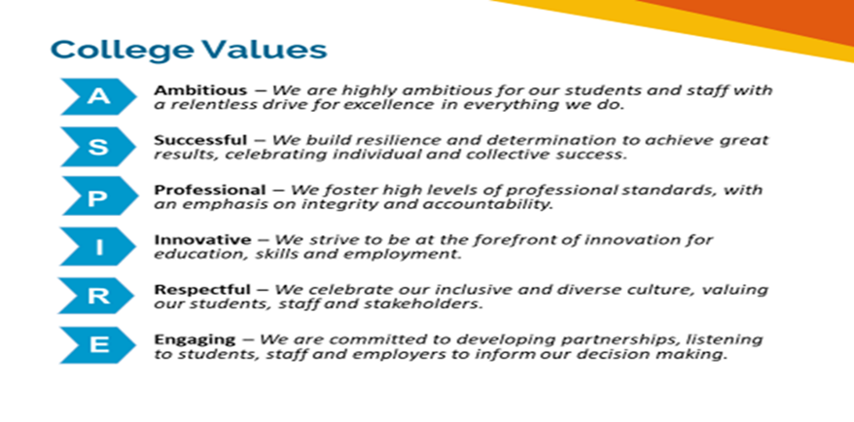
Safeguarding of Children and vulnerable adults
Newham College is committed to safeguarding and promoting the welfare of our learners and young people. We expect all staff to share this commitment. As this role involves regulated activity, the successful applicant will be required to undertake an enhanced DBS check and additional pre-employment checks.

Equality of Opportunity
The College has a strong commitment to working toward the implementation of equality of opportunity in both service delivery and employment. The College’s mission and strategic objectives directly support this aim. All employees are required to actively support the development, dissemination implementation of this aim and related policies and programmes.
We encourage and welcome applications from all individuals, regardless of age, disability, sex, sexual orientation, gender reassignment or identity, race, religion or belief and marriage and civil partnership.
Job Purpose

To undertake teaching and related duties that fully support students throughout their learning journey and provide them with a high-quality learning experience.

Aims of the Post:
- To develop, provide and oversee the full range of professional services associated with programmes of teaching, learning, assessment, and student support in further and higher education.

- To undertake these professional duties as a member of a learning area, and contribute constructively and creatively to:

- service planning, target setting, monitoring and review
- the planning and allocation of workloads and duties
- the maintenance and improvement of service delivery
- delivery of all forms of work-based learning (including apprenticeships)
- Support and assessment (may include delivery in off campus locations e.g., employer’s premises)
- improving efficiency and effectiveness in the use of resources and achievement of outcomes
- establishing and maintaining effective team and other professional relationships
- enhancing the team’s performance and its accountability for such

- To promote the College, its aims, policies, and corporate standards always

- To ensure that the highest standards of customer service and care are always provided.

Duties and Responsibilities:

TEACHING

- Teach Maths and ICT in accordance with the College Standards for Teaching and the Promotion of Learning.

- Deploy a wide range of teaching and student-centred learning strategies that ensure (a) the most effective learning, continuation, achievement, and progression of students, and (b) the most effective use of teaching time and other resources.

- Stimulate and promote effective, student-centred, independent learning strategies for students of all levels of ability.

- Ensure full implementation of the College’s admissions (entry) and induction phase activities for students.

- Undertake continuous (formative) and summative assessments of students.

- Contribute to the development and design of course and course modules.

- Contribute to planning and scheduling process of both student and learning and the overall programme.

- Contribute to the development of learning resources and flexible learning strategies.

- Act in compliance with all course examination, assessment, and validation requirements.

MARKETING

- Advise on the development of new business services and solutions, and new market opportunities.

- Assist directly in the marketing of courses and the College generally, including liaison with schools, employers, training agencies, universities, and attendance at marketing events, and foster partnerships with other agencies where appropriate.

QUALITY

- Ensure the full implementation of course review, evaluation and development, and other quality assurance processes as required by college policy; and work pro-actively to secure constant quality improvement and student completion and achievement of the highest possible standards.

- Undertake regular and systematic monitoring of achievement of all targets set for your area of work.

- Undertake a pro-active role in the performance review, quality audit, self-assessment, and staff development and training processes.

MANAGEMENT OF PEOPLE, RESOURCES & PROCESSES

- Undertake course leadership.

- Collect, organise, and maintain information and other records as required by college policies and systems.

- Undertake all administrative duties in accordance with college and any relevant external requirements.

- Manage all resources under your control effectively and efficiently, and in accordance with college rules and regulations.

- Assist with the specification of equipment, accommodation and other resources required for the full development of the team’s programmes.

6. Work always as part of a learning area and undertake team leadership and management roles as required. .

GUIDANCE & TUTORING

- Undertake the role of personal tutor to groups of learners.

- Undertake entry phase activities such as the interviewing, assessment, selection, and induction of students.

3. Organise and supervise student placements as required.

4. Delivery of all forms of work-based learning (including apprenticeships)

5. Support and assessment (including delivery in off campus locations e.g., employer’s premises)

- Play a full role in the maintenance of students’ discipline, operation of the College’s student disciplinary policy, and the maintenance of high standards of campus life generally.

- Ensure full implementation of college policy on student representation at course level.

GENERAL

1. To always maintain the highest standards of professional behaviour (including compliance with the staff code of conduct), and a positive and customer focused approach.

2. To promote the best image, reputation, and interests of the College always, and in all circumstances.

3. To always act in full compliance with any relevant statutory requirements and all College policies, rules, and regulations.

4. To partake in any duty or other rota as required.

- To carry out such other duties consistent with the professional status of this post at the direction of your line manager, a member of the faculty directorate or member of the College Executive

Person Specification
The following qualities are all deemed essential to the requirements of the post. The College will, therefore, be seeking evidence of these in the selection process, which will include application form, an assessment centre, interview(s) and references. The College is seeking to appoint highly skilled, dynamic, flexible, and committed people with the potential to help us realise our mission and strategic objectives. The appointing panel will, therefore, require sufficient evidence of ability and achievement in each of the following areas to make an appointment.

a) Qualifications:
- Relevant degree / Maths and ICT subject specific qualification

- Teaching qualification PGCE with Maths and QTS/QTLS

- Level 2 English and Maths and ICT
- Assessor’s Qualification (or commitment to obtain within 12 months)

b) A Good Understanding of and Strong Commitment to:
- the principles underpinning the College’s mission and strategic objectives, including equal opportunities

- a business-like and customer focused approach to education and training

- widening access to further and higher education, and boosting student completion and achievement

Excellent Skills, Knowledge & Experience Related to:
- teaching/training and assessment within the specialisms of the post

- experience of teaching learners aged 16-18 is essential

- areas of business, industry, or public/voluntary service relevant to the courses’ markets

The Following Abilities:

- to teach enthusiastically and professionally

- to stimulate and promote effective learning among diverse and challenging learners

- effective communication skills with customers (both as learners and as corporate clients), and professional colleagues

- effective and flexible teamwork within a professional environment

- to utilise flexible work methods (including application of information and communications technology) as a learning, assessment, and administrative tool

- to undertake innovatory developments in all aspects of the curriculum and its delivery

A Successful Track Record of:

- previous employment (graduates without a previous employment history may be shortlisted in certain circumstances)

Please note: Prior to confirming an appointment to the college, individuals are asked to complete a medical questionnaire in order that the College’s Medical Health Contractor can ascertain their medical fitness for the post.

