Job Description:

Job Title | HE Administration Officer
Department | Student Services
Report to | Head of Student Services
Salary | S02
Contract | Permanent
Location | All Sites
Our Vision & Values
“To develop the skills, confidence and qualifications for local people to lead rich lives and build great careers.“
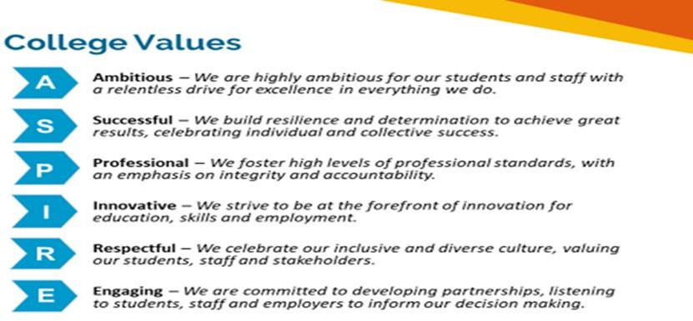

Equality of Opportunity
The college has a strong commitment to working towards the implementation of equality of opportunity in both service delivery and employment. The College's mission and strategic objectives directly support this aim. All employees are required to actively support the development, dissemination and implementation of this aim and related policies and programmes.

Safeguarding of Children and Vulnerable Adults
The College is committed to safeguarding and promotes the welfare of all learners and expects its staff to share this commitment. In addition, they will also state that the College is committed to safeguarding and promotes the welfare of all learners and expects its staff to share this commitment. All posts in the College are subject to an Enhanced DBS check and Barred List check.

Job Purpose
The Higher Education (HE) Administration Officer plays a crucial role in managing the student loan process, supporting students with their applications and ensuring that the organisation adheres to external compliance requirements. This position requires a detail-oriented individual with expertise in management of student records, and a deep understanding of the higher education landscape.

Key Responsibilities
- Manage the student loan portal, ensuring that student records are up to date and accurate. Undertake attendance checking and registration of students.
- Support students with their loan and UCAS applications, providing suitable and appropriate advice on financial matters related to their courses including bursary, maintenance and study loans.
- Maintain a working knowledge of HE data requirements and ensure that staff responsible for collecting this information are appropriately trained.
- Liaise with external bodies and internal departments to assist in the production of HE statutory returns.
- Lead on resolving HE funding and compliance issues as they arise in order to ensure that data is correctly collected and managed.
- Support with HE specific ILR queries and errors including those specific to the OfS via the ILR Data Checking Tool.
- Carry out validation, verification and reconciliation checks on student and curriculum data including enrolment details, fee information, course hours and funding eligibility.
- Assist with the preparations for internal and external audits of the Individual Learner Record, associated documentation, and evidence.
- Maintain strong relationships with academic staff, acting as a link between curriculum and administrative functions in assessment boards.
- To undertake any reasonable duties requested by the Head of Student Services or that are commensurate with the role.

Person specification:

Qualifications | Essential | Desirable
Have a minimum of Grade 4 in English and Maths GCSE level  (Level 2) or equivalent. | ✓
Bachelor’s degree in Administrative Science, Statistics, Information Systems, Higher Education Administration, or a related field. |  | ✓
Experience | Essential | Desirable
Minimum of 3 years of experience in data management, analysis, and reporting, within a higher education setting. | ✓
Previous experience working in higher education in a further education institution. |  | ✓
Experience in preparing and submitting data reports to government bodies, accrediting agencies, and other external organisations. | ✓
Knowledge and Skills | Essential | Desirable
Strong analytical and problem-solving skills. | ✓
Exceptional attention to detail and accuracy in data handling and reporting. | ✓
Excellent written and verbal communication skills. | ✓
Ability to work collaboratively with diverse stakeholders including academic staff, administrative staff, and external agencies. | ✓
Strong interpersonal skills and the ability to build effective working relationships. | ✓
Organisational and record keeping skills | ✓
Ability to manage multiple projects and deadlines effectively. | ✓
Strong organisational skills with a proactive approach to problem-solving. | ✓
Proactive in identifying opportunities for process improvement and implementing best practices. | ✓

Review Details
Date Created | 31/05/2024
Version | 1

