|  |
| --- |
| **Job Description** |

|  |  |
| --- | --- |
| **Job Title** | **Teaching Assistant** |
| **Contract** | **Full-time, Term Time Only** |
| **Grade** | **£21,723 - £23,926 per annum, pro rata (£25,087 - £27,631 per annum FTE)** |
| **Location** | **Stratford and Eastham Campuses** |

|  |
| --- |
| **Our Vision** |

**Mission statement**

The mission of the College is to develop the skills, confidence, and qualifications for local people to lead rich lives and build great careers.

**College Values**

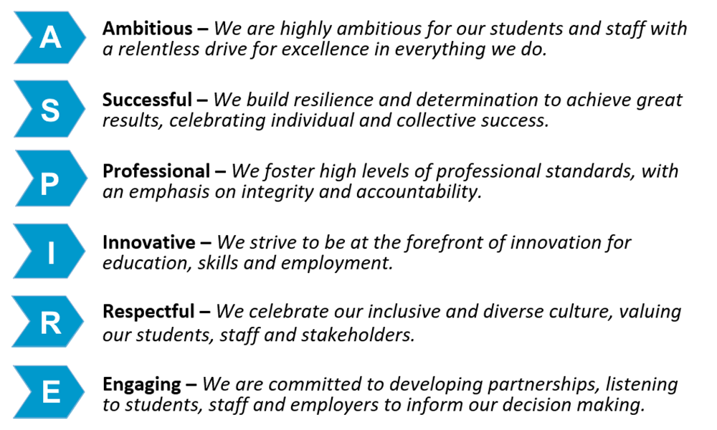

**Safeguarding of Children and vulnerable adults**

Newham College is committed to safeguarding and promoting the welfare of our learners and young people.  We expect all staff to share this commitment.  As this role involves regulated activity, the successful applicant will be required to undertake an enhanced DBS check and additional pre-employment checks.

**Equality of Opportunity**

The College has a strong commitment to working toward the implementation of equality of opportunity in both service delivery and employment. The College’s mission and strategic objectives directly support this aim. All employees are required to actively support the development, dissemination implementation of this aim and related policies and programmes.

We encourage and welcome applications from all individuals, regardless of age, disability, sex, sexual orientation, gender reassignment or identity, race, religion or belief and marriage and civil partnership.

|  |
| --- |
| **Job Purpose** |

Newham College is on a quest to find outstanding Teaching Support Assistants to join our esteemed team. With a strong commitment to excellence, we are carefully selecting top-notch individuals to provide invaluable support to our teaching staff and students. If you are passionate about supporting learners and dedicated to making a positive impact in educational settings, we invite you to join us in shaping the educational experiences of tomorrow's leaders. Be part of our exclusive community, where excellence is celebrated, and every contribution is valued.

|  |
| --- |
| **Key Duties and Responsibilities** |

As a Teaching Assistant (TSA), you will be on the front lines of supporting the educational journey of students, providing invaluable assistance to both teachers and learners alike. Your role extends far beyond the confines of the classroom; you will serve as a mentor, guide, and advocate for students, ensuring that they receive the individualized support they need to succeed. Whether you are assisting with lesson preparation, providing one-on-one support to students, or helping to create a positive and inclusive learning environment, your contributions will be instrumental in fostering academic achievement and personal growth. By offering encouragement, motivation, and practical assistance, you will empower students to overcome challenges, build confidence, and reach their full potential. Your dedication to supporting the educational experience of students will not only make a difference in their lives but also contribute to the overall success of the learning community.

|  |
| --- |
| **Person Specification** |

The following qualities are all deemed essential to the requirements of the post. The College will, therefore, be seeking evidence of these in the selection process, which will include application form, an assessment centre, interview(s) and references. The College is seeking to appoint highly skilled, dynamic, flexible, and committed people with the potential to help us realise our mission and strategic objectives. The appointing panel will, therefore, require sufficient evidence of ability and achievement in each of the following areas to make an appointment.

Essential qualifications include a minimum of a Level 2 or Level 3 Teaching Assistant qualification, such as a CACHE Level 2 or Level 3 Certificate in Supporting Teaching and Learning in Schools. GCSEs (or equivalent) in English and Mathematics are also required.

Desired qualifications encompass additional training or certification in areas such as special educational needs (SEN), safeguarding, or behaviour management. Experience working with children or in educational settings, as well as strong communication and organizational skills, are highly valued.

**A Successful Track Record of:**

Previous employment (graduates without a previous employment history may be shortlisted in certain circumstances)

**The above list of responsibilities is not exhaustive, and the jobholder may be required to undertake other duties commensurate with the level of the role, as reasonably requested by their line manager.**

**This job description accurately reflects the duties and responsibilities of the role at the time the job description was written. These duties and responsibilities may change over time without significantly impacting on the character of the role, the overall level of responsibility, or its grade.**

**Depending on strategic or operational needs, the jobholder may in the future be required to work for another existing or new organisational unit and/or at different sites within Newham College. This may be on a temporary or indefinite basis and may involve a change in line management and/or regularly working at more than one site.**

**In return we offer:**

* Generous Pension Scheme to Academic (Teacher Pension Scheme) and Business Support (LGPS)
* Birthday leave – over and above the generous annual leave
* Employee Assistance Program – via Vita Health, which offers various support including Money, Work, Retirement, Health and Wellbeing, Emotional Support, Management Support, Legal and Your Rights
* Occupational Health Assistance
* 4 x designated staff development days annually.
* Fully and part funded CPD and trainin*g*
* Cycle to work scheme provided by Cycle scheme.
* Family Friendly Policies
* Eye test fee for employees who use VDU.
* Targeted and themed wellbeing initiatives throughout the year
* Gym onsite
* On site Canteen and Coffee Shop on each site.