Job Description

Job Title | Careers & School Liaison Officer
Department | Student Services
Reports To | Careers & School Liaison Manager
Grade | 5
Location | East Ham & Stratford

Our Vision & Values
“To develop the skills, confidence and qualifications for local people to lead rich lives and build great careers.“

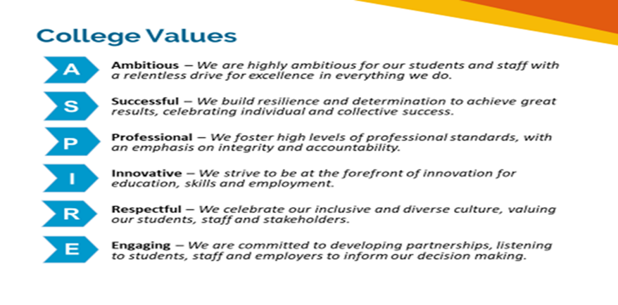

Equality of Opportunity
The college has a strong commitment to working towards the implementation of equality of opportunity in both service delivery and employment. The College's mission and strategic objectives directly support this aim. All employees are required to actively support the development, dissemination and implementation of this aim and related policies and programmes.

Safeguarding of Children and Vulnerable Adults
The College is committed to safeguarding and promotes the welfare of all learners and expects its staff to share this commitment. In addition, they will also state that the College is committed to safeguarding and promotes the welfare of all learners and expects its staff to share this commitment. All posts in the College are subject to an Enhanced DBS check and barred person’s list check.

Job Description
Job Purpose

The Careers & School Liaison Officer will be responsible for raising awareness of Newham College post-16 education offer to students in key feeder schools within the catchment area this will include T Levels and Higher Technical Qualifications. They will attend school careers events and organise taster activities, working closely with curriculum colleagues.

The Careers & School Liaison Officer will also support the Careers Advisor in organising careers events, transition and induction activities and tutorial materials to help raise awareness of career pathways. They will be responsible for supporting students who may be unsure of their chosen course during the first 6 weeks of starting and then during progression events in the Spring term.

The Careers & School Liaison Officer will play a key role in providing advice and support to students applying to University including support with personal statements, applications and financial support.

Key Duties and Responsibilities

- Coordinate the delivery of an effective school events calendar (from classroom presentations and assemblies, to careers events and workshops), to support recruitment and transition advice and guidance, organising diary dates, delivering engaging presentations/workshops, ensuring appropriate staffing, preparing resources and collating event materials.
- Build effective relationships with key school contacts and delivery partners to maximise promotional opportunities and build essential links with the schools.
- Build effective relationships with key school contacts and delivery partners to maximise promotional opportunities and build essential links with the schools.
- Support delivery sessions internally, as appropriate/required, to support students’ skills development, broader college experience and career progression.
- Play a key role at interview evenings as the college’s Post-16 lead and school rep, supporting individuals and ensuring excellent advice and guidance is given, appropriate course offers are made, and that the overall customer experience is positive.
- Support with the internal progression process, providing tutorial support and appropriate advice and guidance.
- Play a key role as part of the working group for the college’s full time enrolment process, ensuring a key presence and support for new school leaver enrollers and ensuring effective processes are in place to support the smooth transition to joining college.
- Support with the development of appropriate materials and website information to support careers advice and guidance and the transition from school to college, for school leavers and parents.
- Support adult learners with progression opportunities including CV writing, job applications and interview techniques.
- Ensure resources and published materials are relevant and up to date on the websites, VLE and noticeboards.
- Liaise closely with the Marketing team and the Admissions team to ensure effective and timely communication of information and feedback.
- Plan and deliver workshops to help inform career choices and raise awareness of progression opportunities.
- Review, monitor and evaluate on a regular basis the effectiveness of the Careers and Schools Liaison delivery.
- Contribute to the areas Self-Assessment Report (SAR) and Quality Improvement Plan (QIP).
- To participate in both internal and external staff development as appropriate.
- To meet the requirements of the Health & Safety at Work Act 1974 and the College’s Health and Safety Procedure.
- Comply with College Acceptable IT Users Policy in line with ‘Cyber Securities’.
- Support College initiatives and aspirations to achieve Net Zero carbon.
- Carry out any other duties commensurate with the role.

NB: The purpose of the job description is to indicate the general level of responsibility of the position. The duties may vary from time to time without changing their general character or level of responsibility.

Person Specification

Qualifications
Level 4 qualification in IAG | Essential
Level 2 qualifications in English & Mathematics | Essential
Experience
A good understanding of education and career statutory guidance and information | Essential
Experience of organising and delivering engaging presentations | Essential
Experience of delivering individual and group IAG sessions | Essential
Experience of developing effective relationship/partnership working | Essential
Experience of representing a brand in an outward facing role | Essential
Experience of developing promotional/information materials | Essential
Experience of creating and maintaining databases and report writing | Essential
Experience of successfully working in an educational or training context | Desirable
Experience in the promotion of education/training | Desirable
Knowledge & Skills
Excellent communication and interpersonal skills | Essential
Ability to work under pressure and to tight deadlines | Essential
Display initiative, be positive and enthusiastic | Essential
Ability to work independently | Essential
Excellent organisational and administrative skills | Essential
Excellent IT skills | Essential
Be a good team player | Essential
Good copywriter/proof reader | Essential
Willingness to work flexible hours including evening and occasional Saturdays | Essential
Demonstrate a commitment to equality, diversity and inclusion | Essential
Suitability to work with children, young people and/or vulnerable adults | Essential

Review Details
Job Title | Careers & School Liaison Officer
Date Created | 01 March 2022
Date Issued to Employee by Line Manager
Version | 1

