
Job Description:
Higher Education (HE) Curriculum Innovation & Quality Manager

JOB TITLE
HE Curriculum Innovation & Quality Manager
ACCOUNTABLE TO:
Assistant Principal Quality, Performance & Innovation
ABOUT THE COLLEGE
Lakes College is a leading technical and vocational Further Education provider serving West Cumbria and beyond. Our vibrant campus offers state‑of‑the‑art facilities, specialist vocational workshops and outstanding industry‑aligned resources — including the National College for Nuclear Northern Hub, a flagship centre for skills development in the UK’s growing nuclear and clean energy sectors. We deliver high‑quality education and training to full‑time and part‑time learners, apprentices and higher‑level students up to degree level.
Our mission is simple and powerful: to enable people to recognise, develop, and fulfil their potential. As a people‑centred organisation, this mission applies equally to our learners, our staff and the employers and communities we serve. We are proud to be a good college, and we are ambitious to become exceptional. Achieving this means continually strengthening our culture, raising expectations and working together to deliver the very best experience for every learner, every day.
Innovation, collaboration and reflective practice sit at the heart of how we work. We encourage our teams to explore new ideas, embrace evidence‑informed approaches and contribute to a culture where professional growth is valued. We use data intelligently to understand performance, drive improvement and ensure that our decisions lead to meaningful impact.
ABOUT THE ROLE
This newly established role provides drive, leadership and cross‑college responsibility for Higher Education (HE) quality assurance, regulatory compliance, and curriculum innovation at Lakes College.
The HE Curriculum Innovation & Quality Manager will ensure that HE provision meets the expectations of the Office for Students (OfS), validating partners, awarding bodies and internal quality frameworks. This includes oversight of HE quality cycles, external examiner processes, programme monitoring, and academic governance.
This is also a strategic growth role. The postholder will work closely with curriculum Heads of Department and the Assistant Principal for Quality, Performance & Innovation to drive curriculum innovation, develop new HE programmes, and embed a culture of enhancement.
This is an exciting opportunity to join a thriving Further Education college located on the edge of the Lake District National Park — one of the UK’s most stunning and inspiring landscapes. The area offers an exceptional quality of life, combining easy access to mountains, lakes and coastline with welcoming communities, low crime rates and a cost of living that remains refreshingly affordable compared with many parts of the UK.
For those seeking a rewarding leadership role alongside a balanced lifestyle, the region provides the best of both worlds: vibrant outdoor culture, space to breathe, and a supportive environment in which to live, work and grow. Whether you’re drawn by the natural beauty, the sense of community or the opportunity to make a real difference in a college with high ambitions, this is a place where you can build a fulfilling future.
ORG CHART:
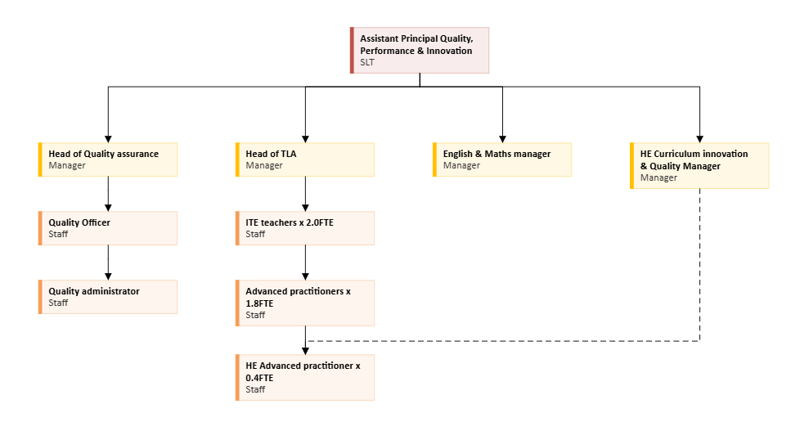
KEY RESPONSIBILITIES AND ACCOUNTABILITIES:
HE Strategy & Cross‑College Leadership
- Lead the implementation of the college’s HE strategy, driving sustainable growth across curriculum areas through new programme development and enhancement.
- Act as the college’s central expert for HE quality and innovation, providing strategic advice to senior leaders, HoDs and academic teams
- Produce reports, analysis and quality updates for SLT, governance, validating partners and external agencies.
HE Quality Assurance & Regulatory Compliance
- Oversee all HE quality assurance processes, including annual monitoring, programme reviews, external examiner processes, and evidence preparation for regulatory or external reviews.
- Ensure compliance with OfS, QAA, awarding/validating body expectations, and college HE policies
- Maintain accurate HE quality documentation, tracking systems, and data dashboards to support quality evaluations.
Innovation in HE Curriculum Design
- Lead and support curriculum innovation across departments, working with the Assistant Principals, curriculum HoDs and teaching teams to design modern, industry‑aligned, research‑informed HE curricula
- Support teams in introducing innovative teaching approaches (e.g., flipped learning, active learning, digital pedagogies) evidenced as high‑impact in HE settings.
- Coordinate new programme approval and validation processes, ensuring programmes are well‑designed, compliant and aligned with strategic priorities.
Teaching, Learning & Assessment (TLA) Enhancement
- Lead and support enhancements to HE teaching, learning and assessment, working with the TLA team to maintain high standards.
- Coordinate and contribute to learning walks, lesson visits and scholarly practice reviews to evaluate HE teaching.
- Promote academic integrity, robust assessment design, and consistent moderation practices across the college.
External Quality Engagement & Partnerships
- Manage relationships with validating partners, external examiners and awarding bodies — ensuring timely responses, action planning and communication.
- Coordinate preparations for external regulation, audits, inspections or reviews.
- Represent the college at HE quality networks, keeping the organisation up to date with sector expectations and best practice.
Staff Development, Training & Support
- Develop and deliver HE-focused CPD aligned with sector evidence calling for enhanced professional development around innovative curriculum and pedagogy.
- Coach and support new and existing HE staff, ensuring they understand HE quality expectations, regulatory frameworks and curriculum standards.
- Promote a culture of reflective practice and scholarly engagement.
HE Data, Monitoring & Performance Improvement
- Monitor and analyse HE performance indicators (continuation, attainment, achievement gaps, student voice, NSS‑style feedback) and lead improvement planning.
- Ensure programme and departmental quality improvement plans are data‑driven.
- Report regularly to PQRs, SPMM and governance.
Enhanced Student Engagement & Experience
- Strengthen student engagement processes, ensuring HE learners’ views inform enhancement actions
- Support departments to embed active learning, belonging and real‑world relevance in HE delivery.
GENERIC COLLEGE ACCOUNTABILITIES
- To operate within the college’s safeguarding children and vulnerable adult’s policy to promote and safeguard the welfare of college’s learners who are under the age of 18, and of vulnerable adults to meet the college’s moral and legal responsibilities.

- To work as a member of the team, both within the section and as part of the service, to promote a team culture and environment and contribute towards the team development and assist others as necessary during periods of peak demand.
- To contribute to the quality system of the section to ensure the delivery of a high-quality service.
- To participate in the college’s performance management scheme, to ensure personal development needs are identified to allow maximisation of a high level of performance.

- To operate and monitor college Health and Safety Policy, to ensure a safe and healthy learning and working environment.

- To proactively create, communicate, implement, and support the college’s Sustainability Development Strategy to ensure college targets are achieved.

- To operate and support college’s Equal Opportunities Policy, to ensure adherence throughout the college.

- To contribute to the smooth running of the college by undertaking other administrative duties as required to support the management of the college.

- To participate in the promotional and marketing activities of the college and ensure a professional and favourable image is always portrayed to enhance the college’s reputation and assist in ensuring its future success.

Note: This Job Description is an outline of the principal accountabilities for the post but is not part of the Contract of Employment.

HOW TO APPLY
For full information about this role or to apply visit www.lcwc.ac.uk/job

Person Specification: Assistant Principal – Quality, Performance & Innovation
 | Essential | Desirable | Assessment Method
Qualifications
First degree or equivalent | ✓ |  | AF / CERT
Management qualification at Level 5 or willing to work towards |  | ✓ | AF / CERT
Higher degree |  | ✓ | AF / CERT
Teaching qualification and evidence of relevant high‑quality teaching practice. | ✓ |  | AF/IV / CERT
Experience
Strong knowledge of Higher Education curriculum, assessment models, and qualification frameworks | ✓ |  | AF / IV / AT
Experience of leading or coordinating Higher Education provision in FE or a similar setting. | ✓ |  | AF / IV / AT
A track record of improving teaching, learning, and assessment. | ✓ |  | AF / IV / AT
Experience of matrix management and the ability to influence others | ✓ |  | IV / AT
Ability to analyse performance data and lead effective interventions. | ✓ |  | AF / IV / AT
Teamwork & Personal Credibility
Create & maintain positive professional relationships, manages own feelings, demonstrate empathy, compassion & equity, maintain a range of internal & external contacts | ✓ |  | AF / IV / AT
Work collaboratively and for the good of all | ✓ |  | AF / AT / IV
Provide effective challenge and support to ensure the college achieves its ambitions for all learners | ✓ |  | AF / AT / IV
Act as a team player | ✓ |  | AF / AT / IV
Accept responsibility for personal activities within agreed parameters | ✓ |  | AF / AT / IV
Display a high standard of personal integrity | ✓ |  | AF / AT / IV
Demonstrate a good understanding of and positive commitment to organisational objectives | ✓ |  | AF / AT / IV
Communication
Communicate effectively by listening, inviting feedback & providing good & timely information in an appropriate format | ✓ |  | AF / AT / IV
Strong leadership, communication and interpersonal skills. | ✓ |  | AT/ IV
Analytical & Decision Making Skills
Ability to analyse complex data and translate it into strategic action. | ✓ |  | AT / IV
Uses logic, analysis, experience, and models to solve problems | ✓ |  | AT / IV
Organised and attentive to detail | ✓ |  | AT / IV
Examine options to find solutions or seeks suggestions that are effective in addressing the problem in hand | ✓ |  | AT / IV
Internal Customer Orientation
Commitment to innovation, inclusion and learner‑centred practice. | ✓ |  | AT / IV
Develop relationships with internal customers and gains their respect | ✓ |  | IV
Treat internal customers fairly and in a non-discriminatory manner | ✓ |  | IV
Personal Effectiveness & Initiative Taking
Ability to reflect, learn and unlearn continuously, developing both your role related technical ability and your leadership practice. | ✓ |  | AT / IV
Demonstrate ability to work under pressure, prioritise and commit to strict deadlines whilst maintaining the quality of output | ✓ |  | AT / IV
Ability to prioritise own work, multi-task, and shift priorities | ✓ |  | AT / IV
Proactive in taking action to achieve goals | ✓ |  | AT / IV
*Assessment method:
AF = Assessed via application form
IV = Assessed via interview
AT = Assessed via test/work-related task
Cert = Certificate checked at interview

