Job Description

Job Title | English Lecturer – GCSE and Functional Skills
Department | Adult Skills
Reports to | Assistant Director
Salary | £31,130 - £32,482 (Unqualified Lecturer)  £34,690 - £44,409 (Qualified lecturer)
Contract | Permanent, Full Time
Location | One of the College centres

Our Vision & Values
“To develop the skills, confidence and qualifications for local people to lead rich lives and build great careers.“

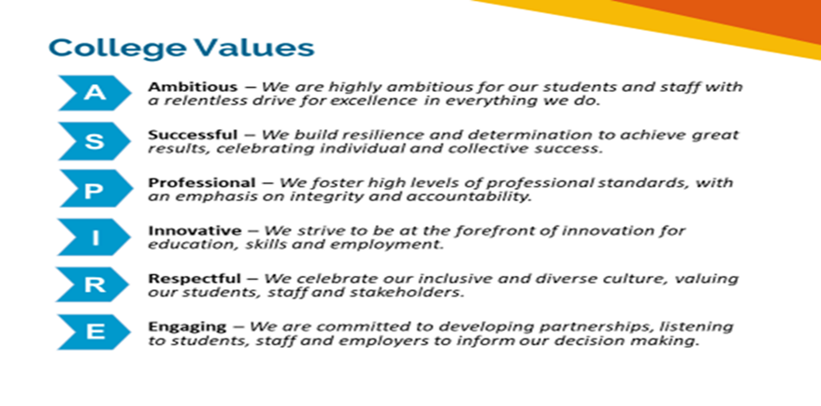

Equality of Opportunity
The college has a strong commitment to working towards the implementation of equality of opportunity in both service delivery and employment. The College's mission and strategic objectives directly support this aim. All employees are required to actively support the development, dissemination and implementation of this aim and related policies and programmes.

Safeguarding of Children and Vulnerable Adults
The College is committed to safeguarding and promotes the welfare of all learners and expects its staff to share this commitment. In addition, they will also state that the College is committed to safeguarding and promotes the welfare of all learners and expects its staff to share this commitment. All posts in the College are subject to an Enhanced DBS check and barred person’s list check.

Description
Job Purpose

We are looking for a keen and committed Functional Skills English Tutor to join our team. The ideal candidate will lead, develop and deliver high quality sessions using a variety of delivery models. This will be through classroom, online and blended sessions across a number of exciting projects
Key Duties and Responsibilities

Teaching
- Provide high quality and effective teaching and learning across entry level up to level 2, to develop the concepts, skills, knowledge, and technical competencies required to progress to employment, further training, apprenticeships and or to progress in their current working role
- Develop high quality flexible learning resources to suit all delivery methods such as face to face and blended learning and to support learners independent study/teaching needs
- Support the successful delivery and outcomes across a number of different projects.
- Accurately track, monitor and record the progress of each learner against their starting points, targets and resource allocation
- Embed high quality induction processes that enable each learner to have a comprehensive understanding of their programme, prevent, safeguarding, health and safety and equality and diversity
- Develop and record effective and high-quality individual learning plans that clearly outline key targets and how understanding, competencies, skills and core employability behaviours will be covered and achieved
- Ensure all work and assignments give learners the opportunities to reach the highest grades and that work submitted is marked in the expected time frames and gives incisive and constructive feedback so learners are clear on the areas they need to improve
- Ensure learners are registered and enrolled for each programme and that achievement claims are timely
- Effectively promote and contribute to creating a culture of safeguarding
- Contribute to the overall quality improvement plans and key performance indicators

General
- To ensure that the highest standards of customer service and care are provided at all times
- Attend and contribute to team meeting and quality improvement meetings where relevant
- To attend monthly progress review meetings.
- To engage fully in the appraisal and performance review process
- Ensure that continual professional development is current and industry relevant
- It may be required, from time to time, to carry out additional tasks from those defined above but associated with your role under the instruction of your line manager.
- Undertake all associated administrative duties and complete paperwork in an accurate and timely manner

Person Specification

- Extensive experience in delivering GCSE and Functional Skills
- A background in education/training and or a qualified trainer
- Degree or equivalent in a relevant professional qualification
- A minimum level 3 teaching qualification (willingness to work towards a higher qualification)
- Level 2 English and Maths

Knowledge and Experience
- Comprehensive understanding of the English curriculum
- Experience of supporting learners with the development of their English and maths
- Strong experience of delivering to 16+ age group with varied abilities in an educational setting
- Knowledge and experience of quality assurance, qualifications and risk assessments
- Familiar with safeguarding and relevant procedures

Skills and Behaviours
- Driven, and ambitious with a positive mindset
- Team player and professional
- Able to motivate and inspire people to achieve
- Passionate about the learning and skills agenda
- Accountable and Responsible
- Able to build and sustain effective working relationships
- Excellent communications skills with people at all levels
- Strong attention to detail and able to keep accurate records
- Able to manage one’s own diary and work in a timely manner using online tools.
- Excellent organisational skills
- Self-motivated and determined with a desire to succeed
- Committed to continuous improvement – personal and organisational

