Job Description:

Job Title | Teaching Support Assistant
Department | Young ESOL
Grade | BS4.21
Scale | £24,023
Contract | Fixed Term Contract
Location | Cross Site

Our Vision & Values
“To develop the skills, confidence and qualifications for local people to lead rich lives and build great careers.“

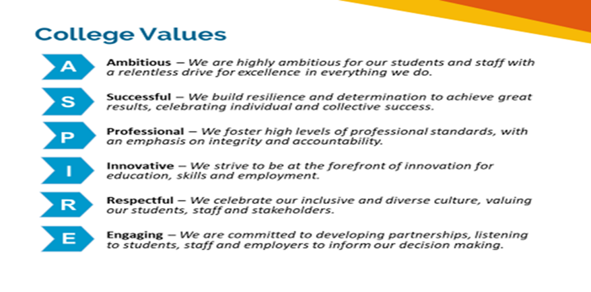

Equality of Opportunity
The college has a strong commitment to working towards the implementation of equality of opportunity in both service delivery and employment. The College's mission and strategic objectives directly support this aim. All employees are required to actively support the development, dissemination and implementation of this aim and related policies and programmes.

Safeguarding of Children and Vulnerable Adults
The College is committed to safeguarding and promotes the welfare of all learners and expects its staff to share this commitment. In addition, they will also state that the College is committed to safeguarding and promotes the welfare of all learners and expects its staff to share this commitment. All posts in the College are subject to an Enhanced DBS check and Barred List check.

Description
Job Purpose

To deliver high quality teaching and learning support to young adult learners with ESOL needs following Lockdown and time away from full -time education to enable them to catch up achieve their ambitions in relation to preparing for language skills development, self-confidence and next steps into further study.

Key duties and responsibilities of the post

- To liaise with teaching staff, and deliver the support needed, developing strategies to achieve outcomes in session plan and individual learning plans provided by teachers
- Provide day to day support for distanced paired and small groups in college
- Help supervise and support employability, enrichment and educational visits
- Help to support in-class and remote lessons prepared by the teacher
- To support the holistic progress of individuals and small groups by facilitating emotional, behavioural and academic support using a variety of intervention strategies
- To follow risk assessments and emergency procedures are followed as in line with college policy
- Support College initiatives and aspirations to achieve Net Zero carbon.

Training
- To attend and complete all training as provided by the college.

General
- To ensure safeguarding practices are undertaken at all times
- To take an active part in team meetings
- To carry out duties as required by the management team
- To be responsible for ensuring effective communication is given at all times
- To be responsible for health and safety of self and others using proactive and reactive strategies.
- To promote equality & diversity incorporating British Values at all times
- To contribute to online reviews and monitoring via E-Trackr

Person specification:

Role and Band Competencies | Essential / Desirable
Education Levels and Qualifications
Level 2 (GCSE) Qualifications in English and Maths | E
Certificate in English Language Teaching (CELTA) | D
L2 or L3 NVQ in Supporting Teaching Learning and Learners | D
Specific Knowledge, Experience & Technical Skills
Knowledge and demonstrate experience of working with young learners | E
A knowledge of young asylum seekers, LAC and ESOL | E
Experience of managing behaviours that may be challenging | E
Good knowledge of health and safety, data protection and equal opportunities | E
Proven ability to solve problems quickly and remain calm in escalated situations | E
Good level of IT literacy using Microsoft software | E
Excellent communication skills both written and verbal | E
Strong interpersonal skills | E
Willingness to support learners and take part in extra curricula activities | E
Personal Attributes
Able to work using own initiative and also work as part of a team |  | E
Excellent punctuality and to be reliable |  | E
Able to work flexibly in order for the learners to participate in line with individual learning plans |  | E
Good appreciation of health and safety in the workplace, data protection principles and equal opportunities |  | E
Newham College is committed to safeguarding and promoting the welfare of our learners and expects all staff to share this commitment |  | E

