Job Description

Job Title | Retention and Welfare Officer
Department | Student Services
Reports To | Head of Student Services – Enrichment, Safeguarding and Welfare
Grade | 5
Location | East Ham and Stratford and any other College sites as required

Job D
Our Vision & Values
“To develop the skills, confidence and qualifications for local people to lead rich lives and build great careers.“

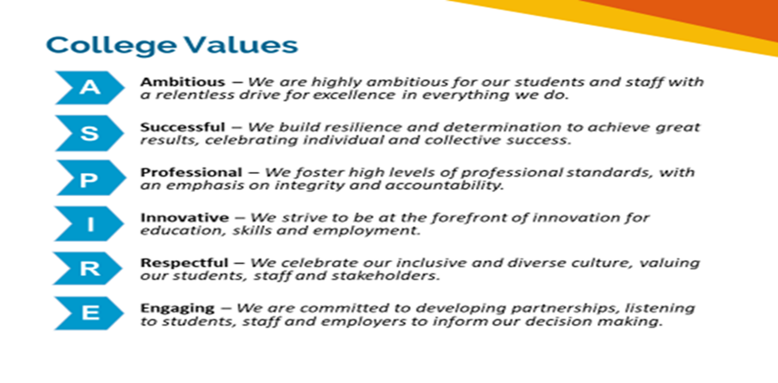

Equality of Opportunity
The college has a strong commitment to working towards the implementation of equality of opportunity in both service delivery and employment. The College's mission and strategic objectives directly support this aim. All employees are required to actively support the development, dissemination and implementation of this aim and related policies and programmes.

Safeguarding of Children and Vulnerable Adults
The College is committed to safeguarding and promotes the welfare of all learners and expects its staff to share this commitment. In addition, they will also state that the College is committed to safeguarding and promotes the welfare of all learners and expects its staff to share this commitment. All posts in the College are subject to an Enhanced DBS check and barred person’s list check.

Job Description
Job Purpose

The Welfare and Retention Officer will play a key role in the monitoring of students at risk of leaving college ensuring that effective intervention strategies are in place to keep students on programme.
The post-holder will be responsible for providing effective welfare and mental health support, advice, and guidance to all learners.
The Welfare and Retention Officer will liaise closely with students, parents and external support agencies to gather and record information relating to any barriers to attendance or learning. They will alert any safeguarding concerns to colleagues in line with the safeguarding policy.
Adjusted working hours can occur to meet the business’ needs. The post-holder should have a flexible approach to hours of work, place of work, and cover needed for holidays

Key Duties and Responsibilities

- To work with curriculum teams to identify and support students who are ‘at risk of leaving’.
- Ensure there is a timely and effective ‘at risk’ referral system is in place.
- To work with curriculum teams to implement and follow through action plans with ‘at risk’ students to ensure they can remain on programme and improve their attendance.
- To provide advice and guidance to staff on welfare and mental health issues and any relevant policy updates.
- To provide advice, guidance, and support to students on a range of welfare issues including but not limited to; financial support, housing, physical health and mental/emotional health.
- To play a key role in the implementation of the College’s Attendance and Punctuality Policy and where required to work with Senior Management and CLT across the organisation to meet college expectations and benchmarks.
- Maintain close links with specialist statutory and non-statutory external agencies and develop effective referral systems. Ensure ‘Welfare Checks and data’ are responded to quickly and via the council’s online portals.

- Effectively promote the welfare services to all students at Newham College including Apprentices and Adult Learners.
- Attend external meetings, training, and events on behalf of the College regarding welfare, safeguarding and mental health, liaising effectively with outside agencies where and when necessary.
- Manage a small case load of welfare and mental health cases.
- To support Care Experienced (LAC)/Previously Looked After and Care Leavers by holding regular PEP reviews whilst also liaising with Social Workers, external partners, and Carers.
- To be prepared to operate on a flexible basis as required and support the department events and activities, I.E enrolment weeks, open evenings/days.
- Contribute to the development of the department and directorate with the Head of Student Services and Director of Student Services.
- To support the wider Safeguarding and Welfare Officers and the wider Safeguarding Team as and when required.
- Members of the team will be expected to work out of normal working hours as and when required.
- To work collaboratively across the College with all students and staff.
- To complete all associated internal and external administration to the highest standard and is delivered in a detailed and timely manner.
- To support with the minute taking of Safeguarding Team and committee meetings.
- Run attendance reports and interrogate and present complex data for Senior Managers and Curriculum.
- To assist in the management of appropriate administrative and data collection systems, which meet College and external partner/agency requirements.
- To participate in both internal and external staff development as appropriate.
- To meet the requirements of the Health & Safety at Work Act 1974 and the College’s Health and Safety Procedure.
- Comply with College Acceptable IT Users Policy in line with ‘Cyber Securities’ requirements and monitor the student impero web searches reporting to the Curriculum Managers and Head of Student Services.
- Contribute to the areas Self-Assessment Report (SAR) and Quality Improvement Plan (QIP).
- Support College initiatives and aspirations to achieve Net Zero carbon.
- Carry out any other duties commensurate with the role.

NB: The purpose of the job description is to indicate the general level of responsibility of the position. The duties may vary from time to time without changing their general character or level of responsibility.

Person Specification

Qualifications
Level 3 qualification in Business Admin or Customer Services or relevant recent experience | Essential
Level 2 English and maths | Essential
Level 3 Safeguarding Training | Desirable
Mental Health 1st Aid qualification | Desirable
Experience
Experience of working with external partners | Essential
Experience of recording data in a timely and accurate manner | Essential
Experience of using and maintaining databases and IT systems to record data | Essential
Experience of delivering high quality information, advice and guidance | Essential
Experience of maintaining databases and carrying out compliance audits | Essential
Experience of developing promotional/information materials | Essential
Experience of delivering advice and guidance on welfare issues and mental health | Essential
Experience of planning, preparing, and taking minutes at team meetings | Essential
Experience of successfully working with young people and adults in an educational setting | Essential
Knowledge & Skills
Excellent communication and interpersonal skills | Essential
Ability to work with data showing a high degree of accuracy and attention to detail | Essential
Ability to lead change, meet deadlines and prioritise workload | Essential
Display initiative, be positive and enthusiastic | Essential
Ability to work independently | Essential
Outstanding numerical and analytical skills | Essential
Excellent IT skills including databases and Microsoft Office | Essential
Ability to work with, interrogate and present complex data | Essential
Willingness to work flexible hours including evening and occasional Saturdays | Essential
Demonstrate a commitment to equality, diversity and inclusion | Essential
Suitability to work with children, young people and/or vulnerable adults | Essential

Review Details
Job Title | Welfare and Retention Officer
Date Created | 01 March 2022
Date Issued to Employee by Line Manager
Version | 1

