Team: | Science
Salary: | NJC Teachers pay spine T1 to T9, £23,444.00 to £36,216.00 per annum depending on experience
Job Summary: | Newham Sixth Form College (NewVIc) is London’s largest sixth form college. It is a vibrant centre for sixth form education with the great majority of students coming from our local schools in Newham. NewVIc’s mission: Enhancing lives through excellent education and learning. NewVIc’s vision: The first choice college for enhancing the lives of students in partnership with parents, employers, and community:  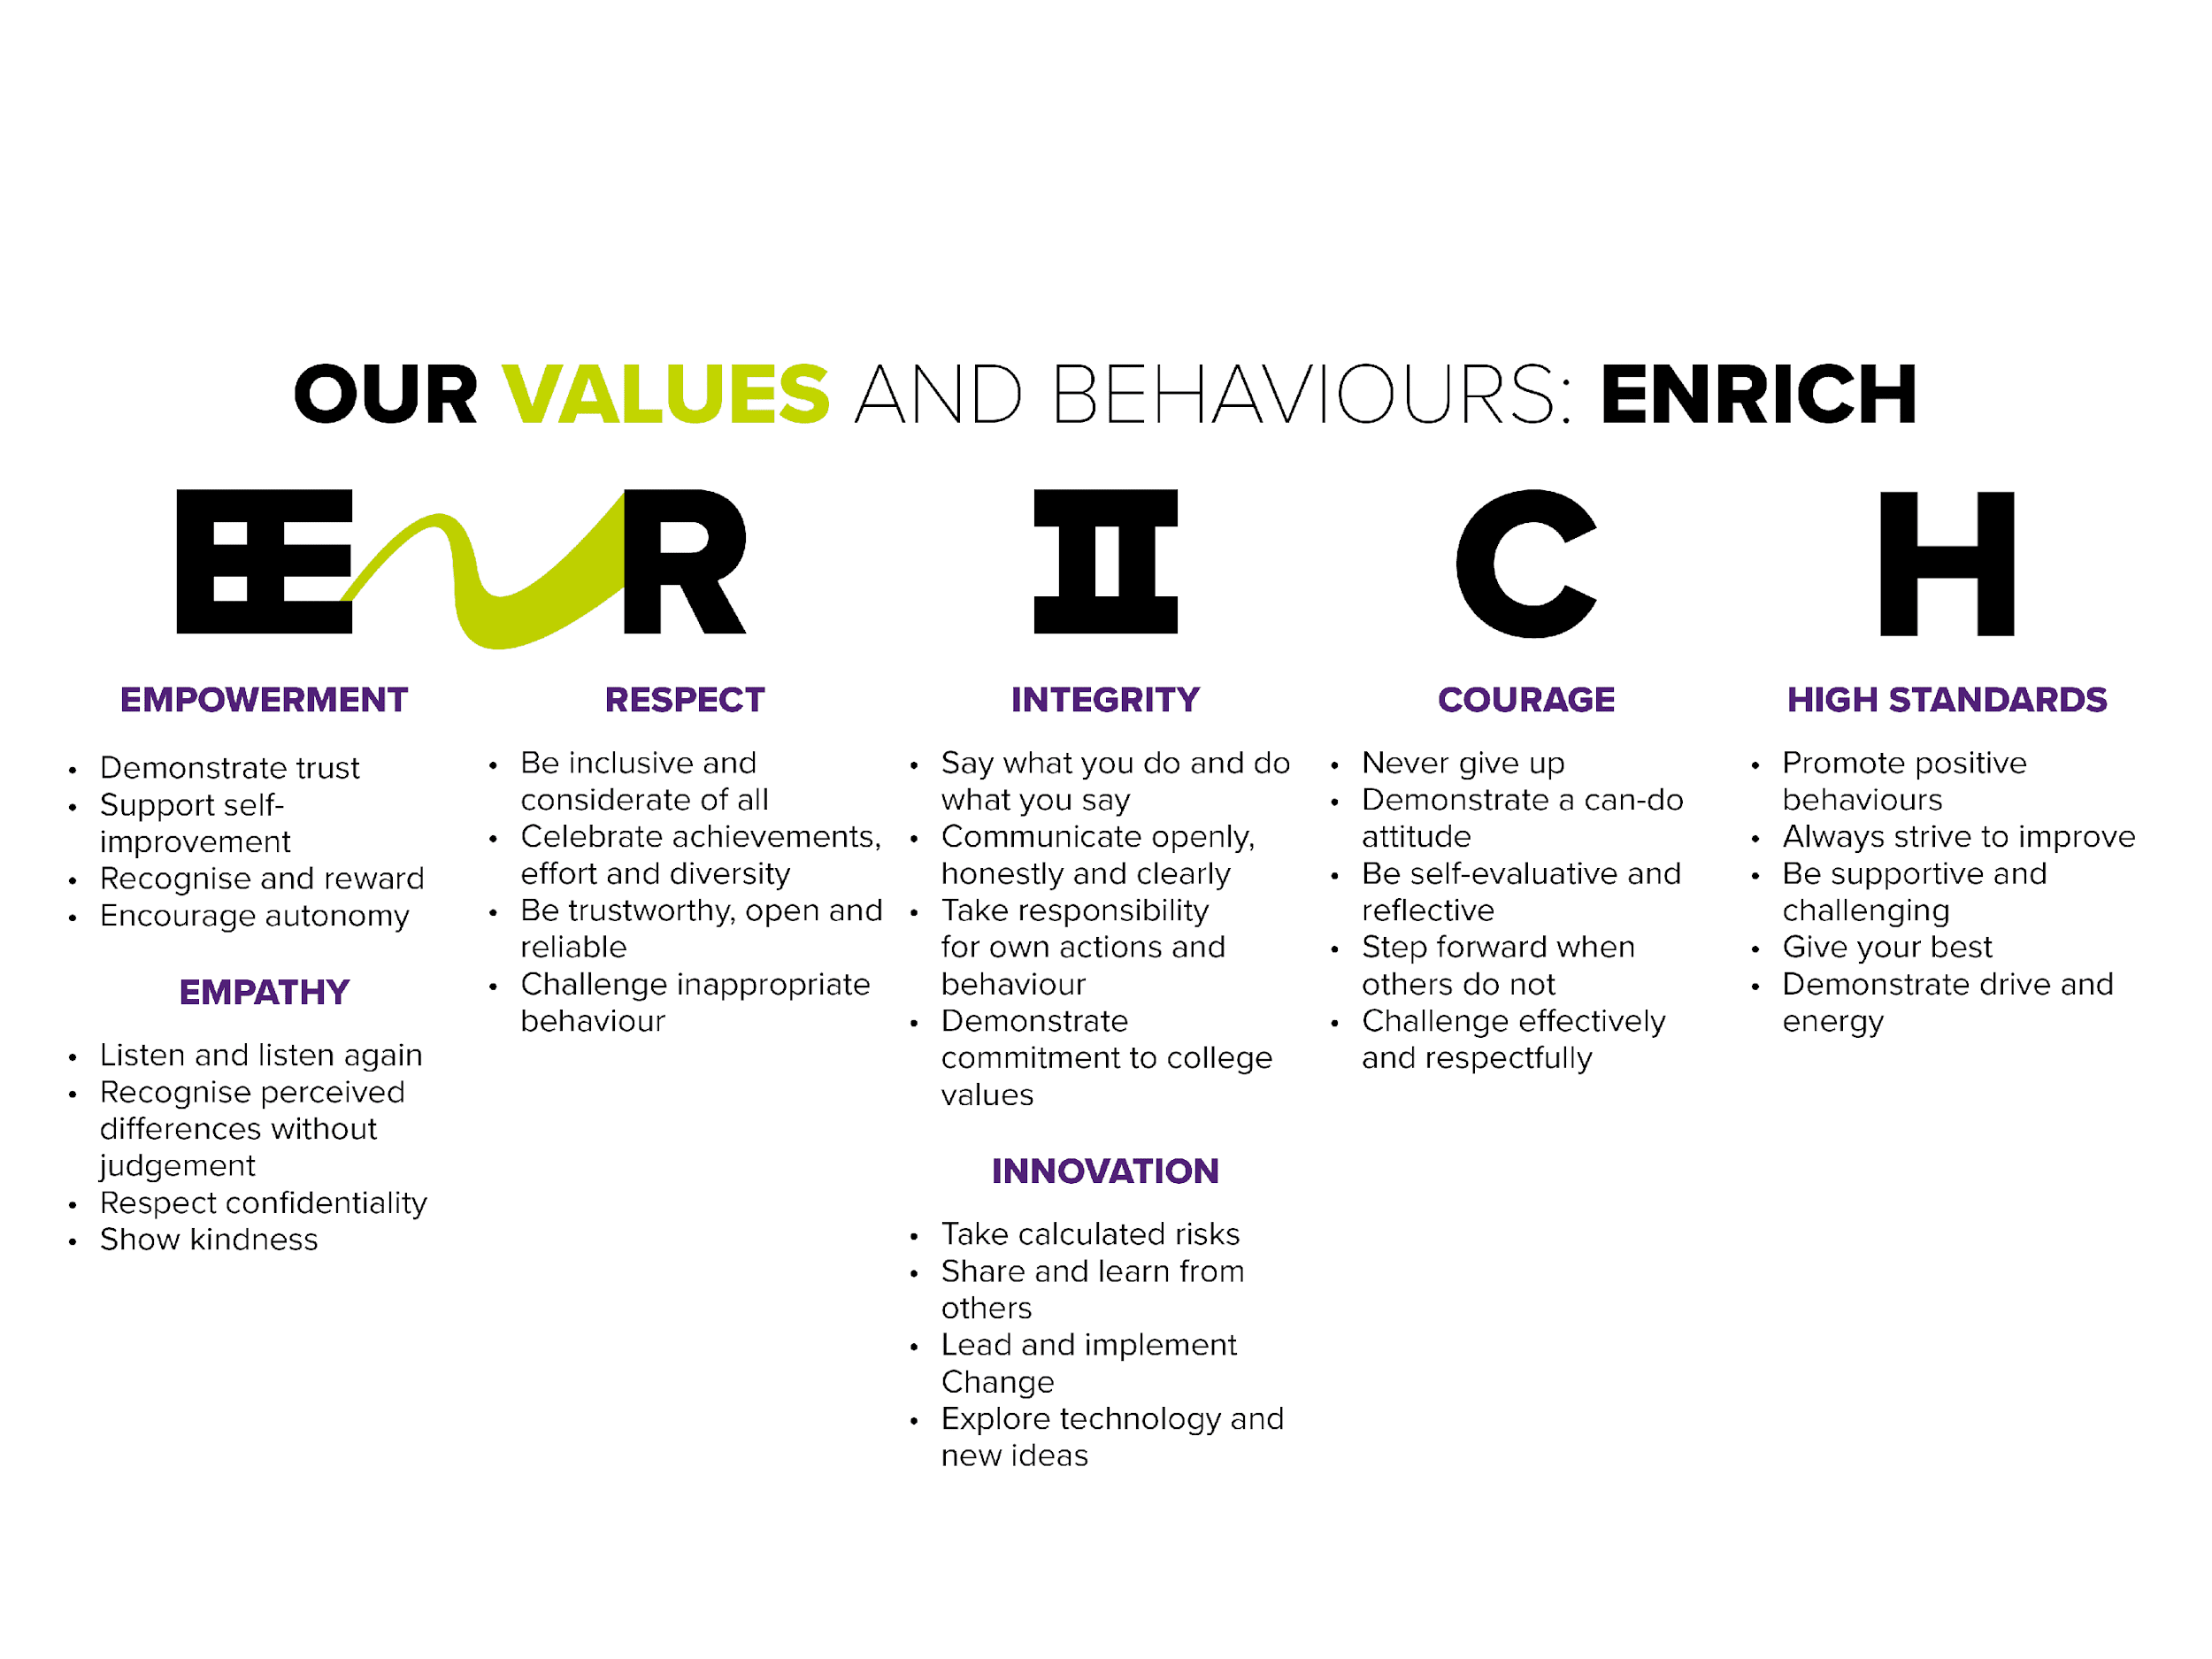  The science team is extremely well-resourced with 6 fully-equipped science laboratories and 2 preparation rooms. The full team comprises 15 staff (including four technicians). Our experienced and dedicated specialists offer a range of courses including:  - A-levels in chemistry, biology and physics  - BTEC extended diploma in biomedical science  - Applied Human Biology  - GCSE Science  - BTEC level 2 applied science  We have a vacancy for a 0.8 Teacher of Biology, covering A-level and BTEC levels 2 and 3 Biology.  To teach at NewVIc you will be committed to supporting students in achieving success. You will work well with 16-19 year olds and contribute to a student-centred environment both inside and outside of the classroom. As a teacher, you will be innovative and reflective, with a genuine interest in young people and how they learn.  A job description for this post is attached to give you more information.
Closing Date:  Vacancy ID: | 12 April 2021  TP/22
Application Form: | For further details, or for an application pack, please visit https://www.newvic.ac.uk/jobs or email jobs@newvic.ac.uk.

Application process: | Candidates are longlisted on the basis of their written application and the extent to which they meet the standard criteria. You are advised to ensure that you use your supporting statement to indicate the extent to which you meet each of the criteria in the person specification below.  The selection day usually starts with a briefing on the post and the college. You will also be asked to complete a short written activity.  In addition, longlisted applicants for teaching posts are usually asked to carry out an observed micro-teaching session of 20 minutes, typically with a group of 6-8 students. Candidates will be informed of the topic for the micro-teaching at the point of being invited in for the selection day.  Following these activities the selection panel decides which candidates to take through to interview, usually on the afternoon of the same day.

Job Description Teacher of Biology

Reports to: | Curriculum Team Leader for Science
Responsible for: | None
Main Purpose /  Main Activities: | As a teacher;  - To contribute to the work of the programme team.  - To prepare and maintain schemes of work.  - To prepare students for internal and external assessment.  - To mark and moderate students' work.  - To provide a stimulating learning environment for students.  - To write reports.  - To maintain students' records.  - To provide consultation for students, their parents, adults and other clients as directed.  - To take part in programme reviews and evaluation.  - To take part in programme and other curriculum development.  - To develop and implement teaching and learning strategies in line with college policy.  - To cover for colleagues as required.  - To observe the requirements of college policy in respect of:  - The mission statement  - Health and safety  - Equality and diversity  - Student discipline  - To monitor the use of equipment and materials.  College responsibilities  - To act as personal tutor to a group of students if required.  - To represent the college at meetings as directed.  - To work with colleagues in support of college policies and initiatives.  - To participate in the college appraisal process.  - To participate in inspections and self-assessment.  Teachers may be required to work up to two evenings per week.  Note: where this is the case, timetables will include equivalent time off during the day.

Other Information

Health and Safety - all employees must comply with the requirements of the Health and Safety at Work Act 1974 and affiliated regulations. Employees are also required to comply with the college’s Health and Safety Policies and take reasonable care for the health and safety of themselves and of other persons who may be affected by their acts or omissions. Where the college has a statutory duty with regard to health and safety employees are required to co-operate with the college and its managers and officers so far as is necessary to enable the college to meet that duty. This includes using equipment and substances in accordance with training and instruction and the reporting of serious dangers to your own or others’ safety.

Equality – the postholder must be committed to the college’s Equality and Diversity Policy and advancing equality through our Equality Objectives.

Performance – the postholder will be required to participate in performance reviews and undertake a plan of training where necessary.

Confirmation of appointment is subject to a satisfactory 10 month probation period.

The post holder will be required to adhere to college policies and procedures.

In addition to the responsibilities listed above, all employees must be adaptable in their approach and undertake other duties that are commensurate with the postholder’s level, wherever they may be, to achieve the objectives of the college.

This post is based at Prince Regent Lane but the postholder may be required to move their base to any other location within the college at a future date.

The postholder may be required to work for 195 days in any year of which 190 will be days on which you may be required to teach in addition to carrying out other duties. Within these 195 days, up to 1265 hours a year will be allocated reasonably to you by the Principal. (Pro rata for fractional appointments.)

Within the 1265 hours you may be required to teach for up to 6 hours over two evenings per week. In addition, you will work such additional hours as may be needed to enable you to discharge your duties effectively including, in particular, the marking of students' work, the writing of reports on students and the preparation of lessons, teaching material and teaching programmes.

The post holder will be asked to complete a criminal records self-declaration form. Criminal convictions will only be taken into account when they are relevant to the post.

We are committed to safeguarding and promoting the welfare of children and young people and expect all staff to share this commitment and participate in statutory training.

Useful Websites:

NewVIc
www.newvic.ac.uk
The college’s own website.

Newham Council
www.newham.gov.uk
The website of Newham Council.

https://www.gov.uk/
The website for Government services and information

The 2018 Ofsted inspection report on NewVIc
www.newvic.ac.uk/statutory-information

Person Specification Teacher of Biology
This is the core person specification for all standard scale teachers at NewVIc.
You are advised to use your supporting statement to indicate the extent to which you meet each of these criteria.
Commitment to:
- The college mission: Enhancing lives through excellent education and learning
- Inclusion, equality & diversity (and specifically the implementation of the college’s Equality and Diversity Policy)
Knowledge and understanding of:
- Current developments in vocational and academic education and training
- The relevant curriculum area in the industrial/commercial sector where appropriate
Skills and abilities in
- Teaching on a range of programmes
- A range of teaching and learning strategies, including use of Information Learning Technology
- Working in teams
- Tutoring
- Curriculum development
Attitudes
- Commitment to NewVIc values
- Commitment to high quality post-16 education and training
- Commitment to equality and diversity
Qualification at:
- You are normally expected to have a degree related to your teaching subject, although we acknowledge that teachers may also be qualified for their subject by other relevant experience. It is essential that you are qualified to at least level 4 in a relevant subject.

- We usually appoint only qualified teachers. We will, however, consider applications from candidates who will commit themselves to gaining a recognised teaching qualification within a set time when there are exceptional circumstances, e.g. extensive relevant industry experience.

- A grade C or higher in English and maths GCSE (or equivalent).

In addition, you will be required to hold, or work towards in a specified time, a recognised teaching qualification.

