
English & Maths Manager

JOB TITLE
English & Maths Manager
ACCOUNTABLE TO:
Assistant Principal Quality, Performance & Innovation
ABOUT THE COLLEGE
Lakes College is a leading technical and vocational Further Education provider serving West Cumbria and beyond. Our vibrant campus offers state‑of‑the‑art facilities, specialist vocational workshops and outstanding industry‑aligned resources — including the National College for Nuclear Northern Hub, a flagship centre for skills development in the UK’s growing nuclear and clean energy sectors. We deliver high‑quality education and training to full‑time and part‑time learners, apprentices and higher‑level students up to degree level.
Our mission is simple and powerful: to enable people to recognise, develop, and fulfil their potential. As a people‑centred organisation, this mission applies equally to our learners, our staff and the employers and communities we serve. We are proud to be a good college, and we are ambitious to become exceptional. Achieving this means continually strengthening our culture, raising expectations and working together to deliver the very best experience for every learner, every day.
Innovation, collaboration and reflective practice sit at the heart of how we work. We encourage our teams to explore new ideas, embrace evidence‑informed approaches and contribute to a culture where professional growth is valued. We use data intelligently to understand performance, drive improvement and ensure that our decisions lead to meaningful impact.
ABOUT THE ROLE
The English & Maths Manager plays a critical cross‑college role in ensuring that Lakes College delivers a high‑quality, compliant, and ambitious offer for all learners studying English and Mathematics.
This post supports the college’s devolved delivery model, providing central leadership, guidance, and quality assurance while working collaboratively with curriculum Heads of Department (HoDs), teaching teams, and the wider Quality function.
The postholder will ensure that curriculum areas meet all national policy expectations, embed English and Maths across vocational provision, and provide consistently high standards of teaching, learning, assessment, and learner progress.
This role is vital in realising the intent of the college English & Maths Strategy 2026–27, promoting a whole‑college culture where English & Maths are everyone’s responsibility.
This is an exciting opportunity to join a thriving Further Education college located on the edge of the Lake District National Park — one of the UK’s most stunning and inspiring landscapes. The area offers an exceptional quality of life, combining easy access to mountains, lakes and coastline with welcoming communities, low crime rates and a cost of living that remains refreshingly affordable compared with many parts of the UK.
For those seeking a rewarding leadership role alongside a balanced lifestyle, the region provides the best of both worlds: vibrant outdoor culture, space to breathe, and a supportive environment in which to live, work and grow. Whether you’re drawn by the natural beauty, the sense of community or the opportunity to make a real difference in a college with high ambitions, this is a place where you can build a fulfilling future.
ORG CHART:
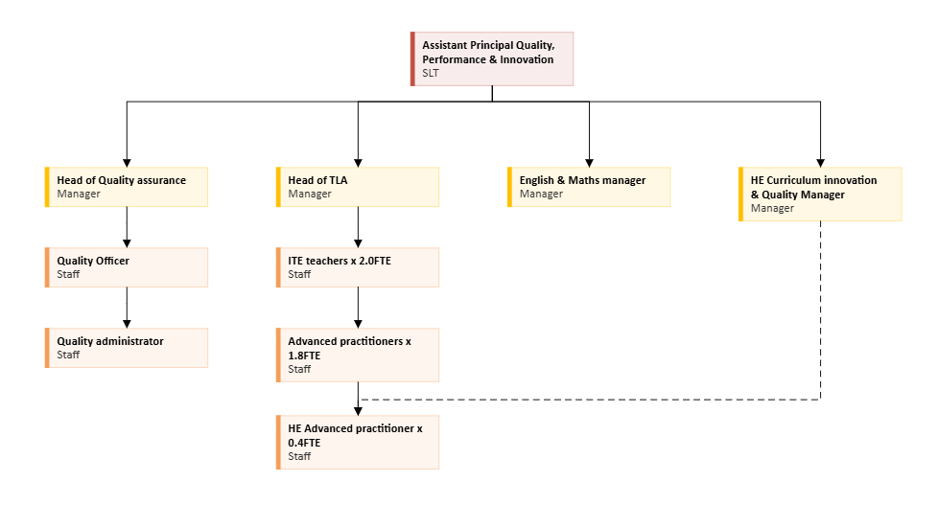
KEY RESPONSIBILITIES AND ACCOUNTABILITIES:
Strategic Leadership
- Lead the college’s English & Maths strategy, ensuring alignment with national policy, Ofsted expectations, and the college Quality Strategy.
- Provide expert guidance on curriculum design, qualification selection, exam board choice, progression routes, and programme suitability.
- Ensure that the English & Maths provision supports the whole community, including 16–18 learners, adults, apprentices, and those requiring stepping‑stone qualifications.
- Coordinate exemptions for learners where appropriate, securing Executive approval where required.
Quality Assurance and Improvement
- Lead the cross‑college quality assurance of English & Maths, including learning walks, lesson visits, work scrutiny, assessment standardisation, and monitoring of Sequences of Learning and lesson frameworks.
- Ensure consistent, high‑quality teaching and learning for all English & Maths delivery across curriculum areas.
- Monitor performance rigorously, including attendance, progress, assessment data, Century engagement, and learner outcomes.
- Produce and present performance updates for Strategic Performance Monthly Monitoring (SPMM), Performance & Quality Reviews (PQRs), and SLT.

Teaching, Learning and Assessment (TLA)
- Provide training and support to ensure teachers use the college’s English & Maths lesson frameworks, Sequence of Learning documents, and assessment models effectively.
- Oversee the creation and application of assessment schedules, including progress checks, mock examinations, and diagnostic assessments.
- Drive the implementation of SPaG standards in English, Functional Skills, and vocational marking.
- Promote evidence‑informed pedagogy and ensure that contextualisation of English & Maths occurs meaningfully within all vocational areas.
Leadership of Digital & Online Tools

- Lead the strategic implementation and consistent use of online assessment and support tools across all English & Maths provision.
- Oversee use of online Initial Assessments, homework, diagnostic insights, and activity monitoring.
- Coordinate staff training and evaluate the effectiveness and value for money of online learning tools.
Timetabling, exams and compliance
- Provide central guidance for English & Maths timetabling, ensuring curriculum areas adhere to college rules.
- Ensure exam compliance, including exam board requirements, invigilation models, access arrangements, and standardised processes college‑wide.
- Support HoDs to secure cover arrangements and ensure continuity of delivery.

Staff Development, Training & Support
- Develop and deliver a cross‑college CPD programme for English & Maths teachers.
- Provide coaching, mentoring, and expert support to improve teaching practice and outcomes.
- Work closely with Head of Quality, Head of TLA, and Curriculum HoDs to ensure shared expectations, consistent standards, and joined‑up support for staff.
Attendance, Behaviour & Learner Experience
- Drive a positive, trauma‑informed approach to attendance, ensuring English & Maths lessons promote belonging, relevance, and enjoyment.
- Monitor attendance patterns across departments and lead early interventions where concerns arise.
- Oversee learner voice mechanisms related to English & Maths and ensure actions lead to continuous improvement.
Partnership, Communication & Stakeholder Engagement
- Act as the central specialist for English & Maths, providing clear communication to HoDs, teachers, data teams, MIS, exams, and senior leaders.
- Engage externally with awarding bodies, exam boards, other FE providers, and professional networks to ensure best practice.
GENERIC COLLEGE ACCOUNTABILITIES
- To operate within the college’s safeguarding children and vulnerable adult’s policy to promote and safeguard the welfare of college’s learners who are under the age of 18, and of vulnerable adults to meet the college’s moral and legal responsibilities.

- To work as a member of the team, both within the section and as part of the service, to promote a team culture and environment and contribute towards the team development and assist others as necessary during periods of peak demand.
- To contribute to the quality system of the section to ensure the delivery of a high-quality service.
- To participate in the college’s performance management scheme, to ensure personal development needs are identified to allow maximisation of a high level of performance.

- To operate and monitor college Health and Safety Policy, to ensure a safe and healthy learning and working environment.

- To proactively create, communicate, implement, and support the college’s Sustainability Development Strategy to ensure college targets are achieved.

- To operate and support college’s Equal Opportunities Policy, to ensure adherence throughout the college.

- To contribute to the smooth running of the college by undertaking other administrative duties as required to support the management of the college.

- To participate in the promotional and marketing activities of the college and ensure a professional and favourable image is always portrayed to enhance the college’s reputation and assist in ensuring its future success.

Note: This Job Description is an outline of the principal accountabilities for the post but is not part of the Contract of Employment.

HOW TO APPLY
For full information about this role or to apply visit www.lcwc.ac.uk/job

Person Specification: Assistant Principal – Quality, Performance & Innovation
 | Essential | Desirable | Assessment Method
Qualifications
First degree or equivalent | ✓ |  | AF / CERT
Management qualification at Level 5 or willing to work towards |  | ✓ | AF / CERT
Higher degree |  | ✓ | AF / CERT
Teaching qualification and evidence of relevant high‑quality teaching practice. | ✓ |  | AF/IV / CERT
Experience
Strong knowledge of English & Maths curriculum, assessment models, and qualification frameworks | ✓ |  | AF / IV / AT
Experience of leading or coordinating English & Maths provision in FE or a similar setting. | ✓ |  | AF / IV / AT
A track record of improving teaching, learning, and assessment. | ✓ |  | AF / IV / AT
Ability to analyse performance data and lead effective interventions. | ✓ |  | AF / IV / AT
Experience of matrix management and the ability to influence others | ✓ |  | IV / AT
Experience using online learning tools such as Century. | ✓ |  | AF / IV / AT
Teamwork & Personal Credibility
Create & maintain positive professional relationships, manages own feelings, demonstrate empathy, compassion & equity, maintain a range of internal & external contacts | ✓ |  | AF / IV / AT
Work collaboratively and for the good of all | ✓ |  | AF / AT / IV
Provide effective challenge and support to ensure the college achieves its ambitions for all learners | ✓ |  | AF / AT / IV
Act as a team player | ✓ |  | AF / AT / IV
Accept responsibility for personal activities within agreed parameters | ✓ |  | AF / AT / IV
Display a high standard of personal integrity | ✓ |  | AF / AT / IV
Demonstrate a good understanding of and positive commitment to organisational objectives | ✓ |  | AF / AT / IV
Communication
Communicate effectively by listening, inviting feedback & providing good & timely information in an appropriate format | ✓ |  | AF / AT / IV
Strong leadership, communication and interpersonal skills. | ✓ |  | AT/ IV
Analytical & Decision Making Skills
Ability to analyse complex data and translate it into strategic action. | ✓ |  | AT / IV
Uses logic, analysis, experience, and models to solve problems | ✓ |  | AT / IV
Organised and attentive to detail | ✓ |  | AT / IV
Examine options to find solutions or seeks suggestions that are effective in addressing the problem in hand | ✓ |  | AT / IV
Internal Customer Orientation
Commitment to innovation, inclusion and learner‑centred practice. | ✓ |  | AT / IV
Develop relationships with internal customers and gains their respect | ✓ |  | IV
Treat internal customers fairly and in a non-discriminatory manner | ✓ |  | IV
Personal Effectiveness & Initiative Taking
Ability to reflect, learn and unlearn continuously, developing both your role related technical ability and your leadership practice. | ✓ |  | AT / IV
Demonstrate ability to work under pressure, prioritise and commit to strict deadlines whilst maintaining the quality of output | ✓ |  | AT / IV
Ability to prioritise own work, multi-task, and shift priorities | ✓ |  | AT / IV
Proactive in taking action to achieve goals | ✓ |  | AT / IV
*Assessment method:
AF = Assessed via application form
IV = Assessed via interview
AT = Assessed via test/work-related task
Cert = Certificate checked at interview

