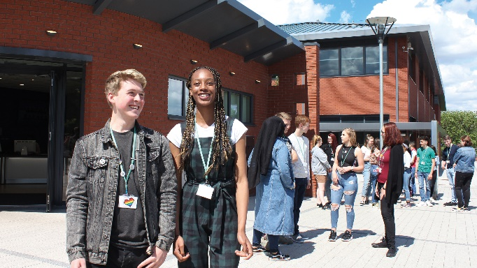

Overview of Halesowen College

Halesowen College aims to provide:

- A broad, inclusive, responsive, and purposeful curriculum
- Exceptional teaching, learning and outcomes
- Learning environments that make a difference
- A truly diverse, empowered, supportive and accountable community
- Sound finances to allow investment and keep us ahead of the game
- A reputation as the go to college

Staff report that they are well supported by their line manager, feeling able to approach them, that they receive regular feedback and feel confident in what is expected of them. Staff work hard and work well together. We are proud of our diversity and so invite individuals to join the college who share this ethos and can contribute to having positive relationships and conversations.

Shortlisting of applicants is anonymous, and we welcome applications from all sections of the community. We have robust onboarding processes to ensure the safety and wellbeing of our students.

There are sustainability and environmental improvements year on year at Halesowen College, supported by an environmental group involving staff and students, to make the necessary step changes so that we can be responsible. This also shows learners how they can take the theory and make it into a reality.

Halesowen College is a thriving tertiary college operating from three main sites, Whittingham Road, Shenstone House and the Coombs Wood Centre. Facilities, buildings and resources are modern, inviting and the campuses are an exciting place to learn and work.
The College is structured in three Curriculum Faculties, each with an Assistant Principal and two business support areas, Learner Support Services and Corporate Services.

Quality and Standards is overseen by a fourth Assistant Principal and the team work across the College to improve the quality of education, creating a culture of enthusiasm for continued professional development and assuring a high-quality learner experience. Their overall aim is to drive up standards in teaching and learning through the tracking, monitoring and support for staff, reporting on performance, improvement strategies and impact.

The College has maintained a good reputation for a sustained period. This was reaffirmed in September 2017 when Ofsted judged the College to be “Good” overall. Achievement rates have steadily improved and are now amongst the best nationally.

We are proud to be recognised as a Leader in Diversity which has been retained since November 2020, for Fairness, Respect, Equality, Diversity, Inclusion and Engagement.

The College primarily serves the communities of Halesowen, Stourbridge, Dudley and Sandwell. Many students are from urban areas including many wards that score highly on the index of deprivation. In addition to providing one of the most comprehensive curriculum offers in the region, the College works hard to remove any barriers that students might encounter. We are the only college in the region to offer a free coach service to all learners with over 2000 students accessing these coach services each week.

The College has:

- Excellent relationships with local schools and recruits students from more than 100 others.
- Some 4,300 funded full-time 16-18 learners
- Both GCE A levels and vocational provision of which 70% of students follow level 3 studies.
- Growing numbers of adults;14-16-year-old elected home-educated students and a small but rapidly increasing number of apprentices.
- Programmes range from Entry Level to Level 4. Adult provision is primarily concentrated on GCSE English, Maths and Access to Higher Education programmes supported by some specific vocational expertise on areas such as Counselling.
- There is a growing number of students who receive learning support assistance and most have access arrangements for their exams or assessment.
- University Centre Halesowen partly funded by the University of Worcester, as well as other extensive partnerships that compliments the College’s higher level vocational pathways for students who are unlikely to access traditional university education.
- Strong relationships with a range of stakeholders, including the West Midlands Combined Authority, Local Enterprise Partnership, schools, multi-academy trusts, employers and the local community.

Why work for Halesowen College – staff benefits include:

- Local Government Pension Scheme or Teachers’ Pension Scheme  - Opportunities to develop in your role with a comprehensive staff development programme  - Away Day in the Summer term  - Our Employee Assistance Programme helps you deal with life challenges including 24/7 GP service, counselling, carer advice, spine and neurological advice, financial wellness, legal helpline.  - Onsite parking, heavily subsidised.  - Business mileage, cars 45p per mile and 24p per mile for motorbikes and 20p per mile for bicycles.  - Birmingham Hospital Saturday Fund – health cash plan through payroll  - Salary sacrifice for Cycle2Work | - Staff Digital Scheme (loans for IT equipment)  - Sick pay scheme (after qualifying periods up to six months full pay and six months half pay should you need)  - Shutdown days December/January  - Remote access to college networks  - Discounts on treatments in our training salons  - Fitness and wellbeing facilities and instructors  - Eye care – VDU users can have their eye test paid for and receive staff discounts at local opticians  - Free Flu Vaccination onsite  - Onsite wellbeing checks

Safeguarding

Halesowen College will carry out pre-employment safeguarding vetting checks to ensure that staff appointed are suitable to work with children and or vulnerable adults.

- We are committed to safeguarding and promoting the welfare of children and vulnerable adults
- All staff employed have safeguarding responsibilities irrespective of their role
- The post that you will be applying for is exempt from the Rehabilitation of Offenders Act 1974 and the amendments to the Exceptions Order 1975, 2013 and 2020.

