Job Description

Job Title | Payroll Manager
Department | Human Resources
Reports To | Director of HR and Organisational Development
Grade | PO6: £47,892 - £49,768
Location | East Ham Campus

Job D
Our Vision
Mission statement
The mission of the College is to develop the skills, confidence and qualifications for local people to lead rich lives and build great careers.

College Values
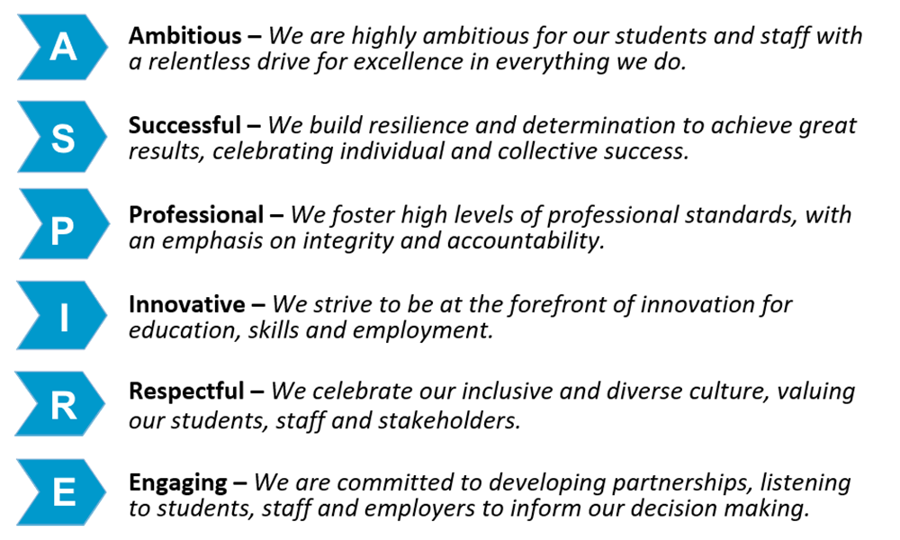

Equality of opportunity
The College has a strong commitment to working towards the implementation of equality of opportunity in both service delivery and employment. The College’s mission and strategic objectives directly support this aim. All employees are required to actively support the development, dissemination and implementation of this aim and related policies and programmes.

Safeguarding of children and vulnerable adults
The College is committed to safeguarding and promoting all learners' welfare and expects its staff to share this commitment. All posts in the College are subject to a Children’s Barred List check. All posts are subject to a Disclosure and Barring Service check at Enhanced Level.

Job Description
Job Purpose

The post holder will be responsible for the College’s payroll operations and HRIS including the management of the day-to-day work of the payroll service and HRIS to ensure that both are delivered efficiently, with responsibility for line managing and supervising staff as appropriate. To be the College expert ensuring statutory and contractual obligations for pay, benefit and pensions are met. Responsible for the development and management of the HRIS, ensuring maximum effective usage by the HR team, efficiency and value for money. Responsible for management reporting within HR.

Key Duties and Responsibilities

Payroll / Pensions
- To manage the payroll section’s day-to-day work to ensure the effectiveness and efficiency of the payroll service, including oversight of the delivery of the monthly payroll cycle and line management of the HRIS and payroll team.
- To provide support, calculate and process payments for all staff, new employees and leavers; including overtime sheets, claim form for hourly paid staff.
- Calculate and process changes to salary including Statutory Maternity Pay, honoraria/acting up / allowances arrangement, annual pay award (increments and costs of living, as advised). Calculate Occupational and Statutory Sick Pay payment in conjunction with the HR Advisors.
- Calculate redundancy and severance payments in conjunction with the HR Manager.
- To lead on and ensure that there are documented procedures in place for the management of the preparation, transmission, and retention of necessary of pay and statutory records, return, statistics, and any other compulsory payments where properly authorised, (including pensions and HMRC returns).
- Liaise with Finance, as appropriate, to ensure that all accounting for payroll and pensions is complete, correct, reconciled, risk minimised and current (including tax, NI, RTI and auto-enrolment); with the defined schedules and timetables completed and resolving any problems in large quantities of complex data and provide reports as required.
- Respond to requests for information promptly and accurately in respect of Teacher’s Pensions, Local Government Pension Scheme, tax, College year-end financial reports, Department for Work and Pension, and other ad hoc reports as required.
- Provide support (and line manage the work of the Payroll Officer) with payroll or pension related queries.
- To provide payroll and system project support on any TUPE, merger, or acquisition for the College, as well as provide independent expert advice on complex payroll matters, as required.
- Ensure that documentation is archived for the required length of time before it is disposed of confidentially and securely.
- Assist with information requests and investigations made by the College’s internal and external audit requirements.

- To develop and run training on systems, processes and procedures to a variety of college audiences, including the team, line managers and senior managers.

- To be a pro-active and positive member of the HR team and participate in relevant cross-group meetings and development activities.

- To carry out any other duties appropriate to the position, as required by the Director of HR&OD.

- To manage projects as requested by the Director of HR and Organisational Development.

Person Specification

Qualifications:

 | Essential Criteria | How Assessed
1. | Full diploma level qualification in Payroll Management (CIPP, Payroll Alliance or other to the BTEC Advance Professional Diploma). | Application form
2. | Level 2 in Numeracy and Literacy | Application form
3. | Qualified member of the CIPD (desirable) | Application form

Experience:

 | Essential Criteria | How Assessed
4. | Experience of managing a monthly payroll function | Application form / Interview
5. | Experience of using Software for People or any other HRIS database. | Application form / Interview
6. | Experience of developing and delivering internal user training. | Application form / Interview
7. | Experience of pension schemes, ideally public sector pension schemes (such as LGPS or Teachers Pensions). | Application form / Interview
8. | Experience of line managing or supervising staff. | Application form / Interview
9. | Experience of working in an educational or public sector setting (desirable) | Application form / Interview

Knowledge and Skills:
 | Essential Criteria | How Assessed
10. | Knowledge of pension and payroll legislation, including auto-enrolment. | Application form / Interview
11. | Knowledge of the requirement for employers to make compulsory deduction to salary and statutory enhancement to salary. | Application form / Interview
12. | Knowledge on how payroll software operates, and the information required from a variety of sources to ensure accurate records are held. | Application form / Interview
13. | Ability to calculate manual net pay calculations and deal with a range of enquires using the appropriate methods of communication. | Application form / Interview / Assessment
14. | Ability to deal confidently with difficult internal and external customers to resolve payroll disputes or errors. | Application form / Interview
15. | Communication effectively with line managers, HR and finance staff and external enquirers. | Application form / Interview
16. | Competent in using a variety of IT software including Word, Outlook and Excel. | Application form / Interview
17. | Work under pressure and complete tasks and objectives to tight deadlines. | Application form / Interview / Assessment
18. | Ability to design comprehensive reports from the payroll system to meet the needs of the user. | Application form / Interview/ Assessment
19. | Ability to remain assertive with internal and external enquirers whilst maintaining a professional approach. | Application form / Interview

Review Details
Job Title | Director of Human Resources and Organisational Development
Date Created | 21st November 2022
Date Issued to Employee by Line Manager
Version | 1

