Job Summary for Head of Finance, Full-time, 36 hours a week

Team Finance
Salary starting salary is £47,572.00 with progression up to £49,688.00 per annum (M3 – SP 39 to 41)

Job Summary
Newham Sixth Form College (NewVIc) is London’s largest sixth form college. It is a vibrant centre for sixth form education with the great majority of students coming from our local schools in Newham. Our vision is to be the first choice college for students and staff.

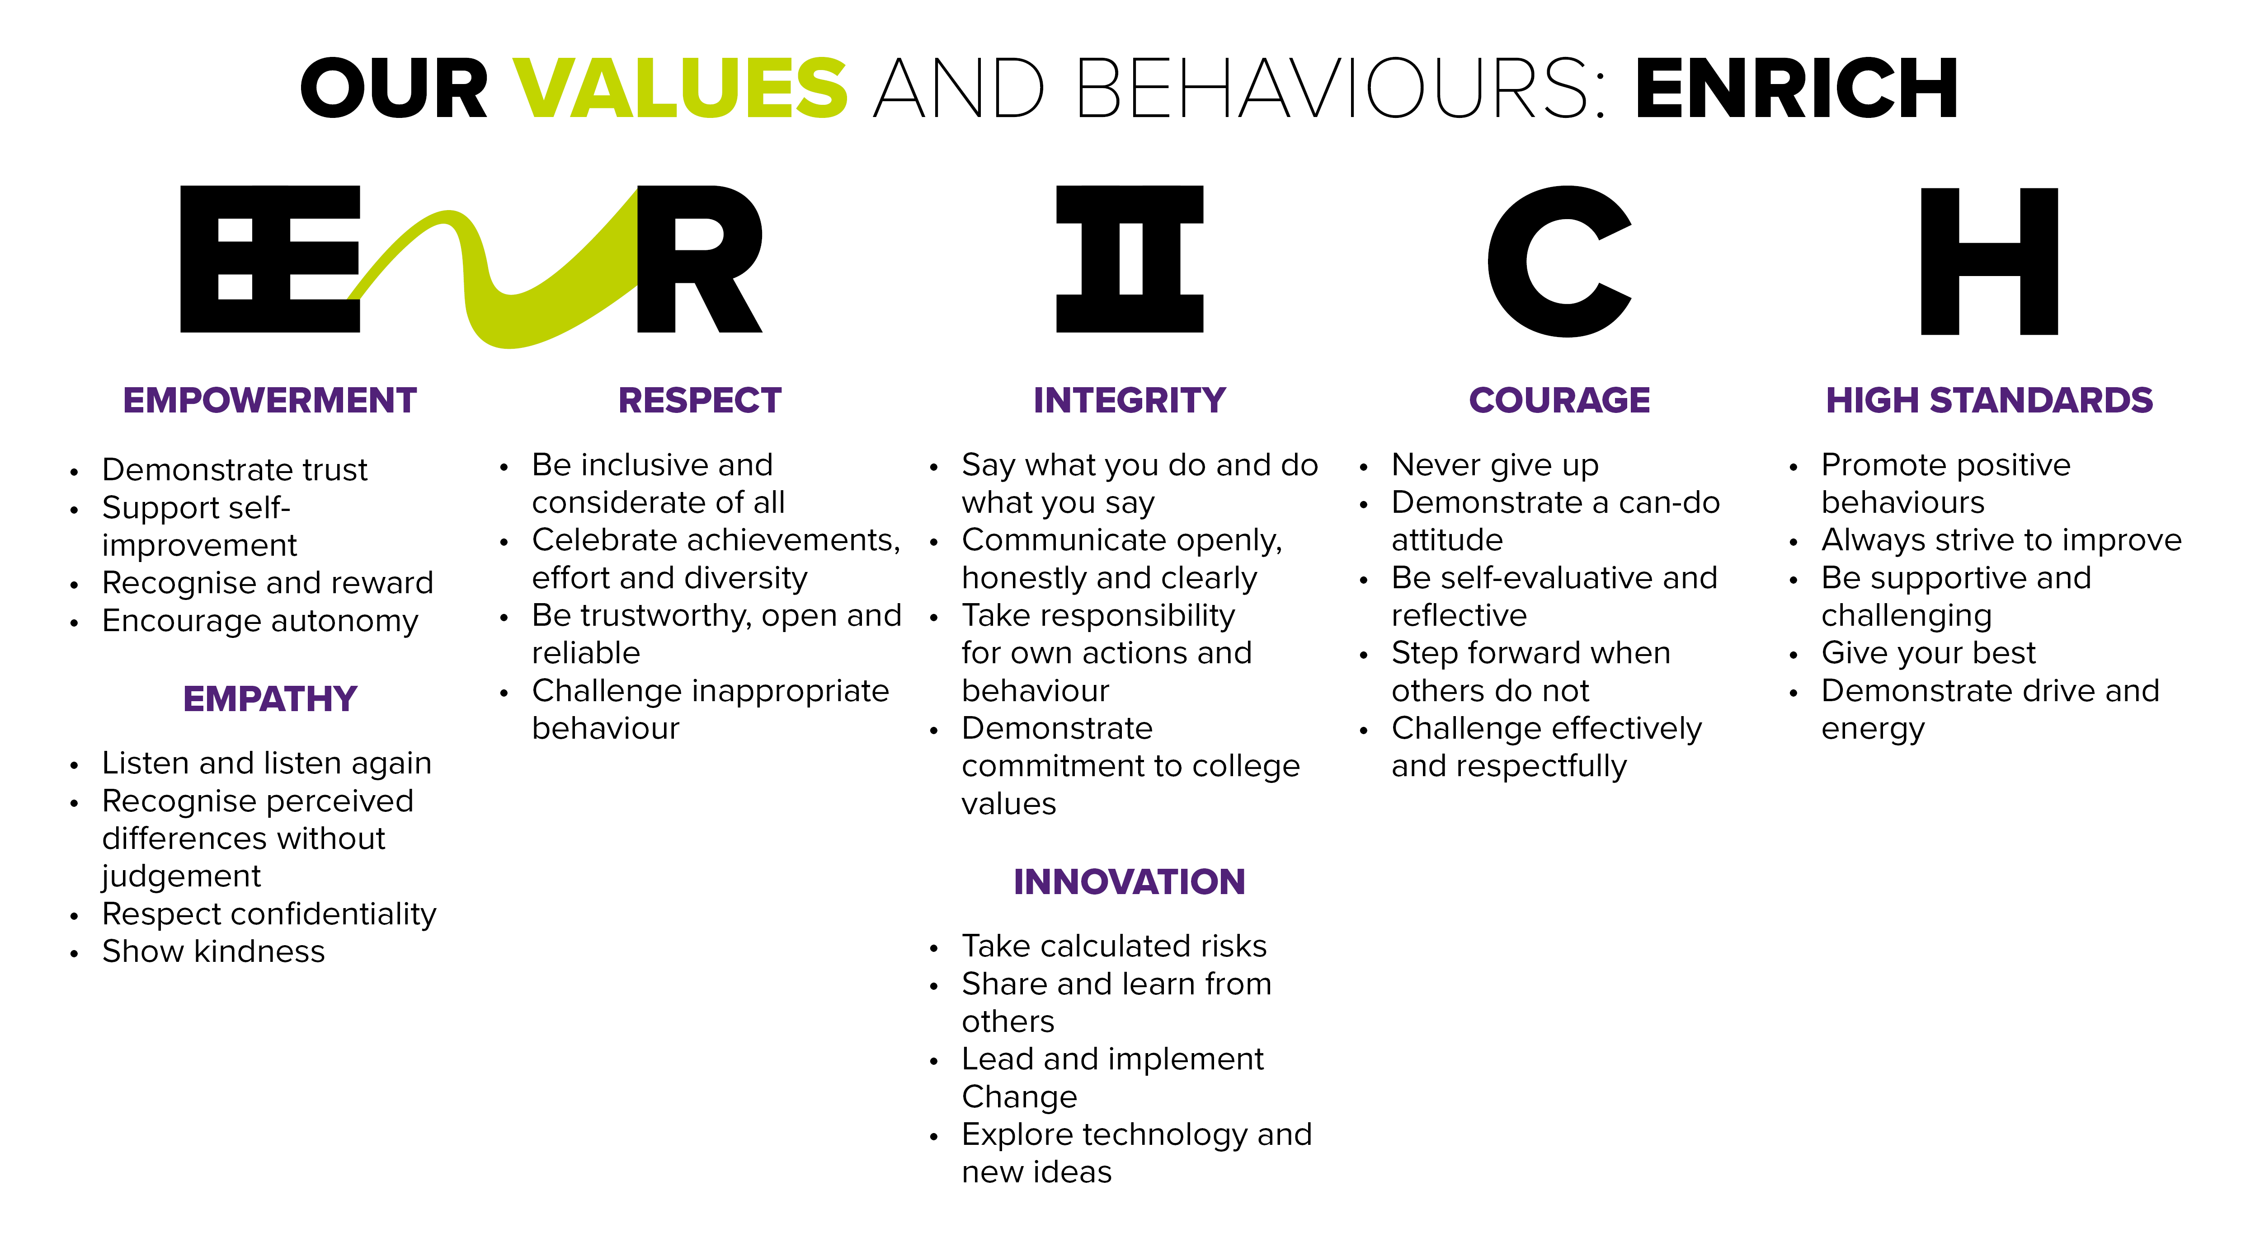

We are looking for an experienced and successful Head of Finance who can demonstrate a commitment to excellence and quality to help us build on our success and make a major contribution to the college as it enters an exciting period of redevelopment.

The college has invested in high quality facilities including a £9million new building which opened in January 2017 and a recently refurbished management hub area where the finance team are located. We offer excellent teaching and support within a strong sense of community.

NewVIc is a forward-looking organisation which values all its staff and working here will give you the opportunity to develop your career and expertise in a successful and innovative student-focused setting.

A full job description for this post is attached to give.

Closing date: | 12 noon 3 November 2020
Vacancy ID: | MP/03
Application process: | To apply for this vacancy please complete the application form available from www.fejobs.com or https://www.newvic.ac.uk/jobs. Applications can be submitted on-line emailed to jobs@newvic.ac.uk

Candidates are shortlisted on the basis of their written application and the extent to which they meet the standard criteria. You are advised to ensure that you use your supporting statement to indicate the extent to which you meet each of the criteria in the person specification below.
Longlisted candidates will be invited in for a selection day. This is likely to include a briefing, a written assessment, a practical test, group activities and an interview by students. After this range of activities has been completed there will be a shortlisting process and selected candidates will have a formal interview with senior managers and one or more representatives from the governing body.

Job Description for Head of Finance
Reports to: | Vice Principal Finance and Operations
Responsible for: | Finance team and any other staff allocated to support Finance, such as temporary staff, apprentices etc.
Main Purpose:  Main Activities:  Procedures:  General Finances:  Budgeting & Reporting:  Auditing:  General: | The Head of Finance is a key member of the college’s resources team, led by the Vice Principal Finance and Operations. The chief responsibilities associated with this post are Financial management and financial systems. The Head of Finance will ensure that NewVIc’s financial strategy (revenue and capital) is effective and ensure effective communications between the finance team and all other areas of the college. Responsibility for procurement and ensuring value for money.  The post-holder will have responsibility for Drafting the college statutory accounts, including those for any college subsidiaries (none at present). In order to fulfil the requirements of this role the post-holder will be required to hold a recognised accountancy qualification and have had direct experience of and responsibility for managing significant accounts of a sizeable organisation. A good working knowledge of further education would be desirable but not essential. The post-holder will be required to prepare and present monthly management accounts to CMT and to prepare the accounts and associated reports for the college corporation on a regular basis. The post is also a key contact for the statutory auditors and internal audit.  - to be responsible for the operational management of the finance functions of the college and contribute towards the successful delivery of the strategic plan while safeguarding the college’s financial health  - to prepare and present monthly management accounts and annual statutory accounts and to input into, and advise on, the planning and budget-setting process  - to produce an annual plan with performance measures and targets and report on these as required  - to work with managers to ensure cost-effective and efficient college services  - to be responsible for the preparation of the college’s annual published financial statements working with the vice principal, presenting them to the external auditors and liaising with the auditors throughout the year as required  - To supervise all College contracts to ensure they comply with best practice and are in line with the financial regulations.  - to provide advice on banking, investments and financial strategies  - to actively participate in the college and with management teams to ensure that the financial perspective is properly represented in all initiatives and decisions  - to regularly review current procedures and controls and re-draft as appropriate given changing legislation, best practice and organisational objectives  - to regularly review the college’s use of financial systems/software and ensure that these are fit for purpose  - to ensure compliance with the financial procedures and regulations by the finance team and other staff  - To create, manage and monitor a finance helpdesk with serve level agreement targets  - Manage the procurement process and ensuring value for money is obtained and all procedures are complied with and reported on a regular basis to SMT.  - Ensure the contracts register is accurate and up to date  - To be a member of all relevant procurement groups in the sector relating to this area and to keep relevant staff up to date.  - to ensure that all payments to suppliers are made in a timely fashion for goods and services that have been received  - to ensure all funds due to the college are received in a timely manner and accounted for correctly  - to ensure value for money is obtained when the college makes purchases, in accordance with procedures  - to ensure that all appropriate project funding returns are completed promptly and accurately  - to ensure that all financial records of the college are accurate and up to date  - ensure that the fixed assets data base is kept up to date and depreciation is calculated accurately  - To ensure the retention of all financial documents is in line with recommended /college Guidance  - to prepare the draft annual budget and the three-year financial forecast in conjunction with the Vice Principal Finance and Operations and SLT  - to prepare and disseminate monthly management accounts within the agreed timetable  - to work with the Vice principal to prepare annual financial statements and the college’s annual budget, cash flow forecast and other financial plans  - to prepare and disseminate other monthly budget reports as required  - to ensure all payroll returns are submitted on time  - to ensure all other statutory financial returns are submitted on time  - to prepare any necessary papers for college committees as required  - to act as a contact for, and liaise with, external auditors and ensure financial statements and the Teachers’ Pension Fund annual return are signed off by the due date  - to act as a contact for, and liaise with, the internal auditors on all areas relating to financial control and procedures  - to ensure audit processes are managed effectively and involve other managers and staff as appropriate  - to advise senior managers of issues of risk which are identified through audits or in any other way  - to attend Governing Body Sub Committees where necessary  - to be responsible for the costing and budgeting of projects, liaising with college managers on the production of project proposals and dealing with funding bodies and the production of reports on projects as required  - to prepare, monitor and report on the financial aspects of all major projects, working with project managers and other consultants as directed and attending ad hoc project management groups as required  - to develop and maintain a detailed knowledge of all necessary accounting standards and requirements and to be the College lead on all technical accounting matters  - to work flexibly according to the demands of the service and to perform such other duties, within the competence of the post-holder, which may reasonably be required from time to time, including work out of normal hours

Person Specification for Head of Finance
You are advised to use your supporting statement to indicate the extent to which you meet each of these criteria.
- – these requirements will be tested at the interview and assessment stage
Experience:
- Qualified accountant (ACA, ACMA, ACCA,CIMA or CIPFA)
- Demonstrable accounting knowledge and experience
- Audit experience (either as an auditor or someone who has experience of the requirements of auditors)
- Working in collaboration and partnership with a wide range of stakeholders
- Management of substantial and complex budgets including build finance and the implementation of rigorous control procedures
- Knowledge and understanding of financial systems
- Experience in multi-function finance office
- Previous experience of financial system implementation
- Knowledge/experience of the further education sector (desirable)

Practical Skills: | - Good verbal and written communication skills with a range of colleagues and stakeholders(I)  - High level of ICT skills and experience (I)  - Able to manage tight deadlines and agreed policies and standards  - Ability to lead and participate in teams efficiently (I)
Personal Qualities & Attributes:  Attitudes | - Flexible and creative in approach and ideas (I)  - Strong leadership and management skills (I)  - Organised, accurate and able to work with minimum supervision (I)  - Commitment to the objective of the organisation (I)  - Commitment to NewVIc’s values  - Commitment to NewVIc values  - Commitment to high quality post-16 education and training  - Commitment to equality and diversity

Other Information

Health and Safety - all employees must comply with the requirements of the Health and Safety at Work Act 1974 and affiliated regulations. Employees are also required to comply with the college’s Health and Safety Policies and take reasonable care for the health and safety of themselves and of other persons who may be affected by their acts or omissions. Where the college has a statutory duty with regard to health and safety employees are required to co-operate with the college and its managers and officers so far as is necessary to enable the college to meet that duty. This includes using equipment and substances in accordance with training and instruction and the reporting of serious dangers to your own or others’ safety.

The College operates a smoke-free policy and the post-holder is prohibited from smoking in any of the College's buildings, enclosed spaces within the buildings, and College vehicles. Staff will not be released for a break that is specifically for smoking.

Equality – the postholder must be committed to the college’s Equality and Diversity Policy and advancing equality through our Equality Objectives.

Performance – the postholder will be required to participate in performance reviews and undertake a plan of training where necessary.

You will be entitled to 35 days’ annual leave per annum plus 3 additional days allocated at Christmas.

NewVIc supports the professional development of its staff. The strong team culture in the college provides a stimulating environment in which to develop your skills. Development needs are discussed during the appraisal process and there is a generous budget for staff development requests that support team and college objectives.

There is an induction programme for new staff.

Confirmation of appointment is subject to a satisfactory 10 month probation period.

The post holder will be required to adhere to College policies and procedures.

This post is eligible for membership of the Local Government Pension Scheme (LGPS).

In addition to the responsibilities listed above, all employees must be adaptable in their approach and undertake other duties that are commensurate with postholder’s level, wherever they may be, to achieve the objectives of the College.

This post is based at Prince Regent Lane but the postholder may be required to visit other establishments or move their base to any other location within the college at a future date.

The post holder will be required to have a clearance from the Disclosure and Barring Services. Criminal convictions will only be taken into account when they are relevant to the post.

We are committed to safeguarding and promoting the welfare of children and young people and expect all staff to share this commitment and participate in statutory training.

- Useful websites:

NewVIc
www.newvic.ac.uk
The college’s own website.

Newham Council
www.newham.gov.uk
The website of Newham Council.

www.london.gov.uk
The website for the Government Office for London.

