Job Description Learning Support Assistant (ALS)

Job Title | Learning Support Assistant (ALS)
Department | SEND & ALS
Reports to | Head of ALS
Grade | Business Support 4.18 - 21
Contract | Permanent
Location | One of the College centres, as appropriate to areas of responsibility of the post

Our Vision & Values
“To develop the skills, confidence and qualifications for local people to lead rich lives and build great careers.“

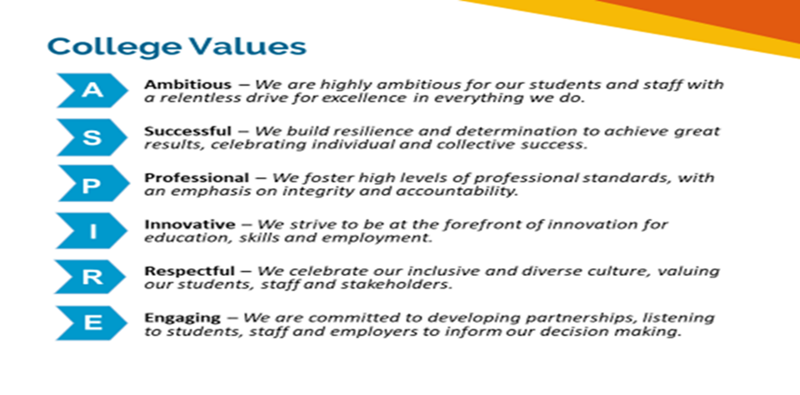

Equality of Opportunity
The college has a strong commitment to working towards the implementation of equality of opportunity in both service delivery and employment. The College's mission and strategic objectives directly support this aim. All employees are required to actively support the development, dissemination and implementation of this aim and related policies and programmes.

Safeguarding of Children and Vulnerable Adults
The College is committed to safeguarding and promotes the welfare of all learners and expects its staff to share this commitment. In addition, they will also state that the College is committed to safeguarding and promotes the welfare of all learners and expects its staff to share this commitment. All posts in the College are subject to an Enhanced DBS check and barred person’s list check.

Description
Job Purpose

Work under the direction and supervision of managers and teaching staff to provide high quality and appropriately targeted support to learners with learning difficulties and or physical disabilities to facilitate their independence, their access to learning and their integration into the college community.

Key Duties and Responsibilities

- To work as part of the ALS Team to provide learning support to young people and adults on mainstream courses. Support may be delivered on a 1:1, small group basis within the classroom, community, or workshop environment under the direction of ALS Tutors and/or course teachers
- Adopt an innovative and creative approach to support learners, employ strategies to empower, promote independent learning and encourage aspirational attitudes to learning
- Collect, record, and analyse data related to learners’ progress as instructed by ALS Tutors and Coordinator
- To invigilate internal and external tests and examinations under formal conditions
- To maintain professional relationships with learners, parents or carers and staff
- Keep records of support provided as directed by the ALS management team.
- Respond appropriately to requests from learners for support in the learning process to maximise their skills, abilities. potential and independence.
- Support the physical, intellectual, emotional, and social development of learners, including contributing ideas and suggestions to support planning, to meet their development needs.
- Asist with behaviour management in and out of the classroom with support from the teaching team, curriculum team and ALS management team.
- Provide personal care support in line with the college policy and guidelines. This may include support with toileting, support at break times and administration of medication.
- Supervise and support community-based learning and educational visits as required.
- Assist those with physical mobility problems to navigate the building, move from site to site and participate fully in off site visits safely.
- Contact home or other external agencies as directed by managers or teaching staff.
- Support learners in a social context through encouragement, listening and talking.
- Attend LSA, course, directorate, College wide meetings and CPD sessions.
- Follow risk assessments and emergency procedures which are in line with college policy.

Person Specification: Learning Support Work (SEND)

Qualifications | Essential | Desirable
Minimum of Level 2 literacy and numeracy (GCSE Grade C/4)
IT skills sufficient to support learners and to develop learning resources

Experience, Knowledge and Skills | Essential | Desirable
Significant recent experience of supporting learners with SEND or ALS needs
Experience of a range of specific learning disabilities and additional needs
The experience/ interest or relevant qualification to support in vocational contexts e.g. IT, Health and social care, hair and beauty etc
Experience of managing complex behaviour and the emotional and physical resilience to work with learners who display behaviours that challenge
The willingness and skill to undertake direct personal care tasks as required, including using a hoist
To have a flexible approach in order to support learners according to their EHCP or support plan
An understanding of health and safety requirements of a working environment.
Demonstrate an understanding of Child and Vulnerable Adult protection (Safeguarding Agenda) and the willingness to increase knowledge.
Good standard of written/verbal communication skills
Good interpersonal skills and the ability to communicate effectively with colleagues, students, parents/carers, and external agencies
Self-starter, well-motivated, reliable and enthusiastic with a successful track record in continuous personal development in issues related to SEND

Other qualities | Essential | Desirable
A satisfactory DBS disclosure at Enhanced level.
Demonstrable commitment to the College’s vision and values.

The above list of responsibilities is not exhaustive, and the jobholder may be required to undertake other duties commensurate with the level of the role, as reasonably requested by their line manager.
This job description accurately reflects the duties and responsibilities of the role at the time the job description was written. These duties and responsibilities may change over time without significantly impacting on the character of the role, the overall level of responsibility, or its grade.
Depending on strategic or operational needs, the jobholder may in the future be required to work for another existing or new organisational unit and/or at different sites within Newham College. This may be on a temporary or indefinite basis and may involve a change in line management and / or regularly working at more than one site.

