|  |
| --- |
| **Job Description – SEMH Mentor** |

|  |  |
| --- | --- |
| **Job Title** | **Social, Emotional, Mental Health (SEMH) Mentor** |
| **Department** | **SEND & ALS** |
| **Reports to** | **Director of SEND & ALS** |
| **Grade** |  |
| **Contract** | **36 hours per week, Permanent** |
| **Location** | **One of the College centres, as appropriate to areas of responsibility of the post** |

|  |
| --- |
| **Our Vision & Values** |

***“To develop the skills, confidence and qualifications for local people to lead rich lives and build great careers.“***

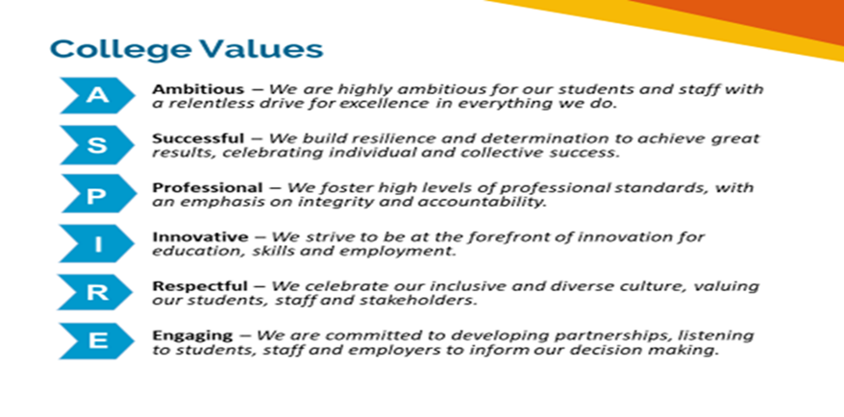

**Equality of Opportunity**

The college has a strong commitment to working towards the implementation of equality of opportunity in both service delivery and employment. The College's mission and strategic objectives directly support this aim. All employees are required to actively support the development, dissemination and implementation of this aim and related policies and programmes.

**Safeguarding of Children and Vulnerable Adults**

The College is committed to safeguarding and promotes the welfare of all learners and expects its staff to share this commitment. In addition, they will also state that the College is committed to safeguarding and promotes the welfare of all learners and expects its staff to share this commitment. All posts in the College are subject to an Enhanced DBS check and barred person’s list check.

**Description**

|  |
| --- |
| **Job Purpose** |

To provide a service to teaching and other staff to address the needs of learners with SEND across college who need help to overcome barriers to learning both in and outside of the classroom.

To work with a range of learners but to give priority to those who have EHCPs in mainstream and Foundation Learning provision who require the most support with their social emotional and mental health needs.

To target, help and support as part of a coordinated response by the college and other agencies to address a range of issues and bring about a positive sustainable change with individual learners and the wider college community.

To support identified individuals on a weekly basis with strategies to develop their emotional resilience and ability to engage with learning.

Support College initiatives and aspirations to achieve Net Zero carbon.

|  |
| --- |
| **Key Duties and Responsibilities** |

1. To support teachers, LSAs, learners and families with issues relating to behaviour and emotional regulation for learners with SEND
2. To attend incidents involving and disciplinaries in relation to learners with SEND and to support with appropriate strategies
3. Support investigations into incidents involving learners with SEND cross college as required. Plan interventions as directed by the SEND and ALS leadership team.
4. Maintain a high degree of confidentiality with regards to student issues.
5. Work on a caseload of learners as identified by EHCPs as requiring SEMH support or those who are referred via the ALS team.
6. To work in partnership with the SEND and ALS team and HoS cross college to create and implement person centred, clear positive behaviour plans, behaviour contracts and other supporting systems.
7. To develop and deliver a 1:1 mentoring schedule for learners who require weekly interventions as advised by the Heads of SEND and ALS.
8. To develop a knowledge and appreciation of the range of programmes, activities, courses, opportunities, organisations, and individuals that could be drawn upon to provide extra support for identified learners.
9. To contribute feedback around progress to the HoS, the learner, families, teachers, and other professionals, at key points and to be used in annual review meetings and progress reviews.,
10. To use e-tracker and espirALS to record interventions and progress for learners supported.
11. To work closely with the safeguarding team
12. Promote the college’s policies on behaviour whilst advocating for learners with SEND to ensure reasonable adjustments are made in line with the SEND code of practice
13. Deliver a range of group activities relating to self-esteem and confidence building as part of the college’s enrichment programme.

|  |
| --- |
| **Person Specification: SEMH (Social Emotional Mental Health) Mentor** |

|  |  |  |
| --- | --- | --- |
| **Qualifications** | **Essential** | **Desirable** |
| To hold a teaching qualification at level 3 or above (AET (PTTLS) or above) |  | ✓ |
| L3 (or above) qualification in Behaviour management/SEMH or similar | ✓ |  |
| Minimum of Level 2 literacy and numeracy (GCSE Grade C/4) | ✓ |  |
| Qualification in specific learning disabilities |  | ✓ |

|  |  |  |
| --- | --- | --- |
| **Experience, Knowledge, and Skills** | **Essential** | **Desirable** |
| Relevant, recent experience of supporting learners who display behaviour that challenges or who require support with their emotional regulation. | ✓ |  |
| Successful recent experience of working with and supporting learners with special educational needs and disabilities | ✓ |  |
| The ability to engage with and quickly establish positive working relationships with a wide range of people including colleagues, students, parents/carers, and external agencies, including circumstances where communication is non-verbal | ✓ |  |
| The ability to manage difficult situations and conversations with sensitivity, confidentiality and discretion. |  |  |
| The ability to maintain a non-confrontational approach in the face of behaviour that challenges | ✓ |  |
| The ability to be a good role model to learners – demonstrating and promoting positive values attitudes and behaviour. | ✓ |  |
| Good standard of written/verbal communication skills | ✓ |  |
| Self-starter, well-motivated, flexible, and enthusiastic with a successful track record in continuous personal development in issues related to SEND | ✓ |  |
| Experience of contributing to positive behaviour plans, behaviour contracts and ILPs | ✓ |  |
| Experience of 1:1 mentoring with learners with SEND or mental health needs | ✓ |  |
| Experience and willingness to deliver enrichment activities relating to social, emotional, and mental health wellbeing to groups of learners with SEND | ✓ |  |
| An understanding of the Further Education landscape and the organisation of post 16 education | ✓ |  |
| Demonstrate an understanding of Child and Vulnerable Adult protection (Safeguarding Agenda) and the willingness to increase knowledge. | ✓ |  |