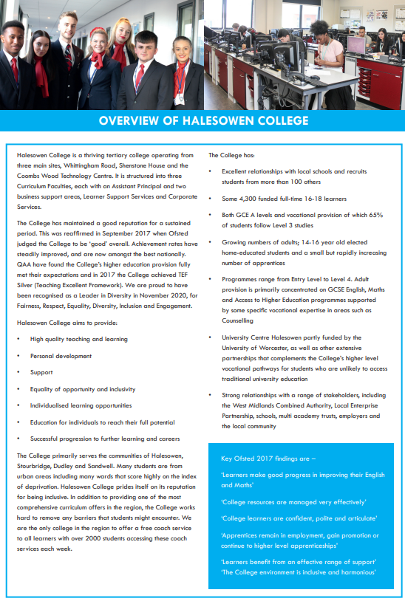



# Lecturer in Social Sciences/Sociology

### Job Description

|  |  |
| --- | --- |
| **Line Manager:** | Head of Division |
| **Contacts:** | College Staff, Students, General Public, College Stakeholders |
| **Job Purpose:** | Teaching staff are appointed within teams delivering programmes of study within various curriculum areas. |
| **Hours:** | 35 hours per week. Occasional extra hours and weekend work may be required, for which time off in lieu is given. Staff are expected to support College events outside of core business hours. |
| **Salary:** | £23,222 pa - £37,443 pa [Pay Spine Points 18-29]  [pro rata for fractional posts] |
| **Annual Leave:** | The leave year runs from 1 September to 31 August  Teaching: 40 days annual leave and 8 Bank Holidays |
| **Pension:** | Teachers’ Pension Scheme and our employer contribution is 23.68%  Employee contributions depend on your annual salary see:  <https://www.teacherspensions.co.uk/members/member-hub.aspx> |
| **Benefits:** | <https://jobs.halesowen.ac.uk/index.cfm?action=content&content=1> |

***The Lecturer will be responsible for:***

* 1. The delivery of subjects at a range of levels to a range of learners
  2. The production of a scheme of work for each area of teaching and a group profile.
  3. The production of suitable and sufficient course material for effective delivery of the curriculum.
  4. The delivery of pastoral support for a group of learners

***Key Tasks and Responsibilities:***

1. Be a member of the course team, attend regular course team meetings and work with the Course Leaders, Pastoral Heads and Heads of Division in achieving the desired outcomes.
2. Act as a Progress Coach to nominated groups or individual students.
3. Plan, prepare, deliver, and review lessons and other activities to ensure the effective

progress of students.

1. Develop resources and materials which meet the needs of all students.
2. Employ a variety of teaching, learning and assessment methods which encourage students to take responsibility for their own learning.
3. Work alongside Course and Subject Leaders to ensure the correct units are included, correct student enrolments are made, tracking and monitoring of key areas (assessment plans, retention, pass and achievement rates) throughout the academic year and complete all assessment and review points.
4. Work alongside Course and Subject Leaders to ensure correct registrations and entries are made via Registry and Exams.
5. Use appropriate technology to support learning.
6. Set regular and relevant homework, tests, and assignments to support and consolidate learning and provide timely feedback on these.
7. Complete registers accurately and maintain clear records of students’ achievement.
8. Produce reports and summaries in line with college policy and procedures.
9. Where directed to, arrange enrichment opportunities for learners.
10. To take an active role in staff development and continual professional updating.
11. Maintain appropriate standards of student behaviour within the learning environment, College campus and in online lessons, with recognition of positive student behaviour and progress.
12. Develop and maintain links with colleagues and outside bodies relevant to the needs of the curriculum.
13. Follow College policy and procedures including Staff Code of Conduct, Safeguarding Policy, Health and Safety Policy and Procedures.
14. Participate in careers guidance and the recruitment and enrolment of students, and attend Open Days, Advice Days and Parents’ Evenings.
15. Any other duties which may from time to time be required and which are commensurate with the level of this post.

**Under DBS legislation and guidelines this is a regulated activity.**

Any other duties, which may from time to time, be required and which are commensurate with the skills experience and grade of the post holder.

**Data Protection**

You are required to meet the specifications of the College’s Data Protection Policy as part of your conditions of employment. This will include information relating to past and prospective employees and students, suppliers and customers.

**Harassment and Discrimination**

You have a duty not to discriminate against or harass colleagues, contractors, students, parents, guardians or potential students or other College visitors, by reason of their age, sex, sexual orientation, gender re-assignment, marriage and civil partnership, pregnancy or maternity, race, disability or religion and belief.

**Safeguarding and Staff Code of Conduct**

You have a duty to abide by the Staff Code of Conduct and Safeguarding Policy.

**Health and Safety**

The College and its employees have legal obligations in respect of the health, safety and welfare of persons at work and the protection of others against risks to health and safety in connection with their activities. Specific health and safety responsibilities are detailed in the College Health and Safety Policy.

Other information for job holders/applicants:

**Disclosure and Barring Service Check**

This post, due to its nature, duties and responsibilities, will be subject to a check by the DBS. The level of check which will apply shall be an “Enhanced” level check.  Information about this disclosure can be found at [www.gov.uk](http://www.gov.uk).

To prevent abuse and implement good practice Halesowen College ensures that recruitment practices are robust and rigorous and that all staff employed have up to date and acceptable references, a full and complete employment history, an Enhanced DBS check and a check of the DBS barred lists.

**Safeguarding**   
Halesowen College is committed to safeguarding and promoting the welfare of young people and vulnerable adults and expects all staff and volunteers to share this commitment.  
Successful applicants will be subject to an enhanced Disclosure and Barring check.

**Equality and Diversity**

Halesowen College is proud of its work in embedding equality and diversity principles in its activities and welcomes applications from all suitably qualified people, irrespective of age, sex, gender reassignment, marital or civil partnership status, disability, race, ethnic or national origin, religion or beliefs, sexual orientation, unrelated criminal convictions or family responsibilities.

We welcome all sections of the community and value the contributions to the achievement of the College’s mission that are made by members of the College from a wide range of backgrounds and experiences. All staff must demonstrate an awareness of equality and diversity principles, as set out in College policies that includes **F**airness, **R**espect, **E**quality, **D**iversity, **I**nclusion and **E**ngagement. It is expected that all members of staff on appointment are committed to and include these principles in their work.

More information on our Equality and Diversity policy can be found at <https://www.halesowen.ac.uk/about/equality-diversity/>

**Childcare Facilities**

There is a day Nursery on the Whittingham Road campus for babies from 12 weeks and children aged 2 to 5 years. It is open 8.00 am to 5.30 pm Monday to Thursday and 8.30 am to 5.00 pm Friday. Further details are available from the Nursery staff on 0121 602 7677.

It is registered at present for 29 children in the early year’s age range. The baby room caters for 9 babies.

**Information Technology**

The College has approximately 2,600 computers across its sites including PCs, laptops, netbooks and Macs running a range of industry standard software. Equipment is available for long and short term loans, and guest access to our wireless network is provided for personal devices. We also run a PC booking system to ensure you can get access to a computer when you need it. A wide range of classroom technologies are in place such as the Moodle Virtual Learning Environment, cameras, voting devices and interactive whiteboards/data projectors.

All staff and students are given a personal computer account with access to email and storage which is available on and off site.

**Smoking**

Halesowen College is a designated smoke-free environment within the perimeter of all College property by order of the College Governors. This rule applies equally to staff and students, and to all categories of visitor. Acceptance of this rule is a condition of employment for staff, and a condition of being a student for students.

**Campus**

The College has three sites, Whittingham Road, Shenstone House and Coombs Wood. Staff can be asked to be based at and/or work across all campuses.

**Note: This job description is current at the time of issue. It should be recognised that, in keeping with organisational changes and developments, it may be necessary to review the duties listed from time to time and change them to meet organisational objectives.**

