Team: | English, Social Sciences & Humanities.
Salary: | Scale T1-T9 £29,665.00 to £45,827.00 per annum (depending on experience and pro rata for part-time)
Job Summary: | Newham Sixth Form College (NewVIc) is London’s largest sixth form college. It is a vibrant centre for sixth form education with the great majority of students coming from our local schools in Newham.  NewVIc’s mission: Enhancing lives through excellent education and learning.  NewVIc’s vision: The first choice college for enhancing the lives of students in partnership with parents, employers, and community.  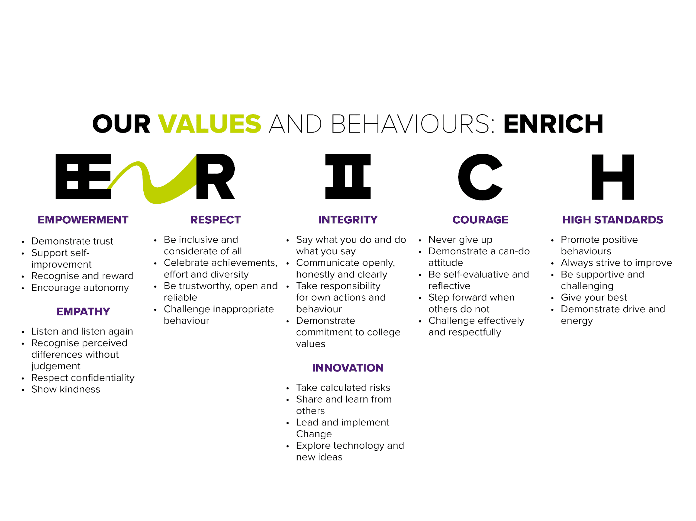  We have an exciting vacancy for a teacher of History (0.7 fte). The successful candidate will be involved in teaching a variety of GCSE and A level History programmes at the College and will be working with a vibrant team of Humanities subject teachers to create an excellent teaching and learning experience for all students studying History at the College.  At NewVIc we strongly believe in team working and see this as one of the reasons for our success. You will work in a supportive team who aim for high standards. Managers will give you guidance and support in your work, while the Head of Curriculum for Social Sciences, Humanities and English will take specific responsibility for your probationary review and appraisal.  You will work well with 16-19 year olds and contribute to a student-centred environment both inside and outside of the classroom. As a teacher, you will be innovative and reflective, with a genuine interest in young people and how they learn.  To teach at NewVIc you will be committed to supporting students in achieving success and have a strong belief in team-working.
Closing date:  Vacancy ID: | 12 noon on 18 May 2021  TP/26
Application process: | Candidates are longlisted on the basis of their written application and the extent to which they meet the standard criteria. You are advised to ensure that you use your supporting statement to indicate the extent to which you meet each of the criteria in the person specification below.  The selection day usually starts with a briefing on the post and the college. You will also be asked to complete a short written activity and micro-teaching.  Longlisted applicants for teaching posts are usually asked to carry out an observed micro-teaching session of 20 minutes, typically with a group of 6-8 students. Candidates will be informed of the topic for the micro-teaching at the point of being invited in for the selection day.  Following these activities, the selection panel decides which candidates to take through to interview, usually on the afternoon of the same day.
Application Form: | For further details, or for an application pack, please visit https://www.newvic.ac.uk/jobs or email jobs@newvic.ac.uk.

Job Description Teacher of History

Reports to: | Head of Curriculum for Social Sciences, Humanities and English
Main Purpose & Activities: | As a teacher:  - To contribute to the work of the programme team.  - To prepare and maintain schemes of work.  - To prepare students for internal and external assessment.  - To mark and moderate students' work.  - To provide a stimulating learning environment for students.  - To write reports.  - To maintain students' records.  - To provide consultation for students, their parents, adults and other clients as directed.  - To take part in programme reviews and evaluation.  - To take part in programme and other curriculum development.  - To develop and implement teaching and learning strategies in line with college policy.  - To cover for colleagues as required.  - To observe the requirements of college policy in respect of:  - The mission statement  - Health and safety  - Equality and diversity  - Student discipline  - To monitor the use of equipment and materials.  College responsibilities  - To act as personal tutor to a group of students if required.  - To represent the college at meetings as directed.  - To work with colleagues in support of college policies and initiatives.  - To participate in the college appraisal process.  - To participate in inspections and self-assessment.  Teachers may be required to work up to two evenings per week.  Note: where this is the case, timetables will include equivalent time off during the day.
Other Information

Health and Safety - all employees must comply with the requirements of the Health and Safety at Work Act 1974 and affiliated regulations. Employees are also required to comply with the college’s Health and Safety Policies and take reasonable care for the health and safety of themselves and of other persons who may be affected by their acts or omissions. Where the college has a statutory duty with regard to health and safety employees are required to co-operate with the college and its managers and officers so far as is necessary to enable the college to meet that duty. This includes using equipment and substances in accordance with training and instruction and the reporting of serious dangers to your own or others’ safety.

Equality – the postholder must be committed to the college’s Equality and Diversity Policy and advancing equality through our Equality Objectives.

Performance – the postholder will be required to participate in performance reviews and undertake a plan of training where necessary.

Confirmation of appointment is subject to a satisfactory 10 month probation period.

The post holder will be required to adhere to college policies and procedures.

In addition to the responsibilities listed above, all employees must be adaptable in their approach and undertake other duties that are commensurate with postholder’s level, wherever they may be, to achieve the objectives of the college.

This post is based at Prince Regent Lane but the postholder may be required to move their base to any other location within the college at a future date.

The postholder may be required to work for 195 days in any year of which 190 will be days on which you may be required to teach in addition to carrying out other duties. Within these 195 days, up to 1265 hours a year will be allocated reasonably to you by the Principal. (Pro rata for fractional appointments.)

Within the 1265 hours you may be required to teach for up to 6 hours over two evenings per week. In addition, you will work such additional hours as may be needed to enable you to discharge your duties effectively including, in particular, the marking of students' work, the writing of reports on students and the preparation of lessons, teaching material and teaching programmes.

The post holder will be asked to complete a criminal records self-declaration form. Criminal convictions will only be taken into account when they are relevant to the post.

We are committed to safeguarding and promotingg the welfare of children and young people and expect all staff to share this
commitment and participate in statutory training.

- Useful websites:

NewVIc
www.newvic.ac.uk
The college’s own website.

Newham Council
www.newham.gov.uk
The website of Newham Council.

https://www.gov.uk/
The website for Government services and information

The 2018 Ofsted inspection report on NewVIc
www.newvic.ac.uk/statutory-information

Person Specification Teacher of History
This is the core person specification for all standard scale teachers at NewVIc.
You are advised to use your supporting statement to indicate the extent to which you meet each of these criteria.
Commitment to:
- The college mission: being a successful learning community
- Inclusion, equality & diversity (and specifically the implementation of the college’s Equality and Diversity Policy)

Knowledge and understanding of:
- Current developments in vocational and academic education and training
- The relevant curriculum area in the industrial/commercial sector where appropriate

Skills and abilities in
- Teaching on a range of programmes
- A range of teaching and learning strategies, including use of Information Learning Technology
- Working in teams
- Tutoring
- Curriculum development
Attitudes
- Commitment to NewVIc values
- Commitment to high quality post-16 education and training
- Commitment to equality and diversity
Qualification at:
- You are normally expected to have a degree related to your teaching subject, although we acknowledge that teachers may also be qualified for their subject by other relevant experience. It is essential that you are qualified to at least level 4 in a relevant subject.

- We usually appoint only qualified teachers. We will, however, consider applications from candidates who will commit themselves to gaining a recognised teaching qualification within a set time when there are exceptional circumstances, e.g. extensive relevant industry experience.

- A grade C or higher in English and maths GCSE (or equivalent).

In addition, you will be required to hold, or work towards in a specified time, a recognised teaching qualification.

