Job Summary for Head of Management Information Systems – Full-time, 36 hours a week

Team MIS
Salary starting salary is £54,207.00 with progression up to £56,618.00 per annum (Grade M5 – SP 45 to 47)

Job Summary
Newham Sixth Form College (NewVIc) is London’s largest sixth form college. It is a vibrant centre for sixth form education with the great majority of students coming from our local schools in Newham. NewVIc’s mission: Enhancing lives through excellent education and learning. NewVIc’s vision: The first choice college for enhancing the lives of students in partnership with parents, employers, and community.

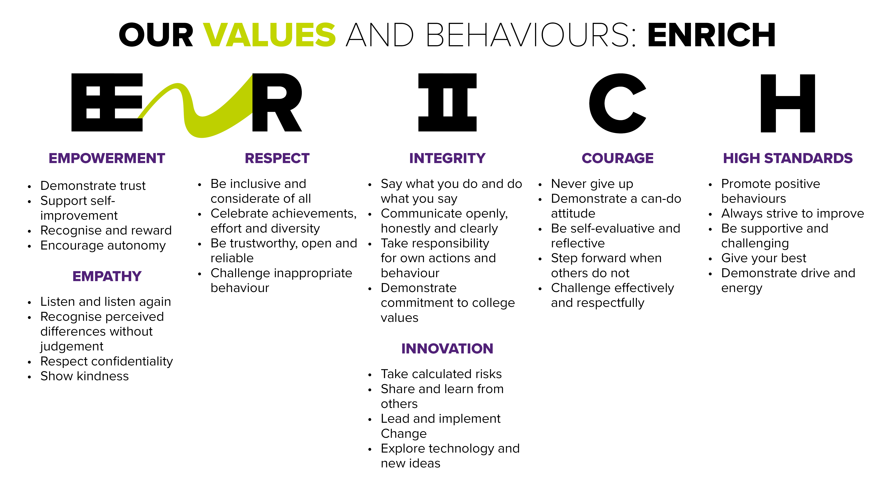
NewVIc is a sixth form college unlike any other. The organisation is focused on providing opportunities for all, and this mission goes beyond the boundaries of sixth form education into provision for adults and services to businesses.

At NewVIc we strongly believe in team working, and see this as one of the reasons for our success.

NewVIc is a forward-looking organisation which values all its staff and working here will give you the opportunity to develop your career and expertise in a successful and innovative student-focused setting.

We are seeking to recruit a Head of Management Information Systems who will work collaboratively as part of the college management team to achieve the college’s strategic and mission objectives. The successful applicant will manage and further develop the college information system to ensure that data required by all stakeholders is produced in a timely and user friendly manner. You will maintain and develop systems and procedures to ensure an efficient and co-ordinated approach to data collection, verification analysis and reporting in support of curriculum and related functions.

Working with our friendly, professional and busy Management Information Services team, this role is pivotal in ensuring that a professional reporting service is readily available, supporting effective and high quality operational functions of the Management Information Services and Examinations teams.

A full job description is attached to give you more information.
Closing date: | 12 noon 2 November 2020
Vacancy ID: | MP/02
Application form: | To apply for this vacancy please complete the application form available from www.fejobs.com or https://www.newvic.ac.uk/jobs. Applications can be submitted on-line emailed to jobs@newvic.ac.uk  Candidates are shortlisted on the basis of their written application and the extent to which they meet the standard criteria. You are advised to ensure that you use your supporting statement to indicate the extent to which you meet each of the criteria in the person specification below.  Longlisted candidates will be invited in for a selection day. This is likely to include a briefing, a written assessment, a practical test, group activities and an interview by students. After this range of activities has been completed there will be a shortlisting process and selected candidates will have a formal interview with senior managers and one or more representatives from the governing body.

Job Description for Head of Management Information Systems

Job Title: Head of Management Information Systems

Reports to: Vice Principal - Finance and Operations

Purpose of the role
To lead and develop the college's College Information Services function, working individually and managing a team to fulfil the functions described below.
Key responsibilities

Leadership
- To manage, support and develop the College Information Services and Exams Team.
- To have accountability for efficient and timely operation of the College Information Services and Exams Team.
- To ensure the Teams are sufficiently resourced and appropriately structured to optimise the delivery of the services required and Effectively communicate the College’s vision, strategy and plans to the CIS team to ensure priorities are aligned and achieved
- To work strategically with the Senior Management Team and other leaders to ensure that information and data reporting is timely, insightful, accurate and supports operational priorities plus improvement goals and in line with the college mission statement
- To work strategically to manage the data requirements of the college for both internal and external stakeholders
- To develop the skills and confidence of team members and employ performance management policies where required
- Deliver sustainability withing the function
- Lead the team by setting clear objectives and targets, regularly monitoring progress and supporting individual development Maintain and develop lines of communications and SLA’s college wide

Reporting
- Maintain and refine the provision of regular and effective data reports providing analytical interpretations of the information provided and develop strategies to deliver improvements
- Use performance evaluation tools and services to support college leaders in the monitoring, interpretation, and management of key performance measures
To develop the ownership and use of data across the college by all teams to enable effective planning, monitoring and improvement
- Ensure that staff teams across the college have access to timely and accurate learner information
- Prepare all relevant information and data to support Ofsted inspections and monitoring visits
- Maintain an up-to-date calendar-format overview of internal and external dependencies implementing function and policy allowing these are met in a timely fashion
- Implement assessment data captures and reports internally, following the college internal assessment calendar
- Prepare and oversee activities linking to college information and data for internal and External Audits with the use of internal reporting, DSATs, FRM and FIS reports
- Oversee parental data access and reports to parents

Data management
- Oversee data processing systems ensuring that systems are in place to ensure that data is processed accurately and in a timely fashion.
- Oversee the security and proper usage of the college's learner data and ensure compliance with the Data Protection Act and other statutory requirements
- Respond to information requests and promoting compliance across the College in line with GDPR and associated legislation.
- Manage and oversee the college's learner information systems and databases (and all other related systems)
- Maintain the quality and accuracy of learner records — ensure they meet funding and audit requirements
- Provide application support to college information system users — including the liaison with teams across college to support their needs and development
- Maintain CIS systems, applying patches and upgrades as necessary and liaising with software providers in the instance of faults
- Develop data strategies and Data warehouse policy

Development
- Work and develop with MS SQL and associated tools to interface with college databases in terms of upload and retrieval of relevant data
- Develop and implement reports using Microsoft SQL Server Reporting Services and other technologies required
- Ensure systems, reports and solutions are fully technically documented and available in a one-stop format.
- Strategic planning and implementation of technical tools to allow for streamlined functionality
- Support managers and curriculum teams by providing pre-populated pro-forma wherever possible for QA processes such as Course Reviews, SARs etc. and advice on ILR, data, audit and funding regimes.
Funding
- Keep up to date with funding guidance and new developments in the education sector and apply changes to data processes and procedures promptly, where needed
- Identify funding key issues or policy changes in order to maximise funding claims by the college — keep SMT and the Director of Finance abreast of any such changes

General
- To work, as needed, with the IT Network Manager in respect of data management network requirements and interfaces.
- To work, as needed, with the Student Services Manager and Team in respect of application / enrolment processes analysing the completeness, accuracy, and appropriateness of the data
- To support effective safeguarding of all young people throughout the college.
- Undertake continuing professional development as appropriate. Take a full part in the College staff development programme including the appraisal process.
- To attend, as necessary, meetings of college leaders / staff.
- To adhere to college policies and procedures e.g. Equality and Diversity, Health and Safety.
- To work occasional unsocial hours including evenings and weekends, with prior arrangements.
- To undertake any such other duties as may be required, commensurate with the post which do not change the character or purpose of the post which are necessary to maintain outstanding standards.

The job description is an outline of the key tasks and responsibilities and is not intended as an exhaustive list. The job may change over time to reflect the changing needs of the College, as well as the personal development needs of the post holder.

PERSON SPECIFICATION FOR HEAD OF MANAGEMENT INFORMATION SYSTEMS
You are advised to use your supporting statement to indicate the extent to which you meet each of these criteria.

REQUIREMENTS | ESSENTIAL | DESIRABLE | WHERE ASSESSED  (e.g. application form/interview)
QUALIFICATIONS | Level 2 Maths and English (at least Grade C) | Higher level management qualification. | A / I
 |  | Degree or equivalent in IT, Business Systems, or similar field. | A / I
KNOWLEDGE | Demonstrate an in-depth knowledge and understanding of the reporting requirements of FE Managers. |  | A / I
 | Demonstrate extensive and up to date understanding of relevant Funding Methodologies. |  | A / I
 | Demonstrate an understanding of developing Key Performance Indicators relevant to the activity of a College. |  | A / I
 | Demonstrate knowledge and understanding of General Data Protection Regulations legislation and compliance. |  | A / I
EXPERIENCE | Proven significant experience of CIS Management in a FE College. | Proven experience of working with Learner Records Systems, preferably Pro-Suite | A / I
 | Proven experience of working at a senior leadership and management level. | Proven familiarity ProMonitor/Mark Book | A / I
 | Proven experience of delivering against CIS related key performance indicators. | Proven experience of presenting information to a range of stakeholders. | A / I
 | Proven experience of liaising with external funding bodies. | Proven experience of working with external examining bodies. | A / I
SKILLS & QUALITIES | Demonstrate advanced level of IT skills (SQL server and report writing tools, MS Office, proprietary software etc.) |  | A / I
 | Demonstrate strong interpersonal skills across all levels of an organisation and with different stakeholders. |  | A / I
 | Demonstrate ability to build strong, motivated, and talented teams. |  | A / I
 | Demonstrate the ability to manage your time effectively across a significant portfolio of work. |  | A / I
 | Demonstrate the ability to be a proactive and innovative problem solver. |  | A / I
 | Demonstrate the ability to communicate effectively both verbally and in writing to a range of audiences. |  | A / I
ATTITUDE | To work flexibly and efficiently whilst maintaining the highest professional standards and to promote and implement the policies of the College. |  | A / I

Other Information

Health and Safety - all employees must comply with the requirements of the Health and Safety at Work Act 1974 and affiliated regulations. Employees are also required to comply with the college’s Health and Safety Policies and take reasonable care for the health and safety of themselves and of other persons who may be affected by their acts or omissions. Where the college has a statutory duty with regard to health and safety employees are required to co-operate with the college and its managers and officers so far as is necessary to enable the college to meet that duty. This includes using equipment and substances in accordance with training and instruction and the reporting of serious dangers to your own or others’ safety.

The College operates a smoke-free policy and the post-holder is prohibited from smoking in any of the College's buildings, enclosed spaces within the buildings, and College vehicles. Staff will not be released for a break that is specifically for smoking.

Equality – the postholder must be committed to the college’s Equality and Diversity Policy and advancing equality through our Equality Objectives.

Performance – the postholder will be required to participate in performance reviews and undertake a plan of training where necessary.

You will be entitled to 35 days’ annual leave per annum plus 3 additional days allocated at Christmas.

NewVIc supports the professional development of its staff. The strong team culture in the college provides a stimulating environment in which to develop your skills. Development needs are discussed during the appraisal process and there is a generous budget for staff development requests that support team and college objectives.

There is an induction programme for new staff.

Confirmation of appointment is subject to a satisfactory 10 month probation period.

The post holder will be required to adhere to College policies and procedures.

This post is eligible for membership of the Teachers’ Pension Scheme (TPS) or the Local Government Pension Scheme (LGPS).

In addition to the responsibilities listed above, all employees must be adaptable in their approach and undertake other duties that are commensurate with postholder’s level, wherever they may be, to achieve the objectives of the College.

This post is based at Prince Regent Lane but the postholder may be required to visit other establishments move their base to any other location within the college at a future date.

We strive for equality throughout the college and positively encourage applications from all sections of the community. The College has a strong commitment to safeguarding and promoting the welfare of young people and expect all staff to share this commitment and participate in statutory training.

All appointments are subject to an enhanced DBS clearance. Criminal convictions will only be taken into account when they are relevant to the post.

Useful websites:

NewVIc
www.newvic.ac.uk
The college’s own website.

Newham Council
www.newham.gov.uk
The website of Newham Council.

www.london.gov.uk
The website for the Government Office for London.

The 2018 Ofsted inspection report on NewVIc
www.newvic.ac.uk/statutory-information

