Job Description

Job Title | ATR357: Talent Acquisition Officer
Department | Human Resources
Reports To | Talent Acquisition Manager
Location | East Ham Campus

Job D
Our Vision

Mission statement
The mission of the College is to develop the skills, confidence, and qualifications for local people to lead rich lives and build great careers.

College values
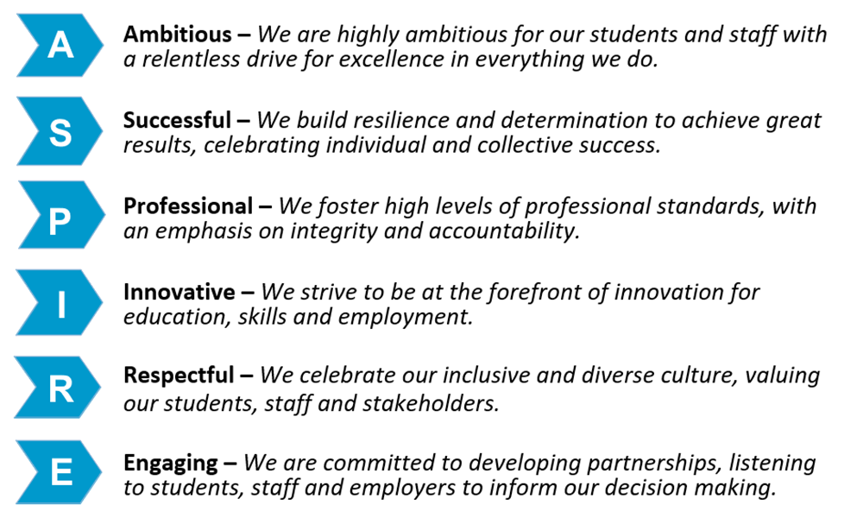
Job Description
Job Purpose
Reporting to the Talent Acquisition Manager, the post holder will provide strong customer focus and support with the co-ordination of the recruitment and selection including effective recruitment, onboarding, and induction. The role is responsible for producing and maintain all HR paperwork / systems that underpins our policies and procedures including processing timely starter information and assisting with correspondence that underpins all other HR policies / procedures.

Key Duties and Responsibilities

Core job duties

- To support the College’s recruitment function working collaboratively with hiring managers and members of the HR team.
- Alongside the Talent Acquisition Manager be the first point of contact for recruitment queries and requests, liaising with internal and external providers.
- To coordinate recruitment activities such as posting job adverts using our preferred suppliers, our website, and the College’s social media platform.
- To ensure that short-listing packs and correspondence associated with recruitment and selection are prepared as required, for example interview invitations, reject letters, reference requests and offer letters etc., delegating to administrative staff as appropriate.

- To progress offers of employment including the completion of pre-employment checks, safer recruitment checks and issue contracts of employment as required as part of the onboarding process.
- To ensure that accurate information relating to new starters is entered onto the HR system and that the Payroll Section is notified by the required deadline.

- To maintain HR manual and computerised records, ensuring that files are up to date so that enquiries can be dealt with promptly.

- Ensure all current and archived paper based and electronic HR files and records, including individual staff files, are maintained, and kept in a well organised system.
- To ensure all recruitment paperwork is completed correctly and in line with GDPR requirements and filed in an efficient and professional manner.
- To work closely with the HR and Payroll colleagues to ensure a seamless experience for new starters.

Additional requirements
- The post holder must demonstrate a flexible approach in the delivery of work. Consequently, the postholder may be required to perform work not specifically identified in the job profile but which is in line with the general level of scope, grade, and responsibilities of the post.
- Ensure continuous professional development (CPD) requirements as specified by the College and that may be identified during college processes, for example Appraisal.
- Carry out the work of the job in a way that is consistent with the culture, ethos, equalities, and inclusion policies of the College.
- To read, understand and apply the College Safeguarding Procedures and ensuring the duties and responsibilities detailed in the College Safeguarding Policy are adhered to and carried out, especially regarding the employment and management of staff.
- Undertake all duties with due regard to the provisions of Health and Safety regulations and legislation, Data Protection/GDPR, the College’s Equal Opportunities policy and Use of ICT policy.
- To support College initiatives and aspirations to achieve net zero carbon emissions.
Person Specification

Qualifications

- Have a minimum of Grade C in English and Maths GCSE level (Level 2) or equivalent.

Experience:

- Experience of working in an administrative role or demonstrate an understanding of this.
- Maintaining administrative systems and procedures to improve a service or demonstrate an understanding of this.
- Working within a recruitment environment and experience of sourcing candidates
- Working on own initiative.
- Experience of having previously worked in a similar environment would be advantageous is desirable but not essential.

Knowledge and Skills:

- Excellent organisational skills.
- Good IT skills - proficient user of Microsoft Office Suite of Packages.
- Excellent interpersonal skills to deal tactfully with a range of clients.
- Ability to work quickly and accurately under pressure.
- Ability to work flexibly as a member of the team.
- Ability to prioritise work to deadlines.
- Forward thinking approach to systems and methodology.

Other
- Must have a keen interest in Talent Acquisition and a desire to learn on the job.
- This post is subject to satisfactory references, enhanced DBS check (Disclosure and Barring Service) and health checks and presentation of original qualification certificates.

