Department: | Quality
Salary: | Starting salary: £55,387.00 with progression up to £60,841.00, scale points L4 – L8
Job Summary: | Newham Sixth Form College (NewVIc) is London’s largest sixth form college. It is a vibrant centre for sixth form education with the great majority of students coming from our local schools in Newham.  NewVIc’s mission: Enhancing lives through excellent education and learning.  NewVIc’s vision: The first choice college for enhancing the lives of students in partnership with parents, employers, and community.  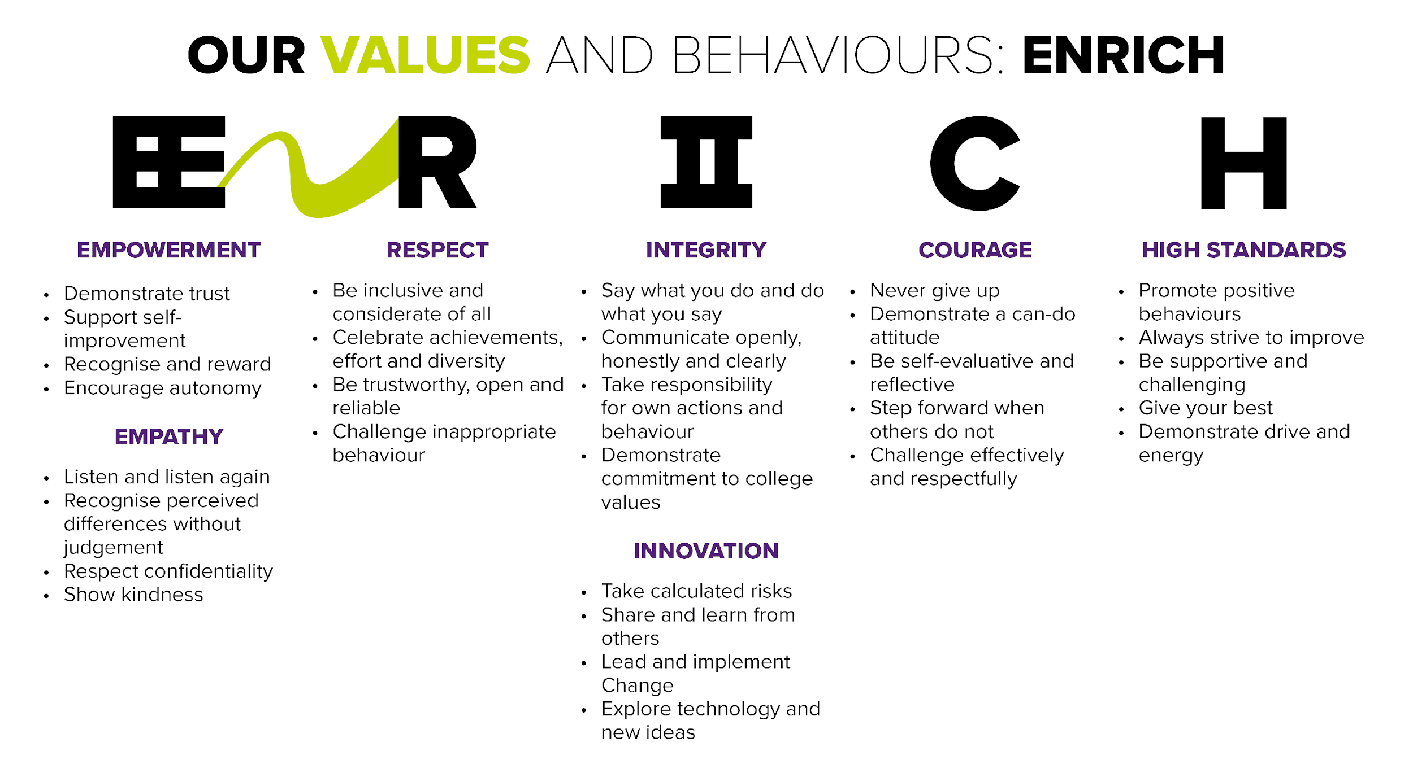  NewVIc is a sixth form college unlike any other. The organisation is focused on providing opportunities for all, and this mission goes beyond the boundaries of sixth form education into provision for adults and services to businesses.  At NewVIc we strongly believe in team working, and see this as one of the reasons for our success.  NewVIc is a forward-looking organisation which values all its staff and working here will give you the opportunity to develop your career and expertise in a successful and innovative student-focused setting.  We currently have a post for a Head of Quality and Curriculum Development to work with colleagues across the College to ensure excellent management of the quality assurance processes, the continuous development of outstanding teaching, learning and assessment and e-learning as well as teacher training and the Honours  Programme that aims to support students wishing to progress to Russell Group, Oxbridge and other selected universities.  Our new Head of Quality and Curriculum Development will drive development and improvement in quality and pedagogy across the College, and have the ability to design and implement innovative teaching and learning strategies underpinned by OLEVI principles. The successful candidate will also have line management responsibility for our E-Learning Manager, and will support and motivate the training of colleagues to use creative e-learning approaches.  To be successful in this role you will need to be able to balance innovation and development with performance and accountability to achieve sustainable improvement.  A full job description is attached to give you more information.

Closing date: | 12.00 noon on 20 April 2021
Vacancy ID: | MP/09
Application form: | To apply for this vacancy please complete the application form available from www.fejobs.com or https://www.newvic.ac.uk/jobs. Applications can be submitted on-line emailed to jobs@newvic.ac.uk  Candidates are shortlisted on the basis of their written application and the extent to which they meet the standard criteria. You are advised to ensure that you use your supporting statement to indicate the extent to which you meet each of the criteria in the person specification below.  Longlisted candidates will be invited in for a selection day. This is likely to include a briefing, a written assessment, a practical test, group activities and an interview by students. After this range of activities has been completed there will be a shortlisting process and selected candidates will have a formal  interview with senior managers and one or more representatives from the governing body.

JOB DESCRIPTION FOR HEAD OF QUALITY AND CURRICULUM DEVELOPMENT
Reports to: Vice Principal - Student Achievement and Progress
Responsible for: Direct line management responsibilities are subject to confirmation but may include:
- Learning Coaches
- LRC and E-Learning Manager
- Honours Programme Curriculum Team Leader

and functional responsibility for PGCE students, NQTs and mentors.

Main Purpose
The Head of Quality and Curriculum Development will lead and manage the College’s Quality assurance and improvement policies and procedures including College self-evaluation, Key Performance Indicators (KPIs) and data analysis and lesson observations, enabling the College to achieve measurable and sustainable improvements in:

- the quality of learning, teaching and assessment
- student achievement and attainment outcomes
- curriculum design and delivery
- services to students and other stakeholders.

The postholder will also be responsible for ensuring that the College is able to be innovative in the development of the curriculum including, in particular, the use of E-Learning.

Main Duties (Generic)

- To support the Principal in realising the vision and values of Newham Sixth Form College.

- To be a champion of change, communication, continuous improvement and empowerment, securing motivation, loyalty and the support of direct reports in particular and staff in general.

- To contribute to the corporate leadership and management of the College including formulation and implementation of strategic objectives, plans and

reviews to ensure that the College fulfils its role as a provider of further education and training in the area served by the College.

- To manage staffing and non-staffing budgets to ensure that expenditure is monitored and maintained within budgetary parameters and the most efficient use is made of resources.

- To contribute to the management of the College’s resources to ensure that efficiency savings measures are identified, targets are met and the most efficient use is made of College resources.

- To represent the College with external agencies and organisations as required in the performance of duties.

- To be a role model for College values, behaviours and team working.

- To participate in the College’s staff appraisal/performance management scheme and professional development arrangements.

- To understand the relevant statutory and College provisions relating to health and safety, safeguarding, equality and diversity and data protection and ensure that they are implemented, monitored and regularly reviewed so that legal requirements and College policies are met.

- To participate in the College’s duty rota.

- To adopt a flexible and adaptable approach to work and working arrangements and carry out any other duties consistent with the key responsibilities and duties of the post.

Main Duties (Specific)

- To lead, manage and develop the staff within the postholder’s areas of responsibility including the management of the performance of teams and individuals within the team.

- To lead and manage the College’s quality planning and improvement systems to ensure that they are able to meet the changing needs of the organisation, its students and external awarding/inspection bodies, ensuring effective quality procedures are in place, conforming to high standards of best practice.

- To develop, support and monitor the achievement of agreed College performance indicators and monitor the outcomes.

- To manage the College’s quality improvement strategy, identifying, in particular, best practice and ensuring that it is disseminated across the College.

- To develop and implement quality assurance, improvement and control policies and procedures including the College’s quality internal audit and observation programmes.

- To be the College’s BTEC (and, as required, other awarding bodies) Quality Nominee.

- To manage the College’s arrangements for self-evaluation and the associated Quality Improvement Plans (QIPs). To monitor the implementation of the QIPs.

- To manage the College’s arrangements for handling student and stakeholder feedback and complaints.

- To work with key internal stakeholders to enable a full understanding of data and purpose of quality improvement.

- To correspond with awarding bodies and take responsibility for external verification management and reporting and monitoring action plans.

- To quality assure the College’s staff and student equality and diversity policies (including the College’s statutory responsibilities) and associated QIPs.

- To ensure that the College is able to develop innovative approaches to curriculum delivery, identifying and sharing best practice and enabling e-learning to be developed across the curriculum.

- To ensure that the College has an effective Honours Programme in place to support students wishing to progress to Russell Group, Oxbridge and other selected universities.

- To quality assure the tutorial programme and ensure it meets the needs of our students.

- To develop a coaching culture within the College incorporating OLEVI principles or other appropriate learning methodologies.

Note

This list of duties is not intended to be exhaustive but simply highlights a number of the major tasks of the post. The post holder may be required to undertake additional duties

(including invigilation) which might reasonably be expected of him/her and which form part of the function of the post.

PERSON SPECIFICATION FOR THE HEAD OF QUALITY AND CURRICULUM DEVELOPMENT

Qualifications:

- Degree or equivalent
- Qualified teacher
- Evidence of continued professional development

Knowledge and Skills

• Ability to think and plan strategically, manage a demanding workload, achieve priorities and meet deadlines
• Strong leadership skills with the ability to motivate, develop, persuade and inspire others using tact, sensitivity and the ability to negotiate and build consensus
• Creativity and enthusiasm, knowing how to develop excellence and how to respond to failure
• Excellent verbal and written communication skills including the ability to represent the college in a wide variety of contexts and with a broad range of stakeholders
• In depth and up-to-date knowledge of the OFSTED framework for Colleges
• In depth and up-to-date knowledge of local and national curriculum opportunities and challenges
- Resilient, flexible and willing to learn from experience and bringing a positive approach, bringing energy and determination and a willingness to work hard
• An analytical approach with strong, problem-solving, project management and data handling skills and the ability to make sound evidence-based judgements
• Be able to work effectively individually and as part of a team
• An understanding of students and their motivations
• An excellent understanding as to how e-learning can enhance the curriculum and student outcomes
• Knowledge of Awarding Bodies and their qualification frameworks

Experience

• Successful teaching experience including the use of innovative solutions to improve the student experience
• Relevant experience relating to the management of a quality function in Further Education
• Relevant experience of developing and implementing quality assurance systems and procedures within Further Education
• Experience of developing and implementing quality improvement initiatives
• Experience of using self-evaluation as a quality improvement tool
• Proven success in motivating people to achieve sustainable improvement
• Experience of preparing a college for Ofsted inspection

- Experience of developing new curriculum

Commitment

- Commitment to NewVIc’s mission and values and to the development of an outstanding college in every respect
- Commitment to the development of every student as a successful learner

Other Information

Health and Safety - all employees must comply with the requirements of the Health and Safety at Work Act 1974 and affiliated regulations. Employees are also required to comply with the college’s Health and Safety Policies and take reasonable care for the health and safety of themselves and of other persons who may be affected by their acts or omissions. Where the college has a statutory duty with regard to health and safety employees are required to co-operate with the college and its managers and officers so far as is necessary to enable the college to meet that duty. This includes using equipment and substances in accordance with training and instruction and the reporting of serious dangers to your own or others’ safety.

The College operates a smoke-free policy and the post-holder is prohibited from smoking in any of the College's buildings, enclosed spaces within the buildings, and College vehicles. Staff will not be released for a break that is specifically for smoking.

Equality – the postholder must be committed to the college’s Equality and Diversity Policy and advancing equality through our Equality Objectives.

Performance – the postholder will be required to participate in performance reviews and undertake a plan of training where necessary.

You will be entitled to 35 days’ annual leave per annum plus 3 additional days allocated at Christmas.

NewVIc supports the professional development of its staff. The strong team culture in the college provides a stimulating environment in which to develop your skills. Development needs are discussed during the appraisal process and there is a generous budget for staff development requests that support team and college objectives.

There is an induction programme for new staff.

Confirmation of appointment is subject to a satisfactory 10 month probation period.

The post holder will be required to adhere to College policies and procedures.

This post is eligible for membership of the Teachers’ Pension Scheme (TPS) or the Local Government Pension Scheme (LGPS).

In addition to the responsibilities listed above, all employees must be adaptable in their approach and undertake other duties that are commensurate with postholder’s level, wherever they may be, to achieve the objectives of the College.

This post is based at Prince Regent Lane but the postholder may be required to visit other establishments move their base to any other location within the college at a future date.

The post holder will be required to have a clearance from the Disclosure and Barring Services. Criminal convictions will only be taken into account when they are relevant to the post.

We are committed to safeguarding and promoting the welfare of children and young people and expect all staff to share this commitment and participate in statutory training.

Useful websites:

NewVIc
www.newvic.ac.uk
The college’s own website.

Newham Council
www.newham.gov.uk
The website of Newham Council.

www.london.gov.uk
The website for the Government Office for London.

The 2018 Ofsted inspection report on NewVIc
www.newvic.ac.uk/statutory-information

