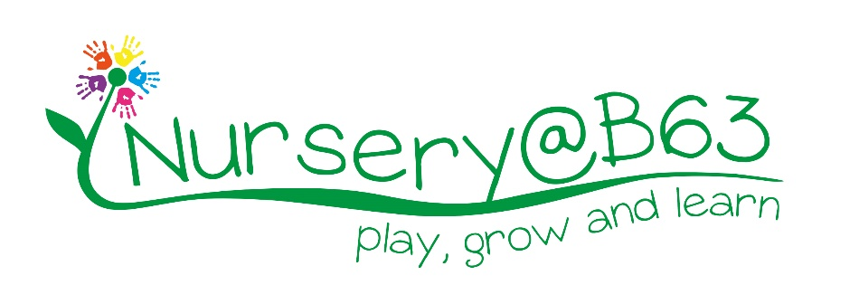
Job Description – Casual Nursery Practitioner

 | Line Manager: |  | Nursery Manager
 | Hours: |  | The nursery is open:  8.00 am – 5.30 pm Monday – Thursday  8.30 am– 5.00pm Friday
 |  | Qualified Nursery Practitioners are invited to apply for our vacancy to support the Nursery Team when staff are absent due to leave, sickness or training. Hours will be variable but could be on occasions up to 40 hours per week. We will work towards providing you with as much notice as possible where planned cover is required but could be at short notice at other times.
 | Salary: |  | £8.72 per hour

The Appointment

To work as part of a team to ensure the efficient running of the nursery providing high quality care for the children attending the nursery that allows a place for children, to play, grow and learn.

Key Tasks and Responsibilities

- To work within the EYFS and promote high standards of care for the children.
- To be responsible for the care and welfare of children within their area of work.
- To adhere to College and Nursery policies.
- To work towards ensuring the regulations and guidelines of OFSTED are met.
- To promote and encourage personal, social and emotional development of the children, including managing feelings and behaviour.
- If requested to record each specified child’s progress.
- If requested to use observation and reflective practice to contribute to planning and evaluation in the setting.
- Provision of a stimulating atmosphere through play in which all children can interact and develop to their full potential.
- To make use of relevant resources to develop children’s skills appropriate to their developmental stage.
- To guide and assist each child using knowledge of differing levels of development and ability.
- To establish and maintain good professional relationships with parents.
- To ensure that children celebrate and experience a range of religious festivals and cultural celebrations.
- To ensure that additional needs of children and babies are met.
- To provide specialist language support to individuals/groups where English is not the first language, when the need arises.
- To help prepare teaching resources and support ethnic minority parents and carers to overcome potential language barriers at home and in nursery.
- To be responsible for the treatment of minor accidents, and the necessary accidents records within their area of work.
- Working within the guidelines set out to ensure efficient running of the nursery.
- Liaison, and co-operation, with other professionals in the field.
- To report to the Nursery Manager any concerns regarding safeguarding, health and safety, PREVENT and welfare.
- To help create attractive displays of children’s work which are regularly changed and kept presentable.
- Be prepared to attend training courses
- It is expected that staff will respond to unforeseen circumstances and emergencies as they arise, commensurate with their qualifications.
- Any other duties/training/development which may be required which are commensurate with the post holder’s skills, experience and grade.

Disclosure and Barring Service Check
All staff must undergo an Enhanced DBS Check and cannot commence employment until satisfactory clearance is received. All staff should attend relevant training on safeguarding children. Halesowen College Enterprises Ltd is committed to safeguarding and promoting the welfare of children and young people and expects all staff and volunteers to share this commitment. The recruitment interview will explore an applicant’s suitability to work with children/young people.

This is a regulated activity under the DBS Policies and Guidelines.

Nursery Staff are expected to:
- Inform management of changes to situations that could warrant the staff member becoming disqualified by association
- Inform management of changes to health / medication that could affect a staff members ability to work directly with children
- Comply with the setting’s and College’s health and safety procedures
- Comply with the setting’s and College’s Safeguarding procedures
- Be free from the influence of alcohol; and substance misuse

Any other duties, which may from time to time, be required and which are commensurate with the skills experience and grade of the post holder.

Disclosure and Barring Service Check
This post, due to its nature, duties and responsibilities, will be subject to a check by the DBS. The level of check which will apply shall be an “Enhanced” level check. Information about this disclosure can be found at www.gov.uk.

To prevent abuse and implement good practice Halesowen College Enterprise Limited ensures that recruitment practices are robust and rigorous and that all staff employed have up to date and acceptable references, a full and complete employment history, an Enhanced DBS check and a check of the DBS barred lists.

Data Protection

You are required to meet the specifications of the HCE’s Data Protection Policy as part of your conditions of employment. This will include information relating to past and prospective employees, children and students, suppliers and customers

Health and Safety
The College, HCE and its workers have legal obligations in respect of the health, safety and welfare of persons at work and the protection of others against risks to health and safety in connection with their activities. Specific health and safety responsibilities are detailed in the College Health and Safety Policy.

Smoking
Halesowen College is a designated smoke-free environment within the perimeter of all College property by order of the College Governors, smoking shelters are provided. This rule applies equally to staff and students, and to all categories of visitor. Acceptance of this rule is a condition of employment for staff, and a condition of being a student for students.

Harassment and Discrimination
You have a duty not to discriminate against or harass colleagues, contractors, students, parents, guardians or potential students or other College visitors, by reason of their age, sex, sexual orientation, gender re-assignment, marriage and civil partnership, pregnancy or maternity, race, disability or religion and belief.

Safeguarding and Staff Code of Conduct
You have a duty to abide by the Staff Code of Conduct and Safeguarding Policy.

Note: This job description is current at the time of issue. It should be recognised that, in keeping with organisational changes and developments, it may be necessary to review the duties listed from time to time and change them to meet organisational objectives.

