JOB DESCRIPTION
Head of Quality

INTRODUCTION
Waltham Forest College is one of London’s most successful Colleges and in February 2018 Ofsted judged the College to be ‘Good’ in all that we do. The College is proud to be described as an ‘inclusive college’ and having a diverse workforce that mirrors our local community.
From the moment you walk into our spectacular building you can see that this is a college built for success. The College firmly believes that our employees are the heart of the organisation and having the right people in the right place is the key to our success
OUR VISION
Careers focussed education inspiring learners to create their future.
OUR MISSION
To deliver outstanding technical and professional learning, which raises aspirations, develops skills and creates futures
OUR VALUES
Our organisational values drive the way we interact with each other and influence our people in creating their future.
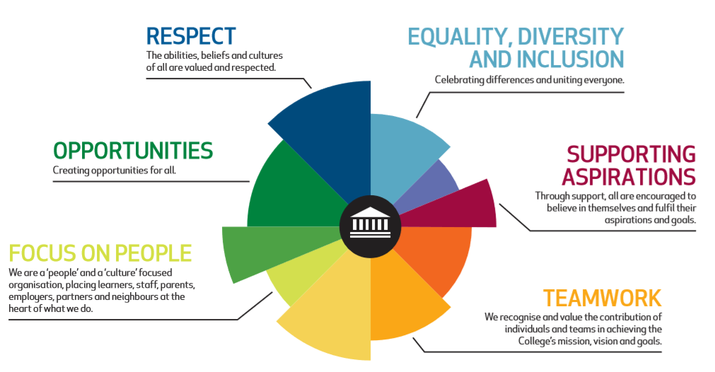

jOB DESCRIPTION
This Job Description sets out the organisational position, reporting lines, key accountabilities and relationships.

Post | Head of Quality
Department | Quality
Pay Spine | Leadership & Management 42 - 45
Post Reports To | Deputy Principal – Curriculum & Quality
Responsible for | Quality Improvement Officer  Administrative Assistant

JOB PURPOSE

To work with colleagues from across the College in the development, implementation, monitoring and review of quality improvement and assurance systems and practice which create a culture of quality and continuous improvement resulting in excellence in all aspects of our work, particularly teaching and learning.

MAIN TASKS

To promote the highest possible standards in customer care, equal opportunities and health and safety practices for the benefit of learners and the wider community served by the College.

To focus the area of work on the process of learning and the needs of learners.

To participate in the development, planning, implementation, monitoring and review of quality assurance systems and policies in collaboration with the Deputy Principal (Curriculum & Quality) and other managers.

To take a lead role in developing, implementing, monitoring and reviewing standard procedures and documentation for ensuring and improving the quality of service, particularly teaching and learning, in collaboration with appropriate staff throughout the College and externally, where warranted.

JOB ACTIVITIES

- To develop, implement, monitor and review standard procedures and documentation for quality assurance and improvement of service whilst ensuring that they are in line with National, Regional and Local developments.
- To work with colleagues in the development, planning, implementation, monitoring and review of quality improvement and assurance systems and policies for application throughout the College.
- To work with the Director for Management Information Systems and other managers to ensure that College systems are developed, integrated and embedded to support the management of performance of the Curriculum as well as the development and implementation of the College’s ILT strategy including E-Learning.
- To participate and contribute in the strategic and operational planning, self-assessment, performance review, performance audit and other quality assurance processes and practice.
- To assist the Principalship and other College managers in organising and preparing the College’s Self Assessment Report.
- To further develop, implement, monitor and review the College’s Course Review Process.
- To support a College internal inspection process and related procedures including carrying out the observation of teaching and learning as required as well as developing and implementing appropriate validation processes.
- To manage the complaints handling process and be responsible for monitoring complaints, reporting on outcomes and reviewing the process.
- To design, implement, monitor and review mechanisms to involve students that ensure learner feedback is sought through surveys etc, articulated and integrated into quality processes and report, as appropriate, on outcomes.
- To design, implement, monitor and review mechanisms to involve parents, employers and other stakeholder groups in quality assurance activities and report, as appropriate, on outcomes.
- To plan, organise and deliver appropriate training and updating events for College staff and other partners on quality related matters.
- To work collaboratively with other managers and advise on best practice in quality assurance and its implementation within the College.
- To analyse, synthesise and prepare quality related reports from a wide range of existing commissioned data.
- To liaise with the internal auditors and College managers (including the Principal) on quality related matters:
- to determine the timetable of events for internal audit reviews and the associated briefs to be followed having regard to the agreed annual plan
- to co-ordinate the preparation of responses to internal audit reports
- to monitor the completion of actions by the College resulting from the reviews carried out by the internal auditors and to prepare progress reports for the Principal and others, as appropriate.
- To take a lead role in the College’s quality sub groups and to participate in the work of other internal and external groups, as appropriate.
- To work with the Deputy Principal (Curriculum & Quality) and others to ensure a high quality of service is provided to improve Teaching, Learning & Assessment and good practice in teaching and is disseminated across the College.
- To undertake the role of Fire Marshall and assist in the safe evacuation of students, staff and members of the public from College buildings.

Waltham Forest College commitments
Waltham Forest College aspires to be an outstanding College and in recognition of the crucial role that members of staff play, individually and collectively, in achieving and maintaining high standards all employees are required to:
- Be a positive ambassador for the College at all times.
- To adhere to the College’s policies, procedures and practices regarding the safeguarding of learners, including attendance at training and updating sessions as required and responding appropriately and supportively to any issues associated with safeguarding.
- Adhere-to the College policies, codes, procedures and frameworks.
- Undertake continuing personal and work related professional and skills development.
- Work collaboratively with colleagues across the College as a whole so as to support the achievement of the College goals.
- Be a positive role model in terms of supporting and promoting equality & diversity.
- Understand and actively support the College’s approach to health and safety and, in particular, to take into account the duty of care for others and oneself in all day to day actions.
- Challenge unacceptable behaviour (such as, for example, discriminatory language, not wearing College ID, shouting or playing loud music in corridors, spitting or swearing) whilst not putting one’s personal safety at undue risk.
- Make an active and positive contribution to team meetings, one to one sessions with line managers and the appraisal process
In recognition of the ever changing environment in which the College operates, the contents of this job description will be the subject of regular review in consultation with the post holder

Person specification
Essential/Desirable criteria will be identified at*
 | AF | I | A
EDUCATION AND TRAINING
Degree and/or professional experience at an appropriate level | E
Attendance at training and updating events relevant to quality in the curriculum and excellence in teaching and learning during the past three years | E
Teaching qualification | E
EXPERIENCE
Proven experience of managing quality in curriculum leading to demonstrable improvements in learner success and the quality of teaching and learning | E
Experience as a teacher or trainer delivering demonstrable high quality outcomes in terms of observation grades and learner success | E | E
Experience of having contributed to the delivery of self assessment processes across an educational or training organisation and of having used such processes to achieve demonstrable improvement | E
Experience of dealing with multiple stakeholders including Awarding organisation. | E | E
Experience of setting up new courses/pathways approval including knowledge of T Levels, apprenticeships and other qualifications | E | E
Experience of using management information systems and data in order to support quality assurance and improvement | E |  | E
Experience of managing budgets and efficient and cost effective resource management | D | D
Experience of setting, monitoring and achieving personal, team and organisational standards & targets | E
Experience of preparing an organisation or team for Inspection | D
Experience of developing and delivering a specific project, policy or strategy which successfully and demonstrably improved the delivery of equality of opportunity or successfully promoted positive attitudes towards diversity within that organisation | E | E
Experience of commissioning and/or undertaking research to support quality improvement in service delivery and/or teaching and learning | D
Experience of contributing to ILT and E-learning initiatives | D
Experience of contributing to strategic and/or operational plans at Middle Management Level or above | E | E
SPECIAL ABILITIES AND APTUTUDE
Strong ability to influence and persuade a wide range of peers, junior and senior colleagues | E | E
Possession of excellent communication and presentation skills (written and oral) | E | E
Ability to forge and sustain good working relationships with individuals and organisations internal and external to the College to promote the interests of the College | E
A sound knowledge of quality assurance and improvement processes and models and the experience of application | E | E
Commitment to putting learning and learners at the forefront of all actions | E | E
Ability to manage a team (both as an assertive leader and in collaborative and supportive team working) in order to achieve demonstrable improvement and high-quality service delivery | E | E
Ability to work under direction and proactively on personal initiative | E | E
Demonstrate an aptitude for proactive and creative identification and solution of problems and barriers to effective working | E | E
Ability to analyse and synthesise information and present it clearly and precisely in a variety of forms (written and verbal) to a range of customers, students and staff in order to underpin quality assurance and improvement processes. | E |  | E
Excellent organisational, administrative and electronic communication ability | E | E
Ability to work flexibly and often under pressure to meet deadlines and targets | E | E
Ability to adopt customer oriented approach and develop that in others | E | E
OTHER REQUIRMENTS
To combine strategic and operational thinking and management with the qualities of analysis and innovation | E |  | E
To contribute to the strategic development of the area of responsibility and to translate strategy into innovative, realistic operational planning and delivery | E | E
Ability to demonstrate a commitment to working with diversity and a range of ability levels, and promoting equality issues as part of everyday practice | E | E
A broad knowledge of the infrastructure, services, challenges of and key strategic issues in the post 16 sector | E | E
Ability to commit to a flexible approach to hours and duties | E
Commitment to the highest possible levels of health and safety for students, staff and others | E
Ability and willingness to undertake continuous professional development | E | E
To have a strong sense of purpose and the drive to achieve agreed goals | E | E

* Key: AF = Application Form, I = Interview, A = Assessment

